
UNIVERSITÉ ABDERRAHMANE MIRA DE BÉJAIA
Faculté des Sciences Économiques, Commerciales et des Sciences de Gestion
Département des Sciences Économiques
MÉMOIRE
En vue de l'obtention du diplôme de
MASTER EN SCIENCES ÉCONOMIQUES
Option : Économie Quantitative
L’intitulé du mémoire :
THE PROSPECT OF ECONOMIC RESURGENCE:
A BLUEPRINT FOR EAST AFRICA’S ECONOMIC LEAP INSPIRED BY THE USA AND UAE

Préparé par : Encadré par :
Mr. KIPROP Emmanuel Dr. Rachid Lalali
Ms. MKOMBOLA Agatha Wakio

Date de Soutenance : 23-06-2025
Jury
Président : BELKHIRI Aimad Edine
Examinateur : KACI Said
Rapporteur: LALALI Rachid

Année universitaire : 2024/2025

Dedications
With love and gratitude, I dedicate this dissertation to my parents, Mr. Mkombola Wasai and Mrs. Mkombola Honoratha; my cherished siblings, Chao, Doreen and Collins; and my dear friends, all of whose faith and support sustained me through this journey.
With delight do I dedicate this dissertation to my parents, Mr Kiprop Julius and Mrs Irene Kiprop, my beloved siblings Qs. Arthur, Dr. Laura and Joshua, my supportive friend, Ms Agaba Marvin, my dear friends and classmates who have simply been a blessing

Acknowledgements
This project wouldn’t have reached maturity without the invaluable and selfless assistance of several individuals and institutions. We extend our profound appreciation to all who constantly contributed their resources, time and expertise to guide us through this academic milestone.
First and foremost, we would like to express an uttermost token of gratitude to our most patient supervisor Dr. ATMANI Anissa, for her timely feed backs and excellent guidance throughout the research process. Her support made it easier to attain fluency and authenticity in our work.
We would also like to appreciate Dr Rachid Lalali who without hesitation took over from Dr Atmani Anissa after her departure in order to enable us successfully to complete our research project.
We also wish to thank the Faculty of SEGC at the University of Béjaïa for an opportunity to pursue this masters’ degree in Economic Sciences. The experience has been intellectually enriching and personally transformative.
An earnest appreciation to the governments of Uganda, Kenya and Algeria for the scholarship awards that have assisted in the broadening of our academic horizons.
A very special thanks to our kith and kin, classmates and compatriots, whose steadfast love, encouragement and support truly grounded us throughout this academic pursuit.
Finally, we are thankful to God for the grace to complete this dissertation.

Table of Contents
Dedications i
Acknowledgements ii
List of abbreviations v
List of illustrations vi
General Introduction. 1
Chapter one: Literature Review 5
Introduction 5
1.1 The notions of economic growth, diversification and development. 5
1.2 Measurement of Economic growth and development; Key indicators 6
1.3 General factors that influence economic growth and development. 7
1.1.3 Theoretical review. 8
1.1.4 Sectoral evolution and key turning points 10
Conclusion 13
Chapter Two: Theoretical and Foundational Framework of Quantitative Study. 14
Introduction 14
2.1 Research Outlook 14
2.1.1 Research approach. 14
2.1.3 Data acquisition. 15
2.2 Empirical Estimation. 19
2.2.1 Stationarity tests. 19
2.3 Model specification and selection. 20
2.3.1 Bounds test for cointegration. 20
2.3.2 ARDL Model Specification 20
2.3.4 Running of diagnostic tests and model validation. 21
Conclusion 21
Chapter Three: Comparative Quantitative Analysis: USA, UAE and Kenya, Uganda 22
Introduction 22
3.1.1 Selected descriptive summary of the data. 22
3.1.2 A visual representation of the evolution of all variables 23
3.2 The Unit Root Test results. 24
3.2.1 Using the Augmented Dicky Fuller test (ADF) 24
3.2.2 Using the Phillips-Perron Unit root test (PP) 24
3.2.3 Kwiatkwoski-Philips-Schmidt-Shin Unit root test (KPSS) 25
3.3 The estimation of the Autoregressive Distributed Lag (ARDL) model. 25
3.3.1 Selection of the optimal lag lengths. 25
3.3.3 Long run ARDL estimations. 27
3.4 Diagnostic tests results. 29
3.4.1 Normality tests for residuals (Jarque – Bera Tests). 29
3.4.2 Serial correlation test for residuals. 30
3.4.3 Heteroscedasticity test for residuals. 31
3.4.4 Testing for stability of models. 31
3.4.5 Ramsey RESET tests. 33
3.5 Discussion of all Results. 33
3.5.1 Response to the research question. 33
3.5.2 Response to subsidiary questions. 35
3.5.3 Examination of Hypotheses. 36
3.5.4 Evaluation of research objectives. 37
General Conclusion 38
4.1 Summary of study 38
4.2 Limitations 38
4.3 Areas of future study 39
Appendices 40
Bibliography 45
Abstract 49

List of abbreviations
ADF- Augmented Dickey Fuller test
AIC- Akaike Information Criterion
ARDL- Auto-Regressive Distributed Lags
COVID-19- Corona Virus Disease 2019
CUSUM- Cumulative Sum
CUSUMSQ- Cumulative Sum of Squares
ECM- Error Correction model
ECT- Error Correction Term
FAO- Food and Agriculture Organization
GCF- Gross Capital Formation
GDP- Gross Domestic Product
GDPc - Gross Domestic Product per Capita
GGFC- General Government Final Consumption Expenditure
HDI- Human Development Index
I ()-Integration Order
ICT- Information and Communication Technology
IMF- International Monetary Funds
IT- Information Technology
KPSS- Kwiatkowski-Phillips-Schmidt-Shin
LM- Lagrange Multiplier
OECD- Organization of Economic Cooperation and Development
OPB- Oil Price per barrel
PP- Phillips-Perron
RESET- Regression Equation Specification Error Test
SAPs- Structural Adjustment Programs
UAE- United Arab Emirates
UN-The United Nations
USA- The United States of America

List of illustrations
List of Tables
Table 1: Identification of variables, abbreviations and expected signs. 15
Table 2: Summary of the data 22
Table 3: ADF results’ table 24
Table 4: PP results’ table. 24
Table 5: The F – Bounds Test Results 27
Table 6: Long run estimations. 28
Table 7: Short run estimations. 29
Table 8: Breusch-Godfrey Serial Correlation LM Test. 30
Table 9: Breusch-Pagan-Godfrey Heteroscedasticity Tests. 31
Table 10: USA’s Ramsey RESET results 33

List of Figures
Figure 1: Annual GDP growth (%)Kenya and Uganda (1983-2023) 12
Figure 2: Graphs showing the evolution of the variables 23
Figure 3: Different lag structures using the AIC. 26
Figure 4:Jarque – Bera normality tests. 29
Figure 5: CUSUM and CUSUM of Squares test charts. 32

General Introduction.
A conversation that all nations will continue to have until the end of time, Economic growth, development and sustainability. The unending dialogue and debate not only fueled by patriotism but also a burning desire to be presented as the strongest, the richest and most admirable, a conversation that most western and eastern nations seem to be occupying the driving seats setting aside the African brethren as only spectators. Isn’t it quite difficult to understand how a continent that is home to not only about 30% of the world mineral reserves (UN enviroment programme, 2024) but also some of the richest soils seems to always significantly lag behind its Western and Eastern counterparts.
Defining economic growth as an increase in the size of a country's economy over a given period of time fundamentally measured by the total production of goods and services which is called the gross domestic product (Reserve Bank of Australia, n.d.) gives us the opportunity to carefully observe this reality. With North America consisting of 23 countries and a combined GDP of 29.87 trillion dollars (World Bank, 2023) and The Middle East consisting of 17 nations and a combined GDP of 3.47 trillion dollars (IMF, n.d.), it is without doubt that one is challenged with the thought of how a region having over twice the number of nations has a much lower GDP, the Sub-Saharan African nations totaling up to 49 nations combining for a GDP of 2.04 trillion dollars (World Bank, 2023). This information only tells us one thing, the African nations are simply underutilizing their vast amount of renewable and non-renewable resources.
With a discussion so wide, we narrow down our focus to two of East Africa’s rich nations, Uganda also known as the pearl of Africa and Kenya and through a comparative approach, appreciate and draw inspiration from the longevity of sustained economic growth of The United States of America (USA) and the incredible and rapid economic success of The United Arab Emirates (UAE). Whereas the USA is undeniably the pinnacle of economic success boasting a GDP of 27.72 trillion dollars as per 2023 (World Bank, 2023) with a tremendous gain of almost 25 trillion dollars in the last 50 years, it is also worth pointing out that in a span of just over 50 years, the UAE has increased its GDP by almost a factor of 500 climbing from a GDP of 1.42 billion dollars in 1971 to a GDP of 514.13 billion dollars as per 2023 (World Bank, 2023).
Through this very time frame, we labor to highlight that Kenya and Uganda were not very far off the UAE in terms of economic capacity fronting 1.78 billion dollars and 1.42 billion dollars (World Bank, 2023) in GDP value respectively in 1971 and over the same period of time been able to climb to 108.44 billion dollars and 48.77 billion dollars (World Bank, 2023) in GDP value respectively as per 2023. The figures above are quite self-explanatory, there is a surely huge gap in the rate of economic development.
Problem statement.
In as much the soil wealth of Uganda and Kenya is not even a debatable subject with not only the largest population in Uganda living off agriculture (Sies & Hintum, 2023) but also the massive contribution agriculture makes to the nations’ GDP (World Bank, 2023), it is important for us also turn our attention to the existence of other major resources and through careful examination, we can agree that Kenya and Uganda possess such a wealth of both renewable and non-renewable resources, a young and active work force, and a continuous rise in regional integration. However, in comparison to highly developed and significantly developing natural resource driven countries like USA and UAE, we have been able to note that Uganda and Kenya lag significantly behind in several key areas. Through very valuable research done by some credible experts (Acemoglu & Robinson, Why Nations Fail: The Origin of Power ,prosperity,and Poverty, 2012) we can cite issues like, inefficient allocation of funds, underdeveloped infrastructure, under exploitation of resources, exercising of ineffective policies and limited industrialization among others and this has undoubtedly impacted the standard of living in these two nations.
With a strong intent on examining how USA and UAE have both significantly capitalized on their renewable and non- renewable resources and in result significantly contributed to their overall growth. We however recognize that the problem lies in identifying and adapting effective strategies, with some fundamentally rooted in innovation, which involves the education and instruction sectors and major institutional stability, which influence policymaking and implementation as in the USA and the others aimed at leveraging finite resources as in the UAE which we believe will be able to produce a more effective framework for the optimization of the resources in Uganda and Kenya and foster the experience of significant economic growth.

Through this study, we believe that we will be able to discover some very good insights and ideas that could be of significant value to understand how best Uganda and Kenya could maximize their resources as a foundation for economic resurgence.
Research Question.
In an economic world in demand of a strong shift in sustainability, to what extend have Kenya and Uganda leveraged their major renewable and non-renewable resources to foster a future of economic resilience, prosperity and diversification?
Subsidiary research questions.
- What are the key economic growth drivers in the UAE and USA?
- How do these drivers compare to those in Kenya and Uganda?
- What roles have natural resources (renewable and non-renewable) played in economic transformation?
- What policies and institutions have been instrumental in sustaining growth in the UAE and USA?
- How can Kenya and Uganda adapt these lessons to accelerate their own economic growth?
Purpose and significance of study.
As we intend to do a deep into understanding which were and are the most valuable resources that USA and UAE possessed and still possess, will we not only be given the opportunity to appreciate their great wealth but also be driven to understand what approaches they took to greatly harness these resources. We will surely be looking at a majority of qualitative and quantitative variables from the patterns of state investment and re-investment to their effective and efficient policy making and execution.
Through this research with the help of important theories and concepts like Rostow’s concept on stages of economic growth and Robert Solow’s growth model will we be able to carry out a comparative approach that we believe will deduce for us a wealth of similarities between these nations and in that will a light be shed on what ways Uganda and Kenya can be able to take full benefit of their abundance and progressively make their way up the economic ladder.

Objectives of the study.
- Through this study, we intend on magnifying the variables that can play very important roles in the resurgent growth of Uganda and Kenya respectively.
- We also intend on providing insightful knowledge into which policies might be best applicable in nations like Uganda and Kenya.
The Hypothesis.
H1: A country’s ability to effectively and efficiently invest into its most valuable resources will have a significant contribution to its overall development.
H2: Behind every fined tuned state, is an efficient policy making system that responds to its evolving needs
H3: In the long run, there is a positive relationship between the presence of skilled human capital and a country’s overall economic development.
The Methodology.
Comparative Economic Analysis inclined to both qualitative and quantitative analysis, through the use of time series and Auto-Regressive Distributed Lags we will be able to compare the major economic aggregates primarily the GDP per Capita and there after the HDI, GDP among others. Through these comparisons shall we be able to analyze the growth patterns of Kenya and Uganda in relation to USA and UAE.

Chapter one: Literature Review

Introduction
This literature review will endeavor to provide us with a solid insight into some of the key theories and concepts that will be relevant in understanding the economic evolutions of these four Nations. Through this chapter we therefore intend to lay a solid foundation to a rather very comprehensive study of how the USA and UAE can act as great contextual models for Kenya and Uganda. This chapter will introduce us to key themes like the notions of Economic growth, diversification and Development, the various indicators used to measure both economic growth and economic development, general factors that influence both economic growth and development and an insight into key schools of thought and theoretical frameworks that will be equally relevant in our exploration.
Additionally, this chapter will give us a brief but solid overview into the economic evolutions of all four nations from the 20th century up until 2023 subject to selected economic theories wherein we will observe the economic growth and development patterns, the key strategies, policies and natural resource avenues that fostered their sustainability. We will also be able to identify the key events and periods within that timeframe and not only how they impacted these nations but also their respective responses to their situations. With a rather solid amount of foundational relevant theoretical and empirical findings whilst exercising a comparative language, this chapter will conclude with an attempt to unearth areas worthy of significant attention.

1.1 The notions of economic growth, diversification and development.
Economic growth is simply defined as the increase in the quality and quantity of goods and services produced within a given economy fundamentally measured by the gross domestic product (GDP) and often taken a step further in terms of GDP per capita to properly examine the average output of every individual as suggested by (Helpman, 2004) and (Acemoglu, Introduction to modern economic growth, 2008) and on the other hand economic diversification, a key component of economic growth can be defined as the process by which a country graduates from depending on narrow sources of income to creating significant income largely sponsored by strong investment into less exploited sectors. It is however also important to note that this diversification tends to often start with a country’s effort to become less reliant on the agriculture sector and evolve into a more industrious economy (Lewis, 1955).
Despite the popularity of the term economic growth, it is however unwise to think that a country’s economic growth guarantees its development as earlier hinted on by an example sighted by William Easterly (Rodrik, 2003). Economic development is a field that requires us to examine areas like life expectancy, access to education, essential services like good health care among others and in this defining development as the process of improving the quality of all human lives and capabilities by raising people's standard of living, self-esteem and freedom (Todaro & Smith, 2020).

1.2 Measurement of Economic growth and development; Key indicators
As earlier stated, economic growth and economic development are two unique lenses through which the overall progress of a country can be evaluated and below are some of the key indicators that have been developed over time to enable us to have valuable insights into these countries’ progress through the lens of Economic growth.
- Gross Domestic Product (GDP): GDP is simply the total value of goods and services produced within each economy often evaluated on a yearly basis (OECD, n.d.). Being able to study the GDPs of these four nations over a significant period will be very pivotal in providing valuable and conclusive assessments.
- GDP (or income) per capita: As appreciated by many key economists like Daron Acemoglu and Elhanan Helpman, this indicator undoubtedly enables us to evaluate the average contribution or income of each individual as it’s the GDP divided by the overall population.
- And through the following indicators, we will be able to assess each country’s economic development.
- Human Development index: A very wholesome indicator that was introduced thanks to the United Nations Development Program that attempts to harmonize three key areas that assess the development of an individual, these being, the length and health of one’s life, the amount of valuable knowledge acquired throughout life and one’s standard of living. Through harmonizing these three aspects we are able to look beyond one’s income but rather how the county’s overall economic growth is having an influence on the entire population.
Through a careful examination of these indicators in relation to each country, we will be able to carefully observe USA’s and UAE’s growth and developmental evolutions and be able to draw out areas of inspiration for Kenya and Uganda.

1.3 General factors that influence economic growth and development.
Below are some of the common key driving factors of economic growth and development.
- Human Capital: According to Endogenous Growth Theory (R.E, 1998) human capital (particularly investments in education and health) plays a central role in enhancing productivity and sustaining long-term economic growth. Educated and healthy individuals contribute more effectively to innovation and efficient resource allocation, which directly impacts national output.
- Strong Institutional Framework: New Institutional Economics (D.C, 1990); (Acemoglu D, Johnson S, Robinson J.A, 2001)posits that the quality of institutions defined by rule of law, transparency, accountability, and property rights profoundly influences economic outcomes. Strong institutions reduce transaction costs, ensure policy credibility, and foster an enabling environment for private sector activity and foreign investment.
- Investment in Technological progress: Romer’s Endogenous Growth Theory (1990) suggests that sustained technological advancement is the primary engine of long-term economic growth. Investment in research and development, innovation, and technological infrastructure fosters productivity improvements across sectors, leading to industrialization and modernization. “Technological change arises from intentional investment decisions made by profit-maximizing agents responding to market incentives.” (P.M, 1990)
- Natural resources: The role of natural resources in economic development is explained through a dual lens. Traditional Neoclassical Growth Theory views natural resources as factors of production contributing to output. However, the Resource Curse Hypothesis (R.M, 1993) highlights that resource abundance can sometimes hinder growth due to mismanagement, rent-seeking behavior, and Dutch disease effects. Recent studies emphasize that with proper governance and sustainable practices, natural resources can be a long-term asset rather than a liability (Singh, Sharma, Radulescu, Balsalobre-Lorente, & Bansal, 2023)

1.1.3 Theoretical review.
The contrasting development paths of Kenya and Uganda (former British colonies in East Africa ‘1895-1963’ and ‘1894-1962’ respectively) versus the USA (former British settler colony ‘1600s-1783’) and the UAE (a resource rich Gulf state under the British influence ‘1820-1971’) highlight the impact of legacies, resource endowments and economic policies.
Several theories try to shed light on these differences (Todaro & Smith, 2020) among them:
- Linear stages theories
Rostow gives 5 stages of growth and development (Rostow, 1960), from which we notice Uganda and Kenya trapped in the second stage of building prerequisites for takeoff, whereas the USA and UAE have noticeably maneuvered through the takeoff stage into maturity which qualifies them for reference in this dissertation. Likewise, the Harrod-Domar economic growth model stresses the importance of savings and investment as key determinants of growth, this leads us to question the resource management and the investment strategies of Kenya and Uganda that have kept them trapped for so long.
- Structural change theory
Conversely, this theory delves into the two-sector model by Lewis (Lewis, 1955);A traditional model conformed to agriculture, low productivity and surplus labor supply and the modern model that is characterized by industrialization, higher wages and high productivity. Uganda and Kenya rely heavily on agriculture (over 20% of their GDP) as compared to the UAE which has agriculture accounting for only 1% of its economy and the USA’s 5.5% of their GDP. This clearly suggests Kenya and Uganda need a blueprint that liberates them from the overreliance on agriculture. In this theory, the underdeveloped economies ought to transform their domestic economic structures from a heavy emphasis on traditional subsistence agriculture to a more modern, more urbanized, and more industrially diverse manufacturing and service economy.
This theory is however only applicable if the supply of labor in the agricultural sector is unlimited, and so are the stages of development by Rostow if the political conditions and background of every nation were similar. The major divergence is without a doubt the Industrial Revolution (1800s). During this period, the USA was witnessing an ascent of its economy, as in growth of factories, railroads and urbanization while the “UAE” remained a pearl trading economy under the British influence, primarily serving as a raw material transportation medium. In contrast, Uganda and Kenya were the source of raw materials and their human capital was traded for slavery to labor in European factories. They missed out on the ‘engine of modern growth’ which is arguably the trap that ties them to the second stage according to Rostow’s perspective.
The discrepancy can also be examined from the lens of the different techniques of colonization. The British in their quest to conquer North America, established inclusive property rights and institutions that facilitated democracy, economic growth and eventually self-governance that fueled the American revolution (1775-1783), which was the beginning of a self-sufficient America (Acemoglu, Introduction to modern economic growth, 2008). In Uganda and Kenya, they established a settler’s economy, where they introduced cash crops like tea and coffee while owning the cash crop farms and exporting the produce to Great Britain (Van Zwanenberg, 1975), to date, Uganda and Kenya export these raw materials, and unfortunately import finished goods of the same materials they export. The British influence on UAE’s was only for the purpose of trade during the industrial revolution.
It is evident that the economic and political aspects of each country are patterned by their history, in this case, colonial. Acemoglu and Robinson, insist on how this history shapes the institutions and the policies a nation implements. “…They convincingly show that countries escape poverty only when they have appropriate economic institutions, especially private property and competition. More originally, they argue countries are more likely to develop the right institutions when they have an open pluralistic political system with competition for political office, a widespread electorate, and openness to new political leaders… (Gary S. Becker, Nobel laureate in economics,1992)”. This presents alternative classic theories of growth:
- International Dependence models.
One of the international dependence theories, the False Paradigm model, suggests that the colonialists prototyped the current economic orientations of developing countries. In an attempt to integrate into the global economy, Kenya and Uganda have been emulating policies that do not suit their economic needs. In Kenya for example, there’s a promotion of cash crop production for export, and a negligence on the development of food security and local sectors. In Uganda, the IMF suggested Structural Adjustment Programs (1980s and 1990s) that led to a short-term economic growth. However, in the long run, Uganda is still dependent on foreign aid rather than achieving self-sustaining industrialization. This aligns with the concept of Neocolonial dependence as discussed by (Todaro & Smith, 2020)and (Acemoglu, Introduction to modern economic growth, 2008) that the false paradigm institutions favor the accumulation of wealth for a group of policy making elites while limiting broader economic independence.

1.1.4 Sectoral evolution and key turning points
The four countries are poles apart in terms of economic structure, with a reasoning rooted in a chain of causality; that is, the policies and institutions, which define the growth pathway of key sectors, which is an upshot of their respective historical backgrounds. Analyzing historical backgrounds reveals how each handled its major crises and turning points.
USA for instance, was heavily dependent on agriculture, a result of a Homestead Act (1862) (Gates, 1968), enacted to transform the economy from subsistence to export driven agrarian economy, by implementation of land ownership laws that made it ideal. Their pivotal point was in the late 1700s during the industrial revolution (Mokyr, 1990), where they shifted to an industrial economy producing majorly steel and railroads. The historical breakpoint occurred between 1945-1970s following World War II (Maddison, 2007) where The USA capitalized on the post war economic landscape, leading to a growth in their GDP, infrastructure and labor-intensive industries (including a recovery from the great depression crisis in1929), fueled by aid to the war-ravaged European nations. This resulted in an ultimate metamorphosis from a colony to the world’s superpower. Over the years, due to globalization and deindustrialization, a product of automation and technological advancements, policies had to be implemented to meet the pursuit for development; consider the case of: The Telecom Act (Congress, 1996) and (Summary of the Affordable Care Act, 2010) to foster the growth of IT and telecommunication sectors, Affordable care Act (2010) that facilitated the expansion of the healthcare sector, one of its largest industries, among others. These reforms have played a major part in making the USA a service-based economy. Today, the services sector constitutes up to 80.2% of USA’s GDP (World Bank, 2023) while the agricultural and industrial sector contributes to 0.9% and 18.9% respectively.
Unreservedly, the UAE’s economy does not revolve around agriculture (0.8% only of its
GDP) due to harsh weather conditions, prior to the oil discovery in Abu Dhabi (1958) and in Dubai (1966), the UAE was a pearl-trade economy (Davidson, 2005) & (Heard-Bey, 1982) that went into freefall after Japan made their entry into the market in 1930 with cultured pearls. The hydrocarbon resuscitated the economy, and the UAE underwent a transformation by establishing industrial zones like Jebel Ali free zone (IMF, 2019) & (Ministry of Economy, 2020); they maximized their investments into their most valued resource. Over the past five decades, the UAE has managed to transfigure into the most diversified economies with a vision 2030 aimed at driving deeper into diversification. Currently,47.7% of its GDP is accounted for by the industrial sector and 51.5% by the services sector (World Bank, 2023).
For Kenya and Uganda, economic structures and events are shaped by globalization, political and colonial legacies, technological changes and post-independence theories. The post-independence attempts to industrialize the economy were made stagnant by: In Uganda Milton Obote’s endeavors were cut short by Idi Amin (Mutibiwa, 1992), followed by the decline of trade due to the expulsion of the Asians (Mamdani, 1973). In Kenya, Mzee Jomo Kenyatta’s efforts were slowed down by the Structural Adjustment Programs (1990s) (Mkandawire & Soludo, 1999), the SAPs equally affected Uganda and slowed manufacturing. On July 7, 2000, the countries formed an East African Community, now includes more East African Nations (UNECA, 2021), with an aim to foster regional integration and promote trade by reducing barriers amongst member countries. This has been the core contributor to the service sectors, currently constituting up to 60% and 49% to Kenya and Uganda’s GDP respectively, nevertheless, agriculture is still a vital sector in these economies, as it contributes to over 22% of their respective GDPs, and industries accounting for only 17.5% and 25.8% in Kenya and Uganda respectively.
The graph below illustrates further the annual growth percentage of Kenya and Uganda’s GDP, over a period of 40 years (1983-2023). The data sourced from World Bank national accounts data, and OECD National Accounts data files, provides a platform to trace the economic evolution of these two countries while underlining their overtime resilience through the erratic global economy.

Figure 1: Annual GDP growth (%)Kenya and Uganda (1983-2023)

Source: World Bank
In the early 1980s, Uganda’s economy suffered dramatically, a consequence of the brutal Idi Amin’s rule, which H.E Yoweri Museveni noticeably recovered from the late 1980s to the 1990s.This was made possible by the IMF reforms of privatization (Adam & Gunning, 2002) and liberalization, setting a stage for growth. The same reforms that stabilized the economy are the same ones that led to the subsequent stagnation, and like any other economy in 2020 Uganda also faced disruptions due to the global COVID-19 health crisis (COVID-19 and Economic Recovery in Uganda, 2021). However, the discovery of Albertine oil (2010), spiked hopes for Uganda’s flight out of the low-income economy; it remains a work in progress till date (Oil and Gas Sector, 2023).
Kenya’s economic evolution since independence was almost the same, except it grew gradually until mid1980s when the nation suffered pressure to implement SAPs suggested by the IMF and corruption that relented its growth through the 1990s (JICA, 2008). Kenya in the early 2000s saw a renewed growth as new liberalization policies were implemented and ICT development (notably mobile banking, M-Pesa) (Jack & Suri, 2014). The 2007-2008 election violence was a major economic shock, yet a turning point as it pioneered the launching of the vision 2030 (Kenya Vision 2030: The Popular Version, 2007) development plan that has succeeded in transforming Kenya to a lower middle-income from a low-income country. Despite the occasional droughts, a growing public debt and political tensions slowing Kenya’s growth and in the same effect, the temporary COVID-19 slowdown (Kenya Economic Update: Navigating the Pandemic, 2020), the policy makers are increasingly fixated on the digital economy (The Silicon Savannah investment) and industrialization for future growth.

Conclusion
This chapter has given us a foretaste of the economic positions occupied by USA, UAE, Uganda and Kenya in their precolonial, colonial and the postcolonial eras. It has also provided us with a solid insight into some of the key theories and concepts that explain the respective economic evolutions of these four Nations. The policies influencing growth and the current economic states of the four nations is undoubtedly dictated by their respective eras during the great industrial revolution (Allen, 2009) & (Acemoglu & Robinson, Why Nations Fail: The Origin of Power ,prosperity,and Poverty, 2012). Uganda and Kenya’s development trajectories are simply a derivative of the colonial systems under which they were governed, with different studies emphasizing the role of structural reforms, governance and external shocks (Rodney, 1972), majorly in the postcolonial period.
While the theoretic review offers valuable insights, the empirical review reveals inconsistencies and gaps as discrepancies have been observed on the results procured from different countries. The research in existence does not independently explain development. It either assumes an unlimited supply of labor in the agricultural sector or overlooks the diverse socio-political factors by implying an even development trajectory across countries, or presumes that all markets work efficiently, or explains underdevelopment without proposing practical solutions. This accentuates the necessity to draw a blueprint that combines strategies while putting history, institutions and global market influences into consideration, and focusing on Uganda and Kenya’s most valuable resources and heaviest investments

Chapter Two: Theoretical and Foundational Framework of Quantitative Study.

Introduction

This Chapter intends to provide us with the foundation to an in-depth empirical investigation that seeks to examine the influence of certain key independent variables on the GDPs and overall development of four different nations and in that aiming to draw out areas of significant correlation. It briefly commences by providing us with an insight into our research methods, period of interest and our method of data acquisition.
This chapter will then endeavor to thoroughly explain the reasons that concern the selection of the variables that will be very pivotal in achieving the objectives of our case study. It will therefore conclude with an introduction of our selected model of analysis with concrete reasons for its usage as well. With the above, this chapter intends to properly equip the reader of this research with the right tools and vision to understand the various findings in the final chapter.

2.1 Research Outlook

2.1.1 Research approach.
This study will fundamentally take the quantitative approach in an attempt to meet the desired objectives given the value and wealth of numerical and statistical data involved in this research. Inclined to comparative analysis driven by the multiple countries under study, this research aims at applying some of the theoretical ideas laid out in chapter one to provide us with a unique uniformity in areas of reference which will enable us to examine and contrast the economic evolutions of these four countries and through that be able to deduce both significant and useful conclusions.
2.1.2 Period of Interest.
This study aims at examining a period worth 3 decades from the year 1992 to 2022. The choice of this time span is to be able to capture as much valuable information as possible which will not only include the minor evolutions but also the major, normally structural transformations experienced that have heavily impacted the economic evolutions of these four countries. It is without contention that a period like 31 years can really bring to life the different seasons that a nation has experienced not just economically but also socially and politically which all undoubtedly impact the growth and development of a country. The choice of this time frame provides the reader with the confidence to trust the findings in this paper.

2.1.3 Data acquisition.
This study is hinged on reliable data sets acquired from very reputable sources, fundamentally, World Bank. The availability of these data sets provided this research with the perfect opportunity to employ all the variables that will be of significant importance to this paper. The availability of these data sets undeniably make these research case studies much easier to undertake and with such reliable numerical and statistical data, this will ensure that the overall findings of this research will be of great value to the economic space.
The data sets acquired are of the following variables.
Table 1: Identification of variables, abbreviations and expected signs.
Variable | Abbreviation | Expected sign
Gross Domestic  Product per capita (Constant US$) | GDPc
Gross Capital Formation  (Constant US$) | GCF | +
General Government Final  Consumption Expenditure  (Constant US$) | GGFC | +
Human Development Index | HDI | +
Source: Author
- Gross Domestic Product per capita (GDPc) – Dependent variable.
Gross domestic product simply defined as the value of goods and services produced in each country merits it to be used in studying the overall growth and evolution of a country’s economy. In an even more precise context, the Real gross domestic product which rather considers the inflation of the country as it is adjusted for price changes qualifies as an even better dependent variable in this paper (Callen, 2025)This paper being interested in evaluating the impact of the independent variables chosen on each country’s economy through which the key components influencing the economic progress and overall development of these countries will be highlighted. Launching deeper and examining the GDP per capita of each country will further provide us with the path to understanding growth and development pathways of the United States and the UAE and be able to draw out ideas that could be beneficial to Kenya and Uganda.
- Gross Capital Formation (GCF)
Gross capital formation refers to the gross addition to national wealth that results from three major categories known as gross fixed capital formation, change in inventories and acquisition less disposals of valuables (Cross Capital Formation, 2021)
This capital formation gives a country the power to produce more goods and services as a sample study done on Rwanda showed that gross capital formation had a positive impact on its GDP (Ntamwiza, 2022). This kind of research provides an ideal basis to include the GCF as a strong independent variable and in addition also aligns with the logical understanding that if a country can acquire more productive capital stock, the country is expected to produce more goods and services, hence increasing its GDP. An example being the UAE, in the past 15 years, it is no coincidence that in a time span where UAE has increased its gross capital stock by about 65% it has also increased its GDP by a similar percentage (World Bank, 2023), this information provides a concrete basis to selecting this independent variable in analyzing the growth patterns in these four countries and make valuable comparisons.

- General Government Final Consumption Expenditure (GGFC)
Public expenditure or investment is an idea that was really encouraged by John Maynard Keynes in his theories concerning economic growth. His belief that an increased government expenditure within the right contexts would foster economic growth and increase a country’s overall output is one of the foundational reasons this paper selects this independent variable (Jahan, 2014).
A sample study done on the Gambia tends to agree with the ideas of Keynes as this research showed that general government final consumption expenditure had a positive contribution on the country’s GDP (Ceesay, 2022), these kinds of findings provide us with the right reasons to select this variable as a probable contributing factor. Evaluating the differences in these countries’ expenditures will probably expose to us the reasons for the existing gaps in growth and development over the past few decades.
While household consumption plays a vital role in stimulating short-term aggregate demand, this study prioritizes Gross Government Fixed Capital Formation (GGFC) as a more robust indicator of long-term economic growth. Theoretically grounded in Solow’s capital accumulation model and Endogenous Growth Theory, GGFC represents deliberate, policy-driven investment in physical infrastructure such as roads, schools, hospitals, research centers, and administrative institutions (P.M, 1990). These investments contribute directly to key structural growth drivers including human capital development, institutional strengthening, technological advancement, and the mobilization of natural resources. Unlike final consumption, which is often volatile and influenced by short-term factors such as inflation, subsidies, or remittances, GGFC is a forward-looking indicator that reflects a government's strategic vision for national productivity and capacity-building. In practical terms, countries like the USA and UAE have historically leveraged government capital formation to drive sustained growth, while in Kenya and Uganda, GGFC captures transformative projects such as the Standard Gauge Railway (SGR), Konza Technopolis, oil infrastructure, and energy development. These initiatives, though delayed in impact, represent the foundations of structural transformation. Consequently, the use of GGFC in this study aligns methodologically and empirically with the objective of understanding the deeper institutional and investment dynamics that drive long-term development, rather than merely capturing short-term consumption trends.
e. Human Development Index (HDI)
HDI being a variable that combines three very important aspects of human development qualifies it as a solid independent variable for economic growth and development in a country because the quality of the citizens influences the quality of the performance of the overall country. Different studies have been done to explain this reality that a higher HDI in a country tends to lead to better economic growth and development because the citizens are more apt to perform and be efficiently productive (Hoa, 2016)and it is not by coincidence that the United states and the UAE rank very highly in their HDI scorers of 0.924 and 0.863 out of 1 respectively as per a study done in 2018 (Smith, 2020).
The above findings are undeniable reasons not to consider the HDI as a key independent variable in explaining the growth of these countries. This paper will enable us to draw observations on where Uganda and Kenya need to improve when it comes to investment into the human development of its citizens in the long run contributing to an upturn in economic performance and development.

2.2 Empirical Estimation.
This section reveals the econometric approach that this paper employs in an effort to evaluate the relationship between the dependent and independent variables of each country. With the help of EViews 10, a software that possess the right capacity to execute this type of work, quality results are therefore expected.
To examine the relationship between the GDP per capita of each country with the selected variables, a general function is deduced which portrays the GDP per capita of each country as the dependent variable at time t (GDPc_{t}) as a function of the selected variables.
General function form:
GDPc_{t} = f (GCF_{t}, GGF_{t}, HDI_{t})
GDPc_{t}: Gross domestic product per capita at time t
GCF_{t}: Gross capital formation at time t
GGFC_{t:} General government final consumption expenditure at time t
HDI_{t}: Human development index at time t
The general function form is then expanded into a linear regression equation whilst employing natural logarithm on all selected variables to fundamentally stabilize variance and improve the interpretation the results.
Linear regression equation:
lnGDPc_{t} = α0 + α1lnGCF_{t} + α2lnGGFC_{t} + α3lnHDI_{t} + ε_{t}
α0: represents the constant term.
αi (i=1 to 3): represents the coefficients of the respective independent variables.
ε_{t}: represents the error term.

2.2.1 Stationarity tests.
This research paper fundamentally employs the Augmented Dicky Fuller (ADF) to examine the presence of unit test among the different variables, results are further examined by the Philips - Perron (PP) and the Kwiatkwosi-Philips-Schmidt-Shin (KPSS). The value of establishing the stationarity of variables is it ensure that spurious regression is not experienced because this eventually leads to misleading results (Baumohl & Lycosa, 2009).
The general form of the ADF test equation is:
$$ΔY_{t}= α_{0}+ β_{t}+ α_{1}{Y_{t}}_{-1}+∑γ_{i}{{Δ_{t}}_{-}}_{i}+ε_{t}$$
Where:
$ΔY_{t}$: first difference of the variable Y at time t
$α_{0}$: constant term.
$β_{t}$: time trend term.
$α_{1}$: coefficient of the lagged dependent variable.
$γ_{i}$: coefficients of additional lagged terms.
$ε_{t}$: error term.

2.3 Model specification and selection.
Having established the order of integration of all 16 variables, this paper circled in on using the ARDL (Autoregressive Distributed Lag) model for estimating and evaluating the impact of the selected independent variables on the GDP of each of the chosen countries.
The ARDL possessing strength in handling both I (0) and I (1) variables combined with its effectiveness in handling small sample sizes merited it as suitable model.

2.3.1 Bounds test for cointegration.
Before estimation is done, it is necessary that an existence of a long-term relation between selected variables is established therefore, this paper uses the bounds test developed by Pesaran et al. (2001) to establish the presence of cointegration hence presence of a long-term relationship between the respective variables.

2.3.2 ARDL Model Specification
Once cointegration was established, the ARDL model was specified (Nkoro & Uko, 2016). The general form of the ARDL (a, b, c, d) model, where a, b, c, d represent the lag lengths for 𝑙𝑛𝐺𝐷𝑃c, 𝑙𝑛GCF, 𝑙𝑛GGCF and 𝑙𝑛HDI respectively, is:
$$ΔlnGD{Pc}_{t}=α_{0}+∑α_{i}ΔlnGD{Pc}_{\left\{t-i\right\}}+∑α_{j}ΔlnGCF_{\left\{t-j\right\}}+∑α_{k}ΔlnGGFC_{\left\{t-k\right\}}+∑α_{n}ΔlnHDI_{\left\{t-n\right\}}+β_{1}lnGDPc_{\left\{t-1\right\}}+β_{2}lnGCF_{\left\{t-1\right\}}+β_{3}lnGGFC_{\left\{t-1\right\}}+β_{4}lnHDI_{\left\{t-1\right\}}+ε_{t}$$
The optimal lag lengths (a, b, c, d) are selected using the Akaike Information Criterion (AIC).
2.3.3 Error Correction Model (ECM)
The ARDL model is also expressed as an Error Correction Model (ECM) intending to highlight the short-run dynamics and the speed of adjustment towards the long-run equilibrium.
$$ΔlnGDPc_{t}=α_{0}+∑α_{i}ΔlnGDPc_{\left\{t-i\right\}}+∑α_{j}ΔlnGCF_{\left\{t-j\right\}}+∑α_{k}ΔlnGGFC_{\left\{t-k\right\}}+∑α_{n}ΔlnHDI_{\left\{t-n\right\}}+βECT_{\left\{t-1\right\}}+ε_{t}$$
where:
$ECT_{\left\{t-1\right\}}$: The lagged error correction term captures the speed of adjustment from short-run deviations back to the long-run equilibrium.
$β$: The coefficient of the error correction term represents the speed of adjustment.

2.3.4 Running of diagnostic tests and model validation.
Following the estimation of the ARDL model, this paper carried out the following diagnostic tests to establish validity of the different models.
A normality of residuals using Jarque-Bera test, a serial correlation test using the Breusch-Godfrey Lagrange Multiplier (LM) test, a heteroscedasticity test using the Breusch-Pagan-Godfrey test and finally model stability tests using both the cumulative sum of recursive residuals (CUSUM), the cumulative sum of squares of recursive residuals (CUSUMSQ) tests and the Ramsey Regression Equation Specification Error Test (RESET) also known as the Ramsey test. (Hosni, 2021).

Conclusion
This chapter has demonstrated the methods used in examining the influence of different variables on the economic growth and development of four different nations through which appropriate analysis is carried out. The Autoregressive Distributed Lag (ARDL) model has been fundamentally employed due to its suitability in handling variables integrated to I (0), I (1) and dealing with smaller amounts of data. Several tests ranging from establishing the stationarity of variables, confirming the presence of cointegration between them to modeling together with model validation are carried then out. These results obtained are further discussed in the next chapter in which this paper delivers an in-depth analysis of the impact of key variables on the GDP per capita of all four nations and from which deductions in reference to our research objectives and made.

Chapter Three: Comparative Quantitative Analysis: USA, UAE and Kenya, Uganda

Introduction

This chapter entails a rather solid presentation of our findings resulting from the application of the theoretical framework provided in the previous chapter to study the impact of several key independent variables of the economic growth and development of the selected countries. Following the use of Eviews10, the Autoregressive Distributed Lag (ARDL) is implemented on each individual country and thereafter is each individual model validated through a series of tests. Through the obtained results, a thorough analysis is done on each individual country and through this is our comparative study between the countries of inspiration (USA and UAE) and the countries in need of inspiration (Kenya and Uganda) appropriately done. This paper further expects to provide key insights into the key drivers of economic growth in the selected countries and intends to provide insightful ideas on how Kenya and Uganda can improve their rate of economic growth and development based off the discoveries made from analyzing USA and UAE.

3.1.1 Selected descriptive summary of the data.
Table 2: Summary of the data
Country | Data | Obs | Mean | Std. Dev | Min value | Max value
USA | lnGDPc | 31 | 10.8479 | 0.135145 | 10.58274 | 11.07197
 | lnGCF | 31 | 28.7611 | 0.269570 | 28.17208 | 29.20061
 | lnGGFCC | 31 | 28.5330 | 0.113643 | 28.34625 | 28.69123
 | lnHDI | 31 | -0.0971 | 0.018168 | -0.127833 | -0.069350
UAE | lnGDPc | 31 | 10.8223 | 0.156465 | 10.61586 | 11.04867
 | lnGCF | 31 | 24.7329 | 0.483726 | 23.86424 | 25.58299
 | lnGGFC | 31 | 24.0548 | 0.527531 | 23.29341 | 24.91467
 | lnHDI | 31 | -0.1917 | 0.070789 | -0.309246 | -0.065072
Kenya | lnGDPc | 31 | 7.20346 | 0.120878 | 7.064027 | 7.465960
 | lnGCF | 31 | 22.7351 | 0.704529 | 21.52622 | 23.71267
 | lnGGFC | 31 | 22.5525 | 0.401221 | 21.80652 | 23.31253
 | lnHDI | 31 | -0.6307 | 0.084826 | -0.740239 | -0.504181
Uganda | lnGDPc | 31 | 6.47732 | 0.293176 | 5.933861 | 6.838506
 | lnGCF | 31 | 22.2174 | 0.684869 | 20.97118 | 23.20533
 | lnGGFC | 31 | 21.3800 | 0.506274 | 20.15698 | 22.31450
 | lnHDI | 31 | -0.8027 | 0.174797 | -1.123930 | -0.597837
Source: Author, Eviews10

The table above reveals some of the key summary statistics concerning all variables with respect to all four countries under study, we can therefore note that the standard deviation throughout all variables demonstrates a moderate variability of each variable.

3.1.2 A visual representation of the evolution of all variables
Figure 2: Graphs showing the evolution of the variables

Source: Excel
The above graphs not only demonstrate the evolutions of all variables under study but also provides us with a solid insight into the relationships between individual variables with respect to the countries under study.
We can however observe a significant gap between the growth rates of USA, UAE and Kenya, Uganda which further solidifies the purpose of this research paper, why does this gap exist?

3.2 The Unit Root Test results.

3.2.1 Using the Augmented Dicky Fuller test (ADF)
Table 3:ADF results’ table
Country | Variable | At Level |  | At First Difference
 |  | T-statistic | 5% C. value | T-statistic | 5% C. value
Uganda | lnGDPc | -0.122069 | -3.568379 | -2.980457 | -2.962972
 | lnGCF | 5.200463 | -1.952473 | -2.485016 | -1953858
 | lnGGFC | -3.521581 | -3.568379 | -4.857494 | -3.587527
 | lnHDI | -2.294380 | -1.952910
Kenya | lnGDPc | -1.432179 | -3.568379 | -5.697580 | -3.574244
 | lnGCF | -2.407663 | -3.587527 | -6.047211 | -3.574244
 | lnGGFC | 4.795508 | -1.952473 | -2.167724 | -1.953858
UAE | lnGDPc | -2.596785 | -3.574244 | -4.023457 | -3.574244
 | lnGCF | 1.771710 | -1.952473 | -4.007597 | -1.952910
 | lnGGFC | -2.290031 | -3.568379 | -5.117359 | -3.574244
USA | lnGCF | -2.701772 | -3.574244 | -4.158115 | -3.574244
 | lnGGFC | 1.900377 | -1.953381 | -2.203873 | -1.952910
 | lnHDI | -3.417015 | -1.953381
Source: Author, EViews 10.
The above table shows that most of the variables are non-stationary at level except for two variables because the t-statistic value is greater than the critical value. The variable lnHDI for both Uganda and USA is stationary at level with the t-statistic being less than the critical value, these variables are therefore denoted as I (0) variables while on the other hand the rest of the variables a stationary at first difference where we have the t-statistic values being less than the critical values which demands us to reject the null hypothesis, these variables are there for denoted as I (1) variables.

3.2.2 Using the Phillips-Perron Unit root test (PP)
Table 4:PP results’ table.
Country | Variable | At Level |  | At First Difference
 |  | T-statistic | 5% C. value | T-statistic | 5% C. value
UAE | lnHDI | -0.006306 | -2.963972 | -3.309690 | -2.967767
USA | lnGDP | 4.896485 | -1.952473 | -3.133045 | -1.952910

The above tables show that both variables become stationary at first difference with the t-statistic values being less than the critical values hence rendering them I (1) variables.

3.2.3 Kwiatkwoski-Philips-Schmidt-Shin Unit root test (KPSS)
Only one variable being ln(HDI) of Kenya required this paper to use the KPSS test where it is confirmed stationarity at level with the KPSS t-statistic value (0.097968) confirmed to be less than the critical value of 0.14600 rendering it an I (0) variable.
The above findings provide this paper with the perfect go ahead into the estimation of the ARDL models for the respective countries.

3.3 The estimation of the Autoregressive Distributed Lag (ARDL) model.
Following the establishment of the stationarity of all variables, this paper now proceeds to estimate the Autoregressive Distributed Lag (ARDL) model to investigate the relationship between the selected independent variables and the economic growth of each country. This process follows a systematic approach that ensures to produce valid output on which proper interpretations in respect to the research objectives are made.

3.3.1 Selection of the optimal lag lengths.
This paper used the Akaike Information Criterion (AIC) to select the optimal lag structure for each country.
The respective ARDL models emerge as the most suitable choices after exhibiting the lowest AIC values for each respective country. The individual values within the ARDL models represent the lag lengths of lnGDPc, lnGCF, lnGGFC and lnHDI in that respective order.
The selection process has been automatically conducted using EViews10 to ensure validity of results.

Figure 3: Different lag structures using the AIC.
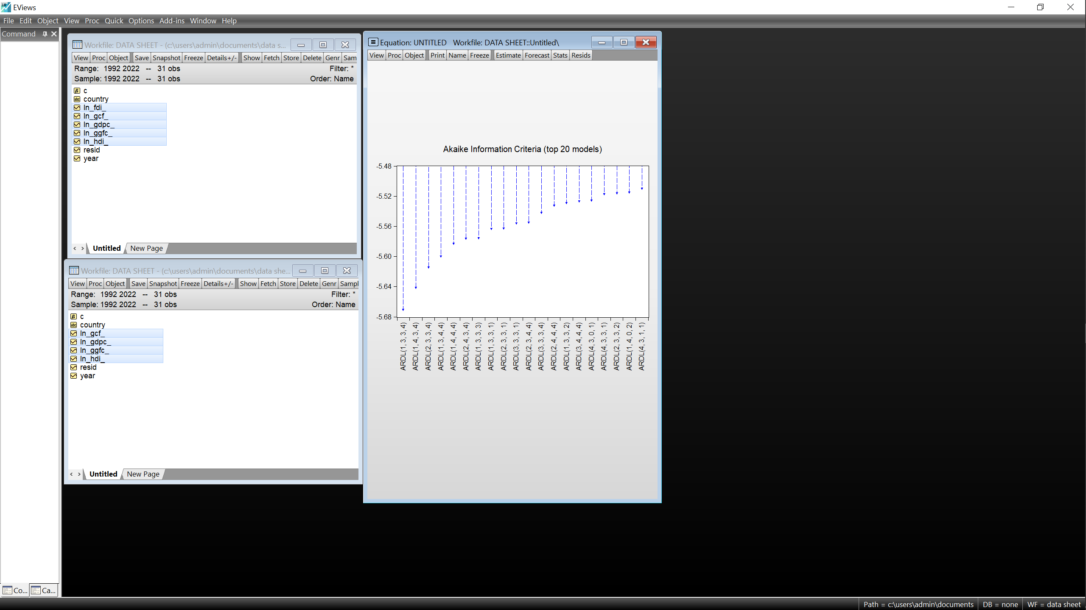
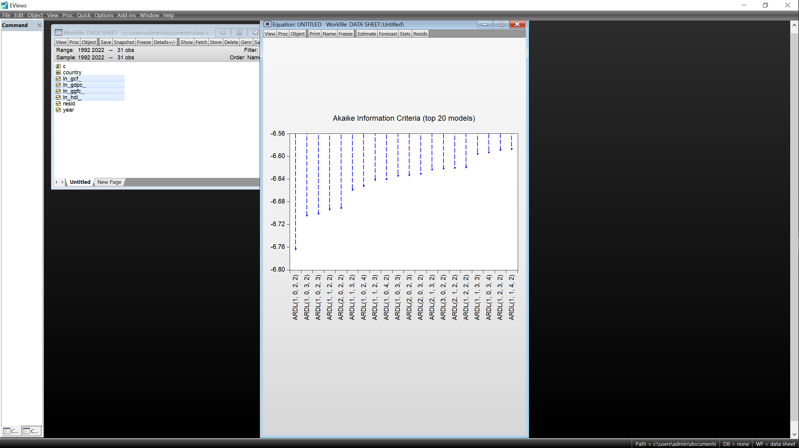
Uganda - ARDL (1,0,2,2) Kenya – ARDL (1,3,34)
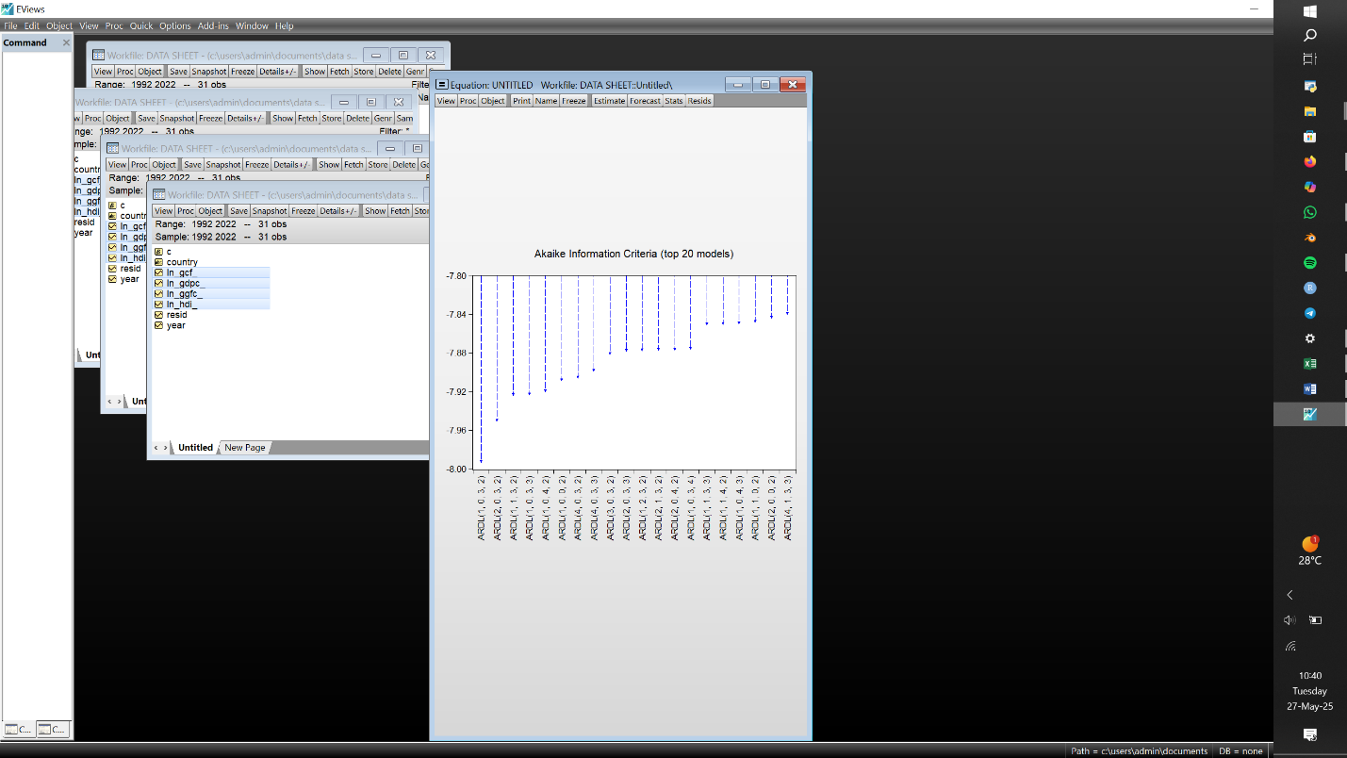
UAE – ARDL (4,2,1,0) USA – ARDL (1,0,3,2)
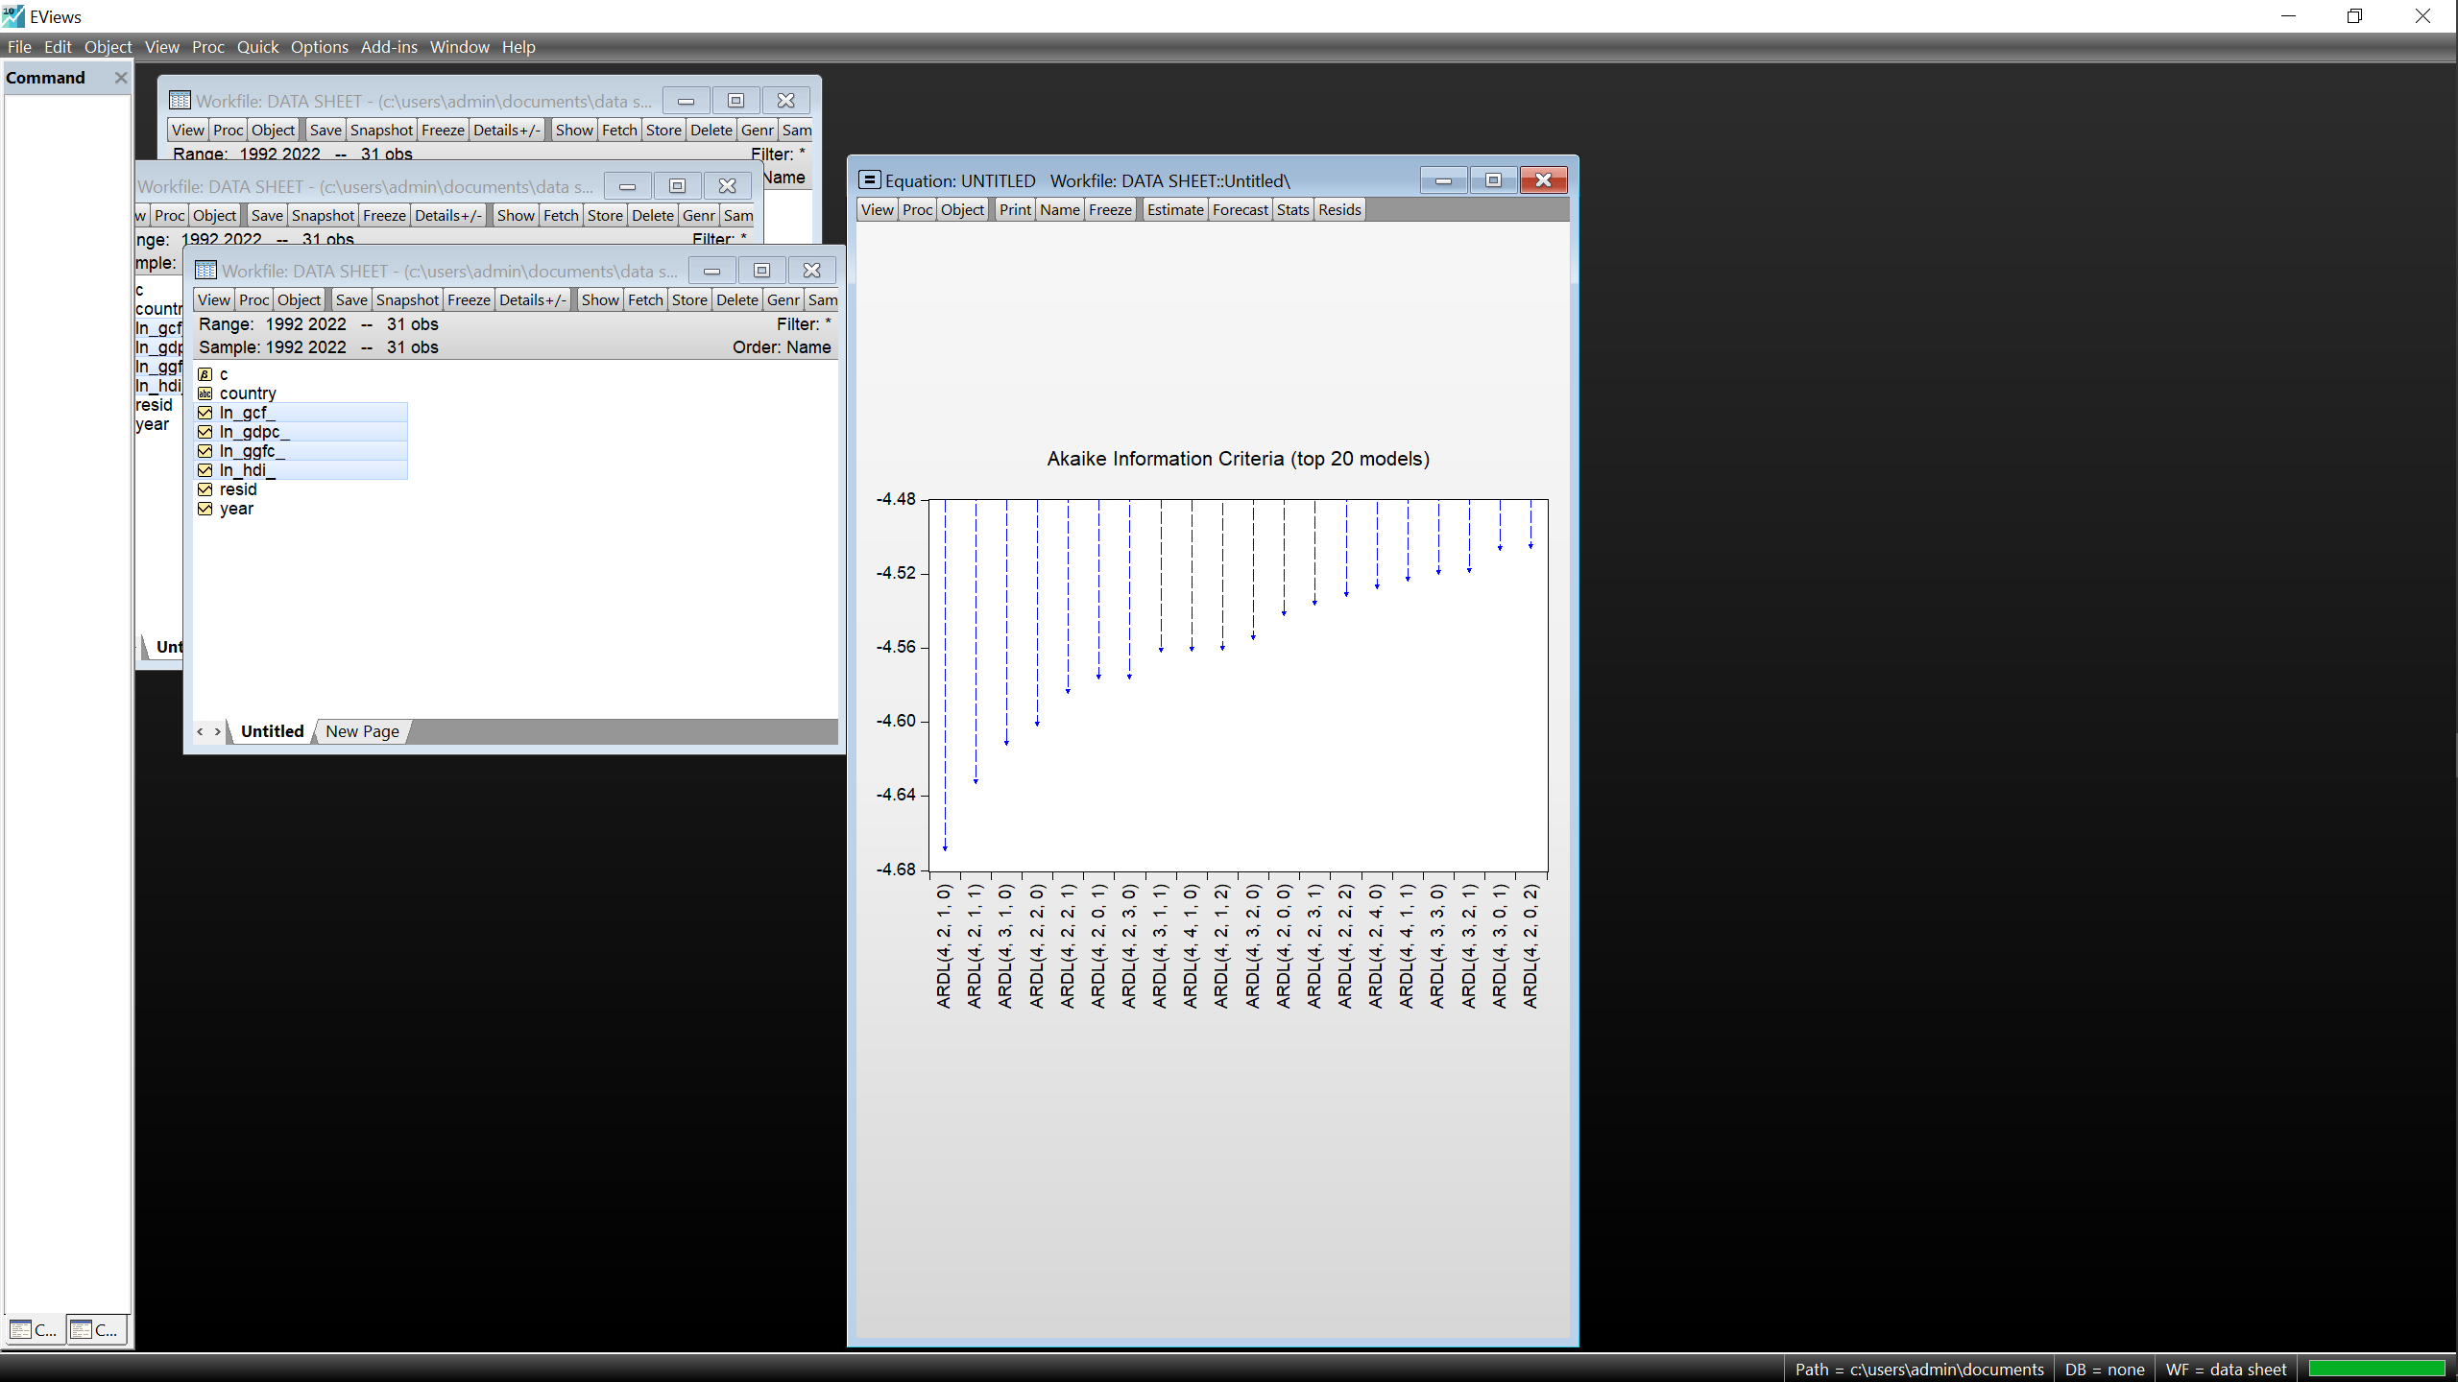
Source: Author, EViews 10
3.3.2 Bounds test for cointegration.
Leading to the estimation of the respective ARDL models, it is important to establish whether a long-run relationship exists between all variables under study. This long-run relationship, known as cointegration hereby implies that the variables evolve together over time, and any short-term deviations from this equilibrium are eventually corrected. Establishing cointegration is crucial because a valid ARDL model demands the presence of cointegration.
Table 5 :The F – Bounds Test Results
Country | F-Bounds Test |  | Null Hypothesis: No levels relationship
 | T-statistic | Value | Signif. | I (0) | I (1)
Uganda | F – statistic  k | 29.64381  3 | 10%  5%  2.5%  1% | 2.37  2.79  3.15  3.65 | 3.2  3.67  4.08  4.66
Kenya | F – statistic  k | 6.640752  3
UAE | F – statistic  k | 11.80524  3 | 10%  5%  2.5%  1% | 2.37  2.79  3.15  3.65 | 3.2  3.67  4.08  4.66
USA | F – statistic  k | 111.3109  3

The table above shows that all the F – statistic values of all 4 countries exceed the upper bound critical value of 3.67 which further affirms the presence of cointegration between all selected variables within each country after the rejection of the null hypothesis of no cointegration.

3.3.3 Long run ARDL estimations.
Having established the presence of cointegration between all variables of respective countries, this paper now delves into estimating the long run ARDL models through which the impact of selected independent variables on the growth and development of respective countries can be studied.

Table 6: Long run estimations.
Country | Variable | Coefficient | Std. Error | T-statistic | Prob
Uganda | lnGCF  lnGGFC  lnHDI  C | 0.306905  -0.202607  0.918550  4.760212 | 0.045035  0.037285  0.133903  1.061842 | 6.814816  -5.433946  6.859821  4.482977 | 0.0000  0.0000  0.0000  0.0002
EC = LNGDPC – (0.3069*LNGCF – 0.2026*LNGGFC + 0.9186*LNHDI + 4.7602)
Kenya | lnGCF  lnGGFC  lnHDI  C | 0.032156  0.676799  -1.617204  -9.907628 | 0.051566  0.105844  0.799345  3.738651 | 0.623583  6.394302  -2.023161  -2.650054 | 0.5446  0.0000  0.0659  0.0212
EC = LNGDPC – (0.0322*LNGCF + 0.6768*LNGGFC – 1.6172*LNHDI – 9.9076)
UAE | lnGCF  lnGGFC  lnHDI  C | -0.155716  -0.258917  0.759540  21.04798 | 0.013286  0.031002  0.186218  0.634015 | -11.72028  -8.351746  4.078766  33.19791 | 0.0000  0.0000  0.0009  0.0000
EC = LNGDPC – (-0.1557*LNGCF – 0.2589*LNGGFC + 0.7595*LNHDI + 21.0480)
USA | lnGCF  lnGGFC  lnHDI  C | 0.328377  0.143663  1.734166  -2.518962 | 0.015320  0.048082  0.286530  1.324137 | 21.43413  2.987869  6.052300  -1.902342 | 0.0000  0.0079  0.0000  0.0733
EC = LNGDPC – (0.3284*LNGCF + 0.1437*GGFC + 1.7342*LNHDI – 2.5190)
Source: Author, EViews 10.
Note: *p-value incompatible with t-Bounds distribution.
The long run model equations are expressed as follows:
Uganda: lnGDPc_{t} = 4.76 + 0.31lnGCF_{t} - 0.2lnGGFC_{t} + 0.92lnHDI_{t}
Kenya: lnGDPc_{t} = -9.91 + 0.03lnGCF_{t} + 0.68lnGGFC_{t} - 1.62lnHDI_{t}
UAE: lnGDPc_{t} = 21.05 – 0.16lnGCF_{t} - 0.26lnGGFC_{t} + 0.76lnHDI_{t}
USA: lnGDPc_{t} = -2.52 + 0.33lnGCF_{t} + 0.14lnGGFC_{t} + 1.73lnHDI_{t}

3.3.3 Key selected elements of the short run ARDL estimations.
Table 7: Short run estimations.
Country | CointEq(-1)* | P - value | R - squared | Adjusted R - squared
Uganda | -0.447485 | 0.0000 | 0.929807 | 0.918101
Kenya | -0.655777 | 0.0000 | 0.867073 | 0.783994
UAE | -0.366688 | 0.0000 | 0.814813 | 0.716772
USA | -0.672676 | 0.0000 | 0.969334 | 0.962365
Source: Author, EViews 10
The above table displays very key information, firstly the values denoted as CointEq(-1)* being the values that approximately explain how much of the deviation from the long run equilibriums is corrected within a single period, secondly the R – squared indicates the percentage of variation of lnGDPc explained by the model and finally the Adjusted R squared value accounts for the independent variables included in the model.

3.4 Diagnostic tests results.
Having estimated the ARDL models, it is however important to establish their validity to guarantee quality interpretations and overall results of this research. This process is undertaken through several steps.

3.4.1 Normality tests for residuals (Jarque – Bera Tests).
Figure 4:Jarque – Bera normality tests.
Uganda Kenya
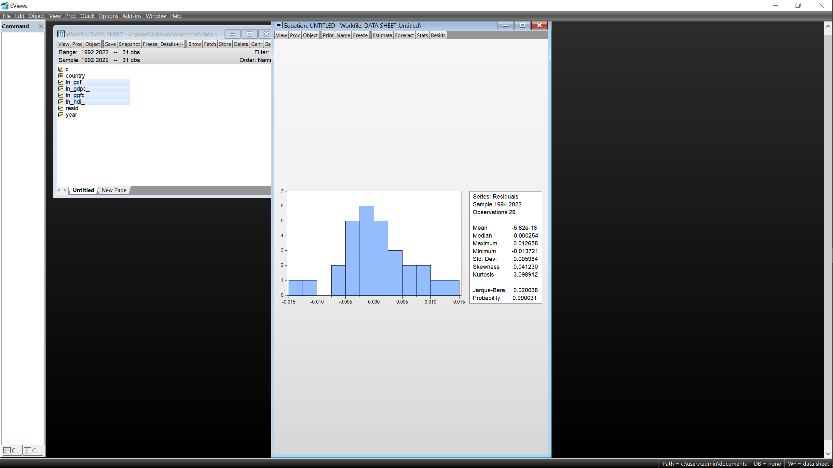
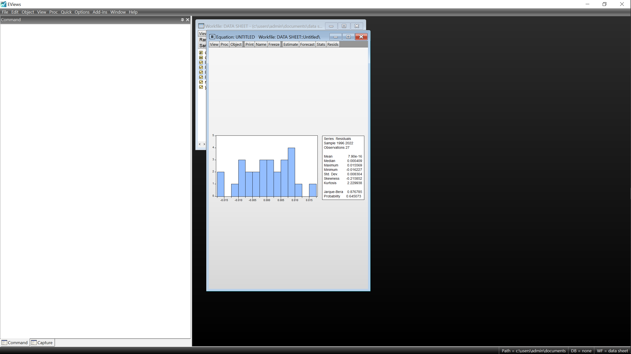

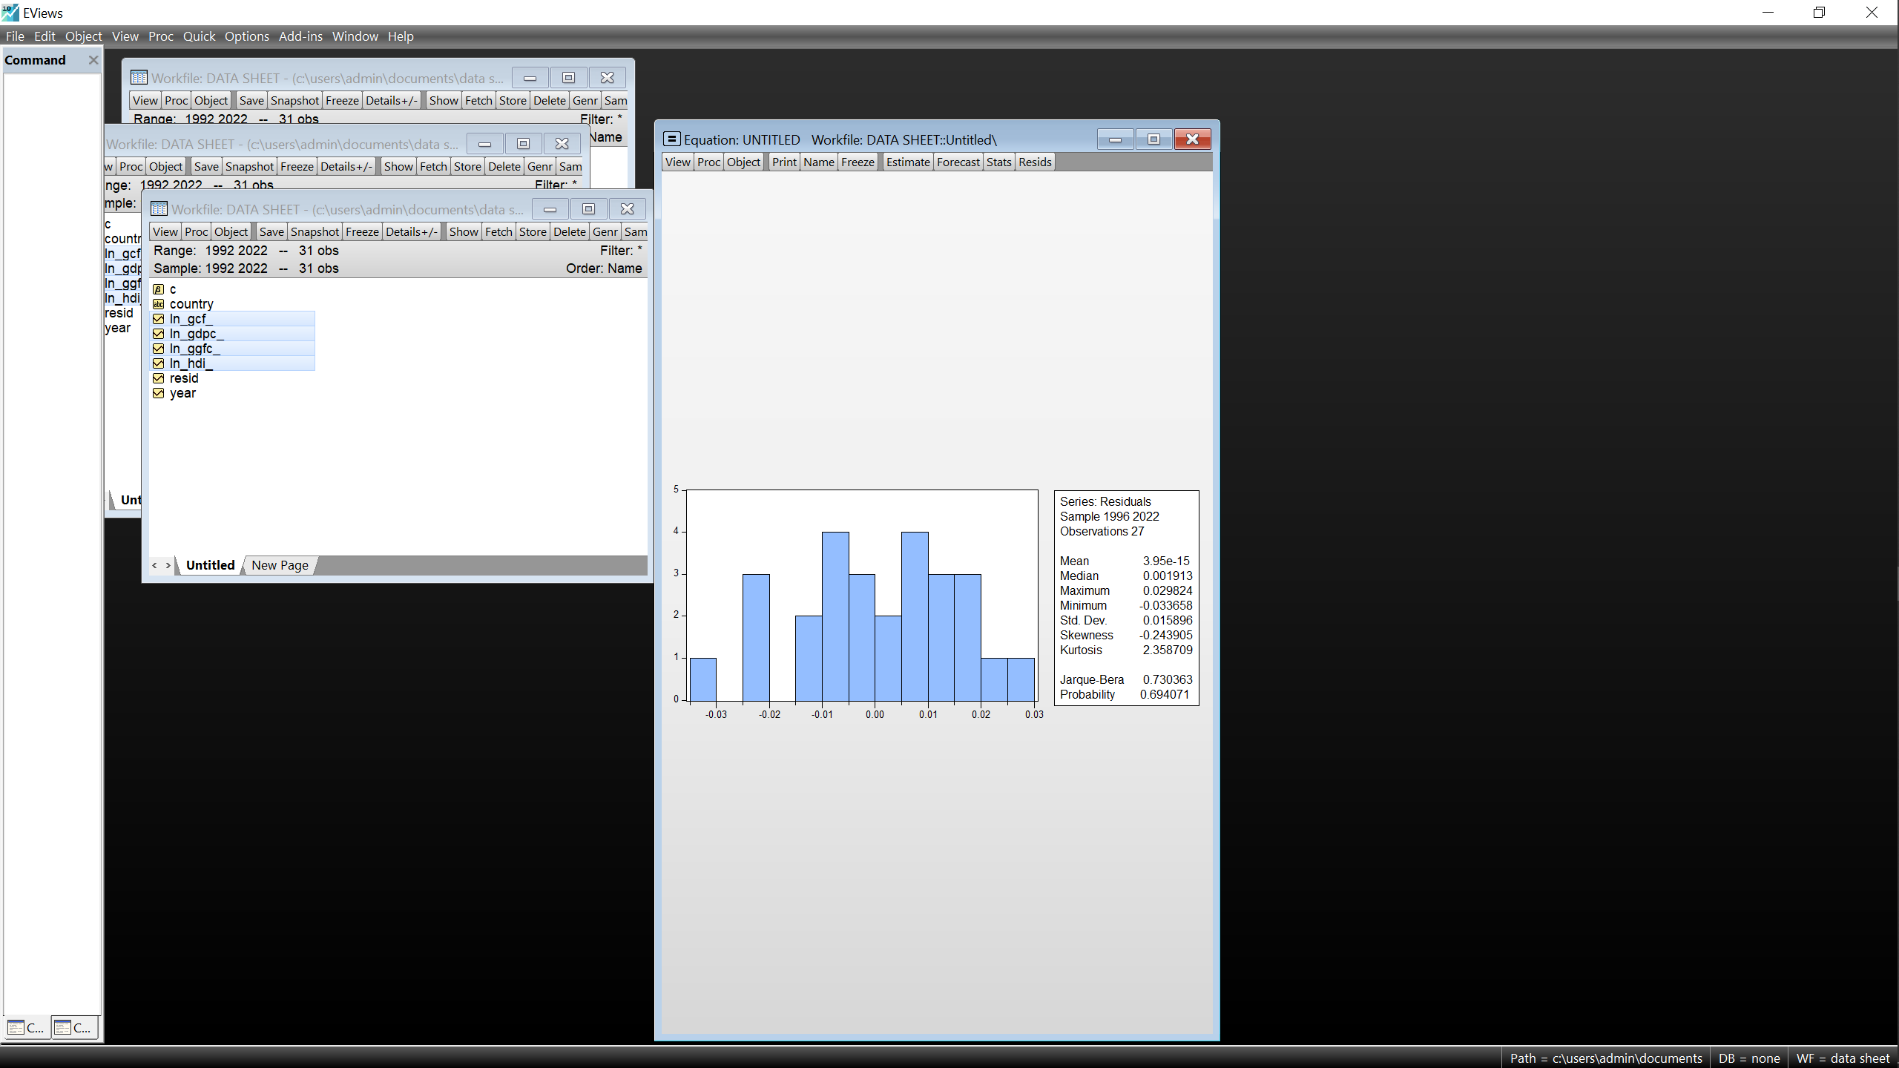
UAE USA
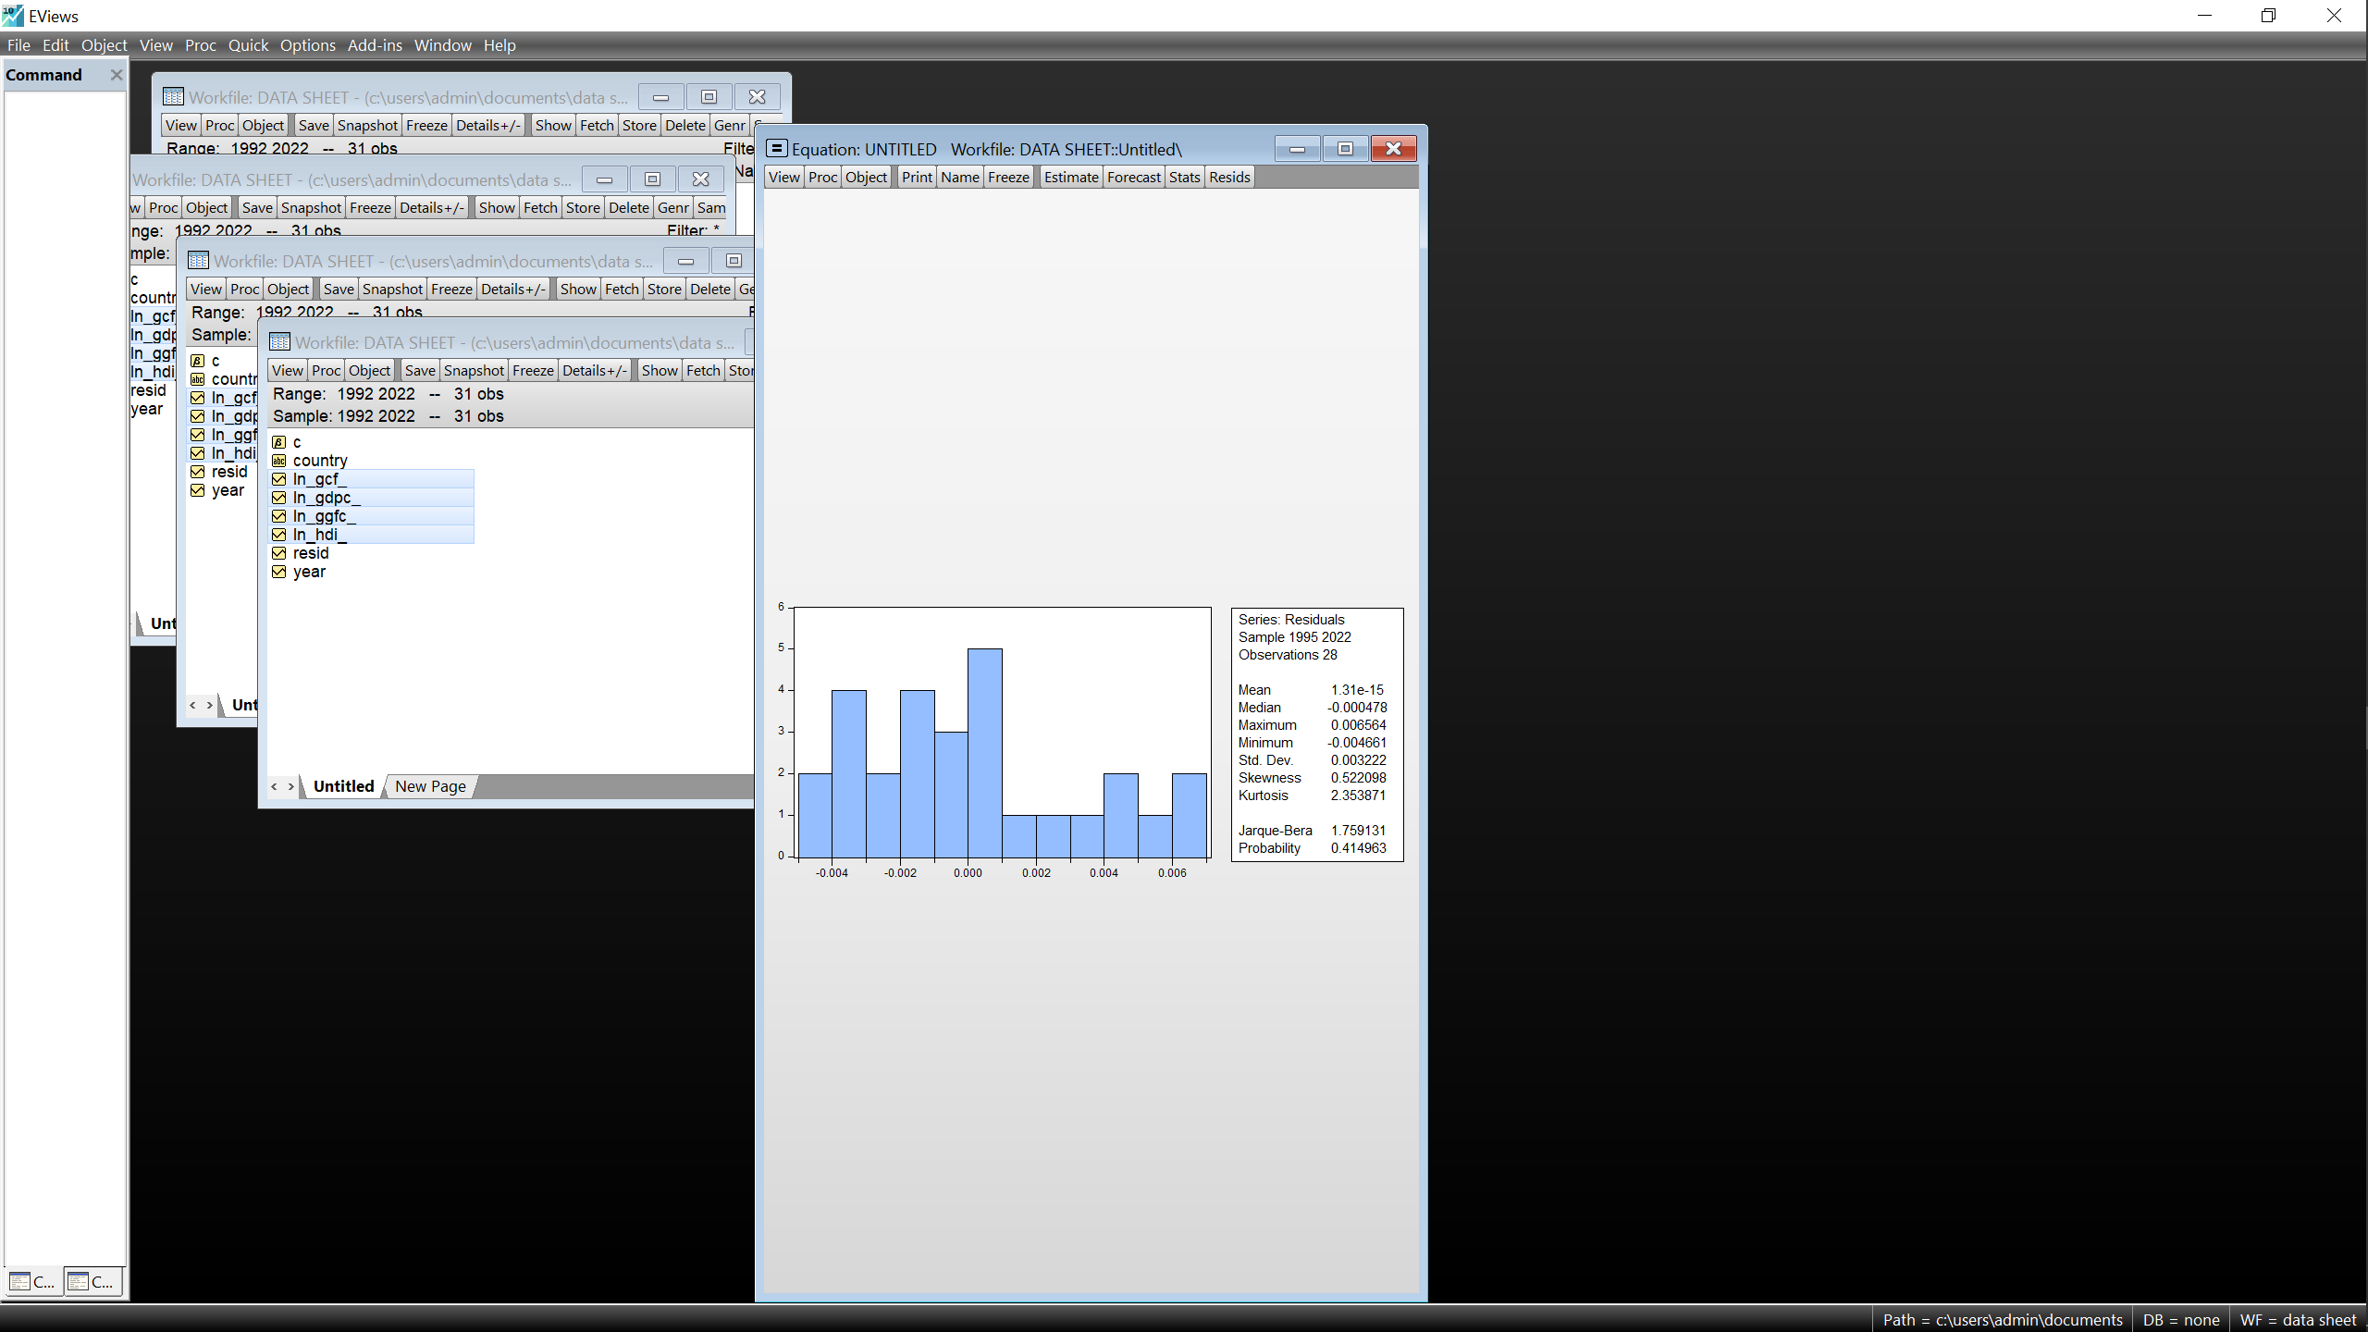
Source: Author, EViews 10
From the above figures, this paper confirms a normal distribution for all four models looking at the probability values all being greater than 0.05, we therefore accept the null hypothesis.

3.4.2 Serial correlation test for residuals.
Table 8: Breusch-Godfrey Serial Correlation LM Test.
Country | Breusch-Godfrey Serial Correlation LM Test:
 | Null hypothesis: No serial correlation at up to 2 lags
Uganda | F-statistic 0.738597  Obs*R-squared 2.199424 | Prob. F(2,18) 0.4917  Prob. Chi-Square(2) 0.3330
Kenya | F-statistic 1.366662  Obs*R-squared 5.795797 | Prob. F(2,18) 0.2987  Prob. Chi-Square(2) 0.0551
UAE | F-statistic 0.381020  Obs*R-squared 1.393782 | Prob. F(2,18) 0.6900  Prob. Chi-Square(2) 0.4981
USA | F-statistic 0.298557  Obs*R-squared 1.007356 | Prob. F(2,18) 0.7459  Prob. Chi-Square(2) 0.6043
Source: Author, EViews 10
With all probability values for both the F-statistic values and the Obs*R-squared values being greater than 0.05, therefore the null hypothesis of no serial correlation is accepted which proves that the errors are independent further strengthening all models.

3.4.3 Heteroscedasticity test for residuals.
This test is carried out using the Breusch-Pagan-Godfrey Heteroscedasticity Test where this paper seeks to establish that the variances of the errors are constant.
Table 9: Breusch-Pagan-Godfrey Heteroscedasticity Tests.
Country | Heteroscedasticity Test: Breusch-Pagan-Godfrey
 | Null hypothesis: Homoscedasticity
Uganda | F-statistic 2.152541  Obs*R-squared 13.41712  Scaled explained SS 6.697111 | Prob. F(8,20) 0.0786  Prob. Chi-Square(8) 0.0983  Prob. Chi-Square(8) 0.5696
Kenya | F-statistic 0.801960  Obs*R-squared 13.05099  Scaled explained SS 1.585373 | Prob. F(14,12) 0.6570  Prob. Chi-Square(14) 0.5225  Prob. Chi-Square(14) 1.0000
UAE | F-statistic 0.964889  Obs*R-squared 10.15716  Scaled explained SS 2.423156 | Prob. F(10,16) 0.5068  Prob. Chi-Square(10) 0.4268  Prob. Chi-Square(10) 0.9919
USA | F-statistic 2.149050  Obs*R-squared 14.50294  Scaled explained SS 4.057253 | Prob. F(9,18) 0.0799  Prob. Chi-Square(9) 0.1055  Prob. Chi-Square(9) 0.9076
Source: Author, EViews 10

With all corresponding Probability values that are significantly greater than 0.05, the null hypothesis is therefore accepted, and homoscedasticity is further confirmed.

3.4.4 Testing for stability of models.
This Paper fundamentally used the Cumulative sum and Cumulative sum of squared residuals which both provide graphical representation making it easier to examine stability within provided parameters. However, the Ramsey RESET Test was also applied to further strengthen the models.

Figure 5: CUSUM and CUSUM of Squares test charts.
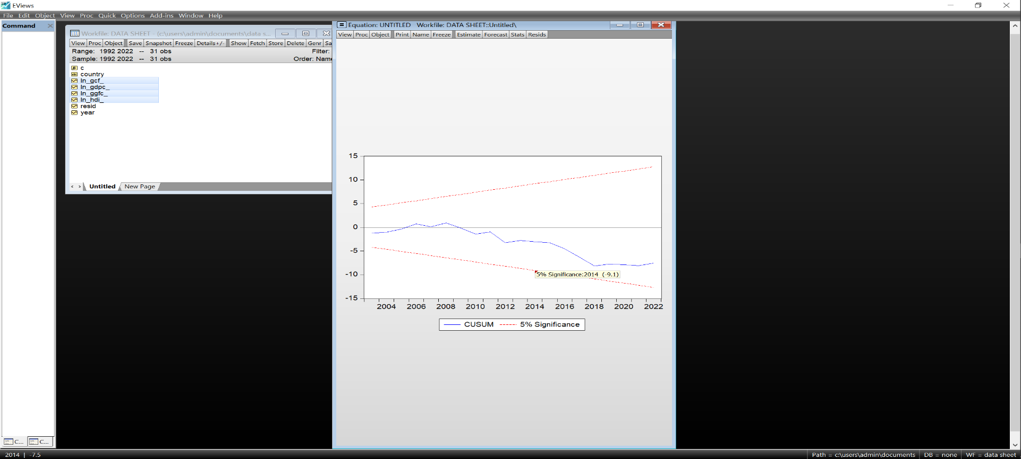
Uganda
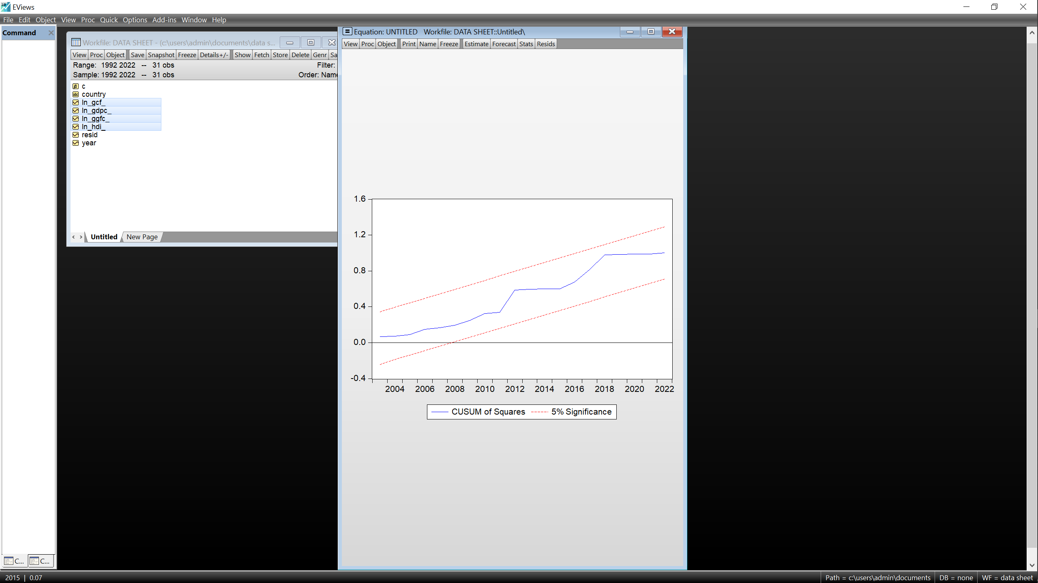
Kenya
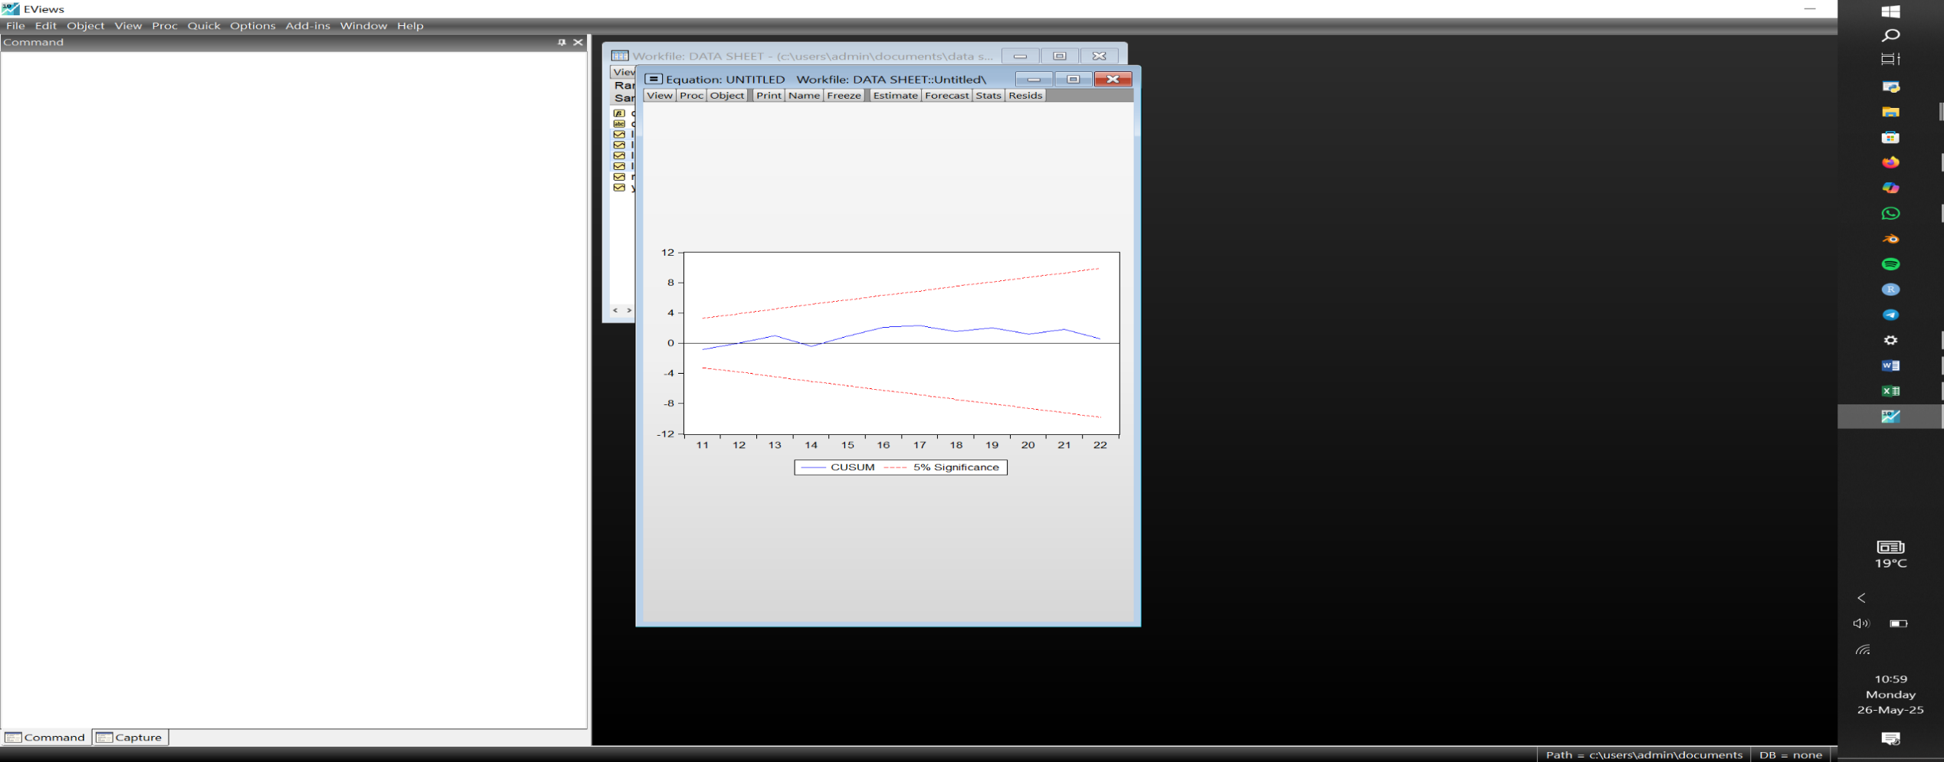
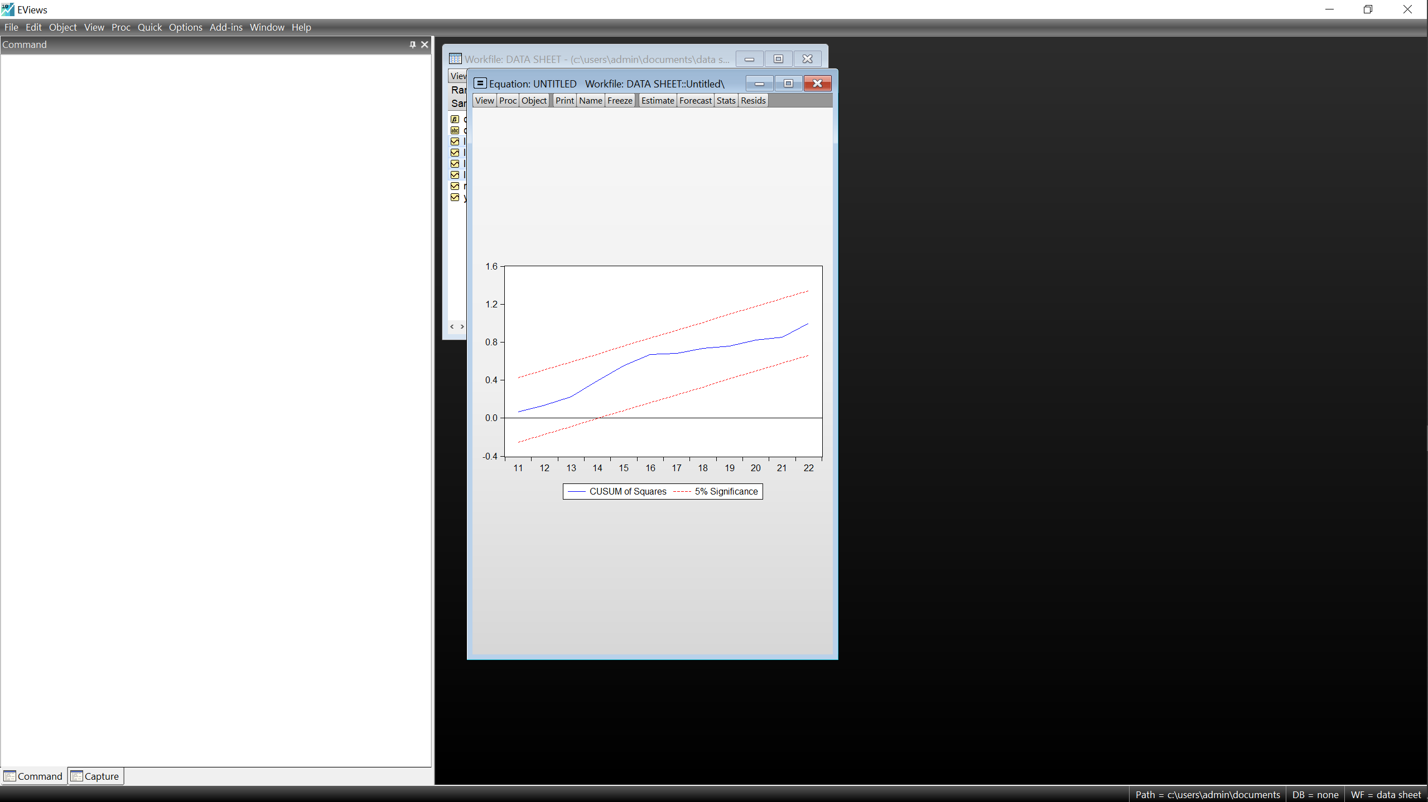
UAE
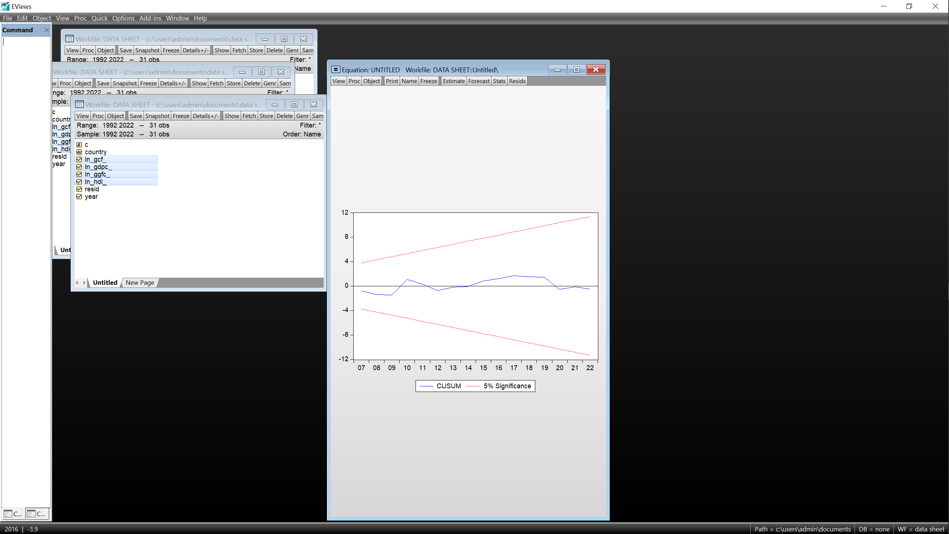
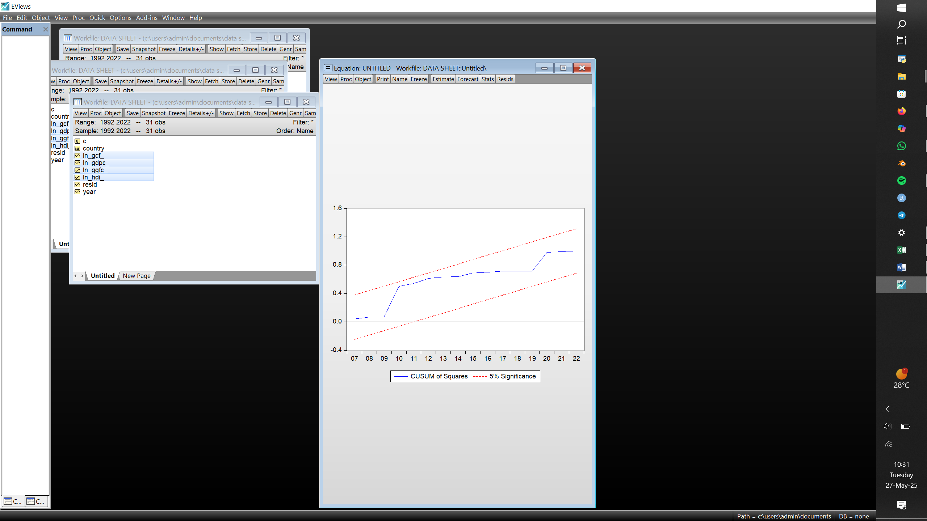
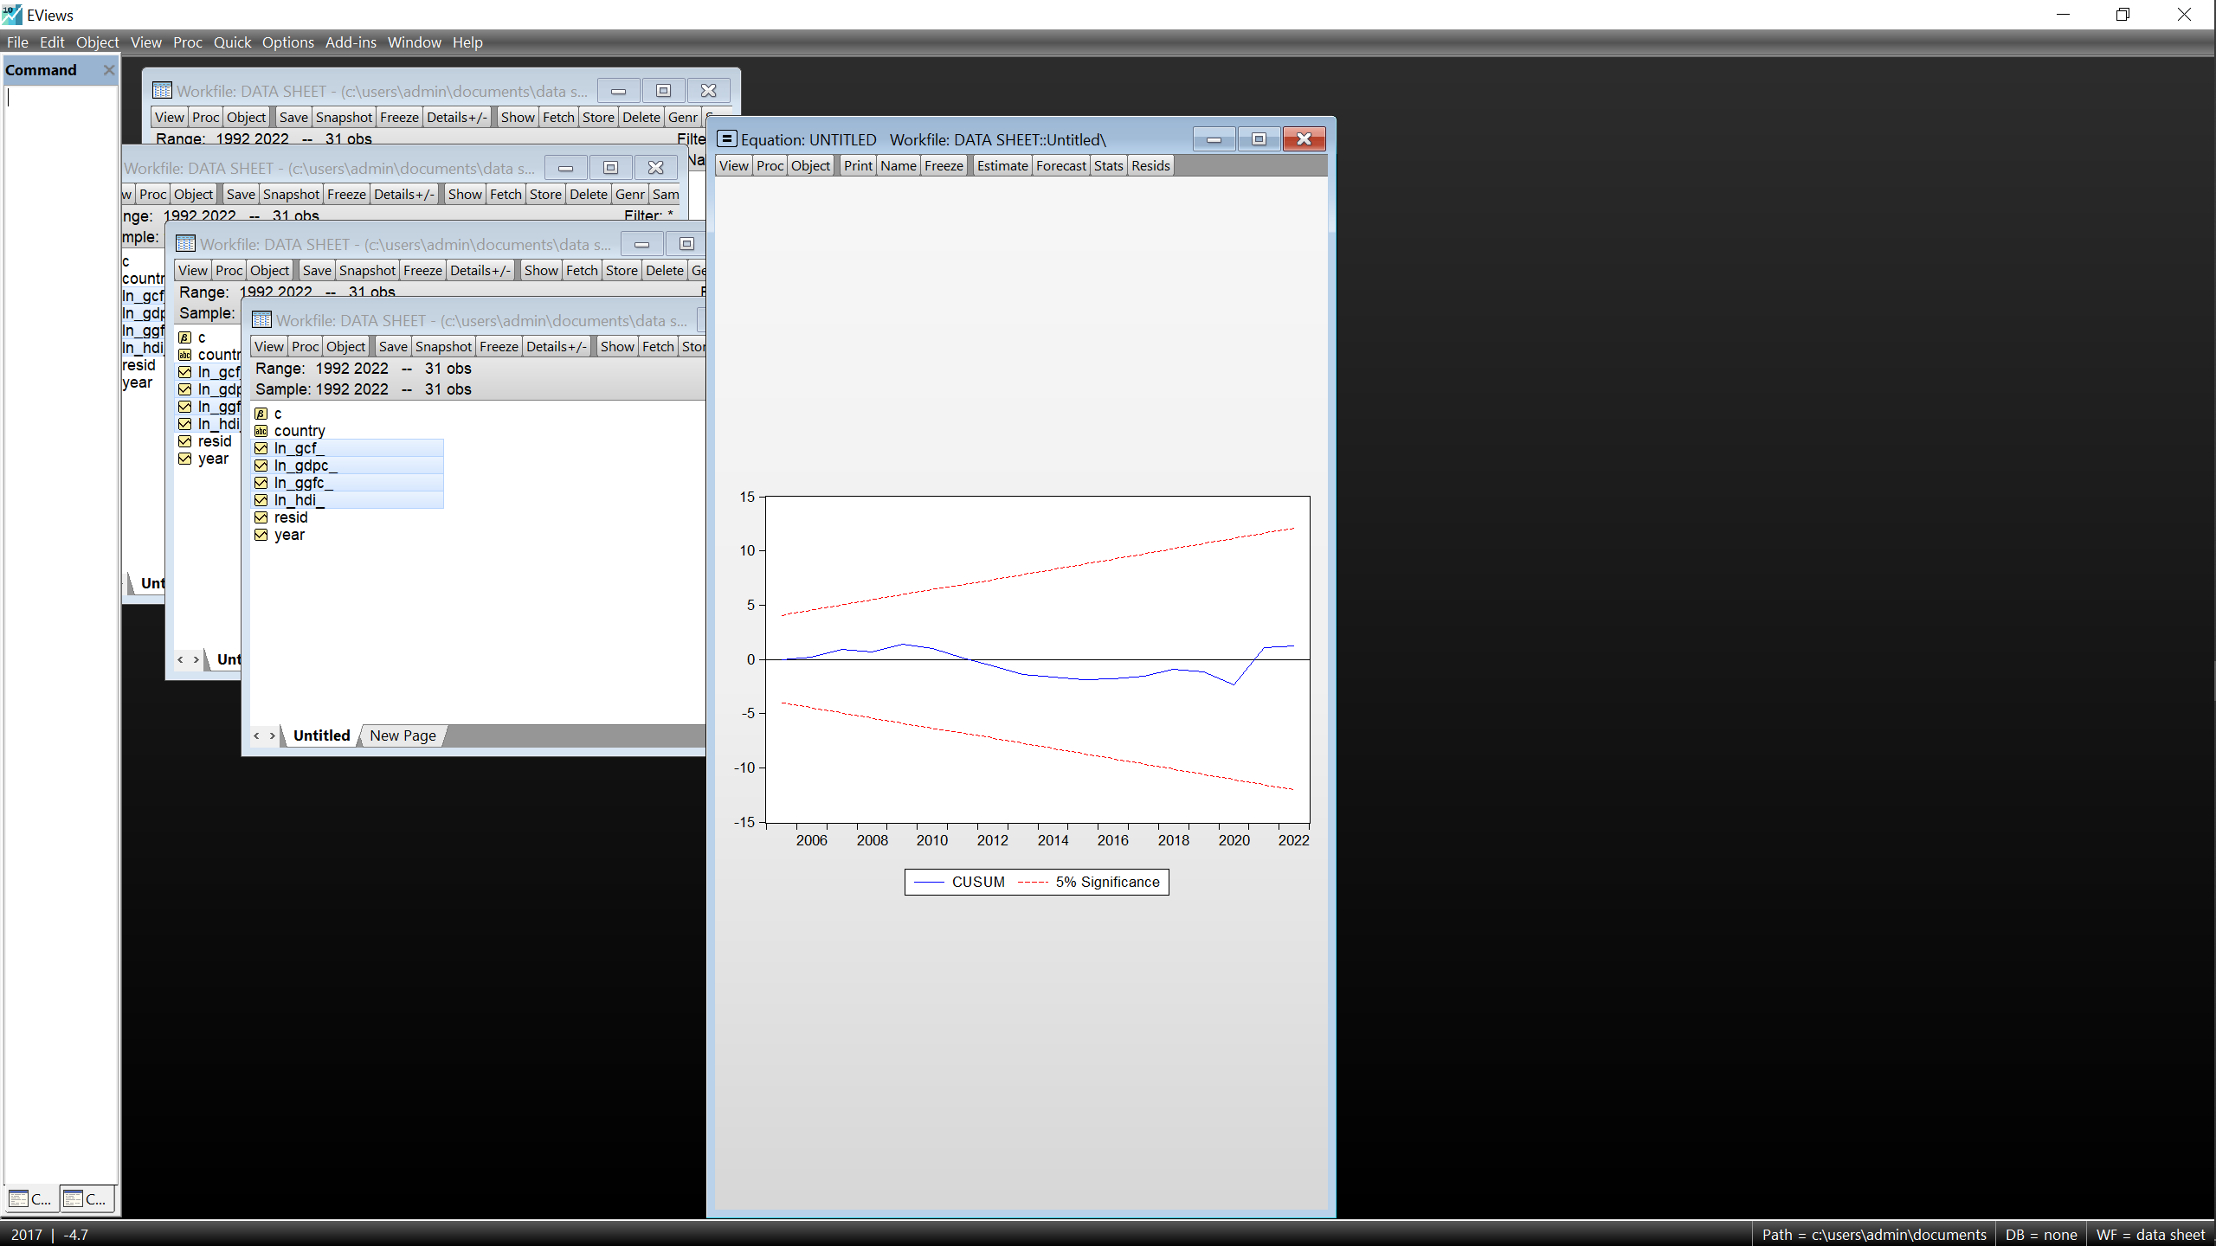
USA
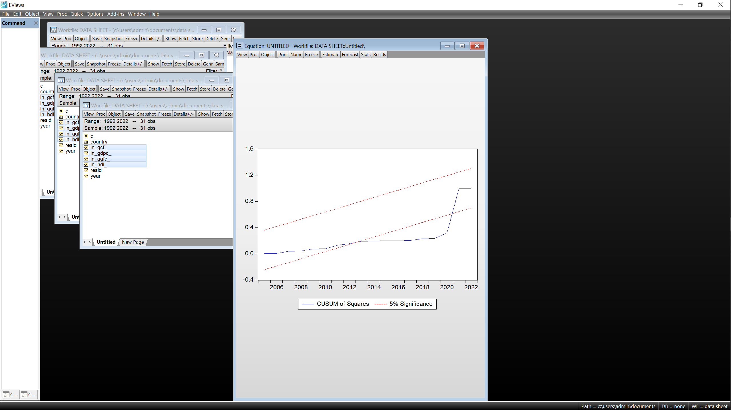
Source: Author, EViews 10.

3.4.5 Ramsey RESET tests.
With the USA displaying some form of irregular behavior on the CUSUM of squares chart, this paper only inserts here the tests result for the USA to establish its validity.
Table 10: USA’s Ramsey RESET results
 | Value | df | Probability
t-statistic | 1.670646 | 17 | 0.1131
F-statistic | 2.791057 | (1,17) | 0.1131
Source: Author, EViews 10With the probabilities well above 0.05, we fail to reject the null hypothesis, therefore the model for USA is also correctly specified.

3.5 Discussion of all Results.
Upon completing the process of validating all models, this section now delves into the interpretation of results while linking them to the research objectives, hypotheses, and research questions presented in the general introduction.

3.5.1 Response to the research question.
In an economic world in demand of a strong shift in sustainability, to what extend have Kenya and Uganda leveraged their major renewable and non-renewable resources to foster a future of economic resilience, prosperity and diversification?
Through the selection of the USA and UAE as potential countries of inspiration, in an effort to respond to the above question, we firstly need to examine these two countries, the USA being one of the largest economies in the world (Silver, 2025), the ARDL model of USA shows that all three variables have a significant impact on its growth and development with firstly gross capital formation (GCF) with a coefficient of 0.33 indicating that the USA has over the years spent their funds putting in place productive capital to improve the quality and quantity of goods and services produced within its borders for example the expansion of its technology sector (Chernicof, 2025) and energy sector (IEA, 2024) further demonstrated in the excellence of their policies for example the chips and science act almost 3 years ago (US. Department of Commerce, 2024), these have significantly contributed to the growth of their economy, and it is undeniable that their technology sector is one of USA’s biggest strengths. When we examine the government final expenditure (GGFC) with a coefficient of 0.14 which also shows a positive impact and this indicates that funds have been properly allocated in areas like payment of workers, providing of services for example with such a large population, the USA boasts an unemployment rate of about 4% (Bureau of labour and statistics, 2025) together with a very wealthy service sector which further proves the impact of this variable on its growth and development. Finally in examining the HDI with a coefficient of 1.73 indicates the impact of their healthy working and active population on their growth, USA boasts an HDI index value 0.938 which is significantly higher than Uganda and Kenya with 0.582 and 0.628 respectively which again demonstrates USA’s commitment to making sure their population is of high value, ranking high with some of the best education facilities in the world (Drozdowski, 2024) which have undoubtedly contributed to their world class technology sector among others. Having laid such and solid and referential foundation in USA, we examine the UAE, through her ARDL model, we observe that the two variables (GCF and GGFC) do not have a positive impact on its economy, while this may sound surprising, it is however important to note that UAE has in the past heavily relied on its oil and gas resource exports including crude oil while maximizing the excellent oil and gas prices (Humssi, Petrovskaya, & Abueva, 2022) and even further more recognizing that UAE possess a wealth fund (Emirates Investment Authority) through which a good percentage of their oil revenues are directed for other types of investments (Chen, 2022) in other nations and not necessarily within its boundaries and this could lead to overshadowing of these two variables.
However, it is also important to note that some investments might not yield immediate returns because they are more structural for example an investment education given that UAE is a relatively young nation, it is expected to see such outcomes however this model too agrees that HDI has a positive impact on the growth and development of the country with a coefficient of 0.76. Laboring to elaborate the impact of key resources in a nation, another ARDL model was estimated to show the impact of the oil sector on UAE’s economic growth.
lnGDP_{t} = 16.53 + 0.37GGFC_{t} + 0.24OPB_{t} , with OPB represent the production of oil barrels. This model might further indicate that not only is the oil and gas sector with a coefficient of 0.24 contributing to the growth of UAE but also that government expenditure directed towards the oil and gas sector plays a key role in its growth.
With the above findings and analysis, Uganda and Kenya can now draw inspiration in that through the model of Uganda, it is observed that both GCF (0.31) and HDI (0.92) contribute to its economic growth unlike GGFC (-0.2), these results relatively agree with our hypothesis however the negative coefficient of the general government final consumption expenditure might indicate misuse and misallocation funds leading to an inverse relationship and it comes by no surprise that Uganda is among the most corrupt nations in the world with a score of 26 out 100 indicating high corruption (Transparency international, 2024). Kenya on the other hand exhibits an interesting pattern with HDI having a negative impact on its growth (-0.76) which poses certain questions as to whether Kenya is really maximizing the potential of her citizens while GCF (0.03) having a positive but negligible impact on the growth and development with together finding the GGFC (0.68) being insignificant, the former might indicate that the country must be dealing with management of some depreciating capital stock which might undermine the impact of other capital stock while already known that government final consumption plays more of an indirect role though crucial in the economic growth and development of a country, the discovered insignificant result GGFC (0.68) for Kenya might suggest that Kenya final expenditure is in no way impacting the growth and development of the country which might suggest the idea of Kenya improving its expenditure in certain areas for example improving salaries in highly productive sectors which can be of significant motivation for even higher performance.
This brief insight into these findings seems to indicate that Uganda and Kenya still have a lot of resources to maximize, and this paper will be covering this in the next section.

3.5.2 Response to subsidiary questions.
This paper observes that the development of human capital and exploitation of the major resources with in USA and UAE have proven to be very significant in their growth and development and in comparison to Uganda and Kenya, it is observed that these two countries still lag behind the development of their citizens which limits future innovation and invention and further more noted that slow exploitation and underutilization of natural resources for example the arable soils, the discovered oil in Uganda has taken long to bear significant fruits while Kenya on the other hand has a fair share of underutilized resources like industrial minerals, energy resources like wind, their iconic wild life among others (Snr, 2025). This lack of maximizing could be explained by low impact of gross capital formation which might indicate a lack in significant investment enough to trigger significant economic growth and development.
It is quite clear that the degree of management of resources within these respective countries has impacted their growth and development and is easily observed in their current GDP values among other key indicators. Good governance and policy making has undoubtedly greatly impacted USA and UAE as cited earlier. Uganda and Kenya need to firstly ensure there is proper governance and management of funds upon which well calculated investment plans can be put in place notably ensuring that the citizens became more innovative, inventive, productive and valuable through investing in high quality education, good health care which in the long significantly shape the growth and development of these countries.

3.5.3 Examination of Hypotheses.
H1: A country’s ability to effectively and efficiently invest into its most valuable resources will have a significant contribution to its overall development.
The indicated significance of firstly the HDI proves that investment into the human being as the foundational resource eventually yields good long-term results and secondly examining the positive impact of GCF and oil production in USA and Kenya further solidifies the hypothesis.
H2: Behind every fined tuned state, is an efficient policy making system that responds to its evolving needs.
Some of the policies cited earlier employed in these countries especially USA and UAE prove that putting quality policies in place really meets the needs of the nation.
H3: In the long run, there is a positive relationship between the presence of skilled human capital and a country’s overall economic development.
This has been undeniably indicated in the coefficients of the HDI of all countries except Kenya, demonstrating the key roles played by having a higher developed population which provides a high-quality working population leading to innovation and inventions.

3.5.4 Evaluation of research objectives.
- Through this study, we intend on magnifying the variables that can play very important roles in the resurgent growth of Uganda and Kenya respectively.
This paper through an intense approach has been able to identify the need for Uganda and Kenya to invest in not only skilling up its population but also ensure other aspects like good health services to ensure long working and active life spans.
This Paper has also identified areas like Commercial agriculture in both countries and maximization of nonrenewable resources like oil for the case of Uganda can play very significant roles in their growth and development.
- We also intend on providing insightful knowledge into which policies might be best applicable in nations like Uganda and Kenya.
Uganda and Kenya need to implement policies that protect and support local farmers and investors to encourage an increase in local productivity, maximization of local resources and minimize importation even increase exportation which eventually leads to a better performing economy.
Uganda and Kenya should implement policies that hold foreign investors strictly to minimize over exploitation of resources and excessive profit repatriation which robs a country of the opportunity to benefit from its resources hence stagnant growth and development.

General Conclusion

4.1 Summary of study
This research aims at developing an idea around the key economic drivers for UAE and USA from 1992 to 2022, the methods used to leverage their renewable and non-renewable resources and compare their path to economic sustainability to that of Kenya and Uganda as they aim for the same. The Auto-Regressive Distributed Lag econometric model is employed in the time series data sourced from reputable and reliable sources to analyze the long-run relationship between macroeconomic growth, development with government investment, government expenditure and human development on the individual countries. The results demonstrate an average overall positive relationship between the selected variables and the economic growth and development in the selected countries. The study highlights the importance of a sound policy making system and effective investment in principal resources in stabilizing a nation’s economy and its overall development. Adopting the idea to such a system could help Kenya and Uganda break free from the reliance on a system ill-suited to their current needs, one that appears to undermine the implementation of policies that enhance industrialization and living standards. This study provides policymakers with ideas and valuable insights with empirical support for drawing a blueprint for East Africa’s economic transformation. The findings in fact, offer an idea for a strategic model that could benefit the entire Sub-Saharan African region, in the ongoing conversation of an envisioned Economic Resurgence.

4.2 Limitations
The analysis conducted in this study acknowledges the historical differences among the four countries, their distinct political systems and their varying positions within the global economy. These contextual disparities might limit the applicability of direct policy transfer since the effectiveness of policies demands them to be tailored to the unique needs and institutional capacities of individual nations. Kenya and Uganda also had some data gaps and inconsistent historical records (data limitations common for developing nations) that may have influenced the analysis, especially given the reliance on secondary data sources. Nevertheless, despite these limitations, the comparative analysis, employed meticulous econometric techniques that warranted the reliability and credibility of the findings within the acknowledged constraints.

4.3 Areas of future study
A significant portion of our proposed blueprint has been covered in this study. However, the full potential of the vision will be achievable if several avenues are explored deeper. For instance:
- The role and importance of institutional quality and rule of law in upholding policies as well as corruption and the downsides of institutional inequality as internal barriers to sustainable growth.
- A comparative case study with successful African economies for a regional relevance. Example: Botswana exemplifies effective management of Diamond revenues (Reuters, 2025), Morocco showcases diversified export-driven and industrialized economy (Institute, 2024).
- Use of econometric models like Dynamic Stochastic General Equilibrium (DSGE) or Computable General Equilibrium (CGE) models, that could help project the long-term results of adopting policy frameworks from UAE and USA in the contexts of Kenya and Uganda.
This study in conclusion, acknowledges the ongoing efforts towards regional trade integration such as the expansion of the (EAU) East African Union (Community, 2022) and the ongoing extension of the Standard Gauge Railway(SGR) to connect the Kenya’s Mombasa port with Uganda’s industrial zones in Kampala (Railways, 2021). It commends national initiatives aimed at leveraging valuable resources like the Silicon Savannah project -a growing hub for digital innovation in Kenya (Ministry of ICT, 2020) and the Albertine Graben oil project in Uganda (Authority, 2023).

Appendices
- Appendix 1: Unit Root Tables
a)Uganda
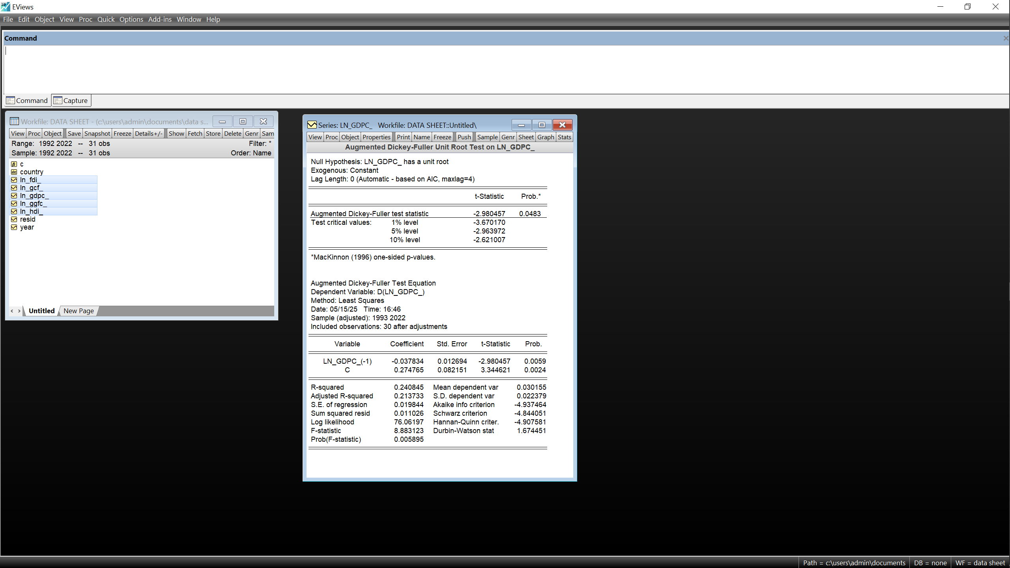
~ln(GDPc) ~ln(GCF)
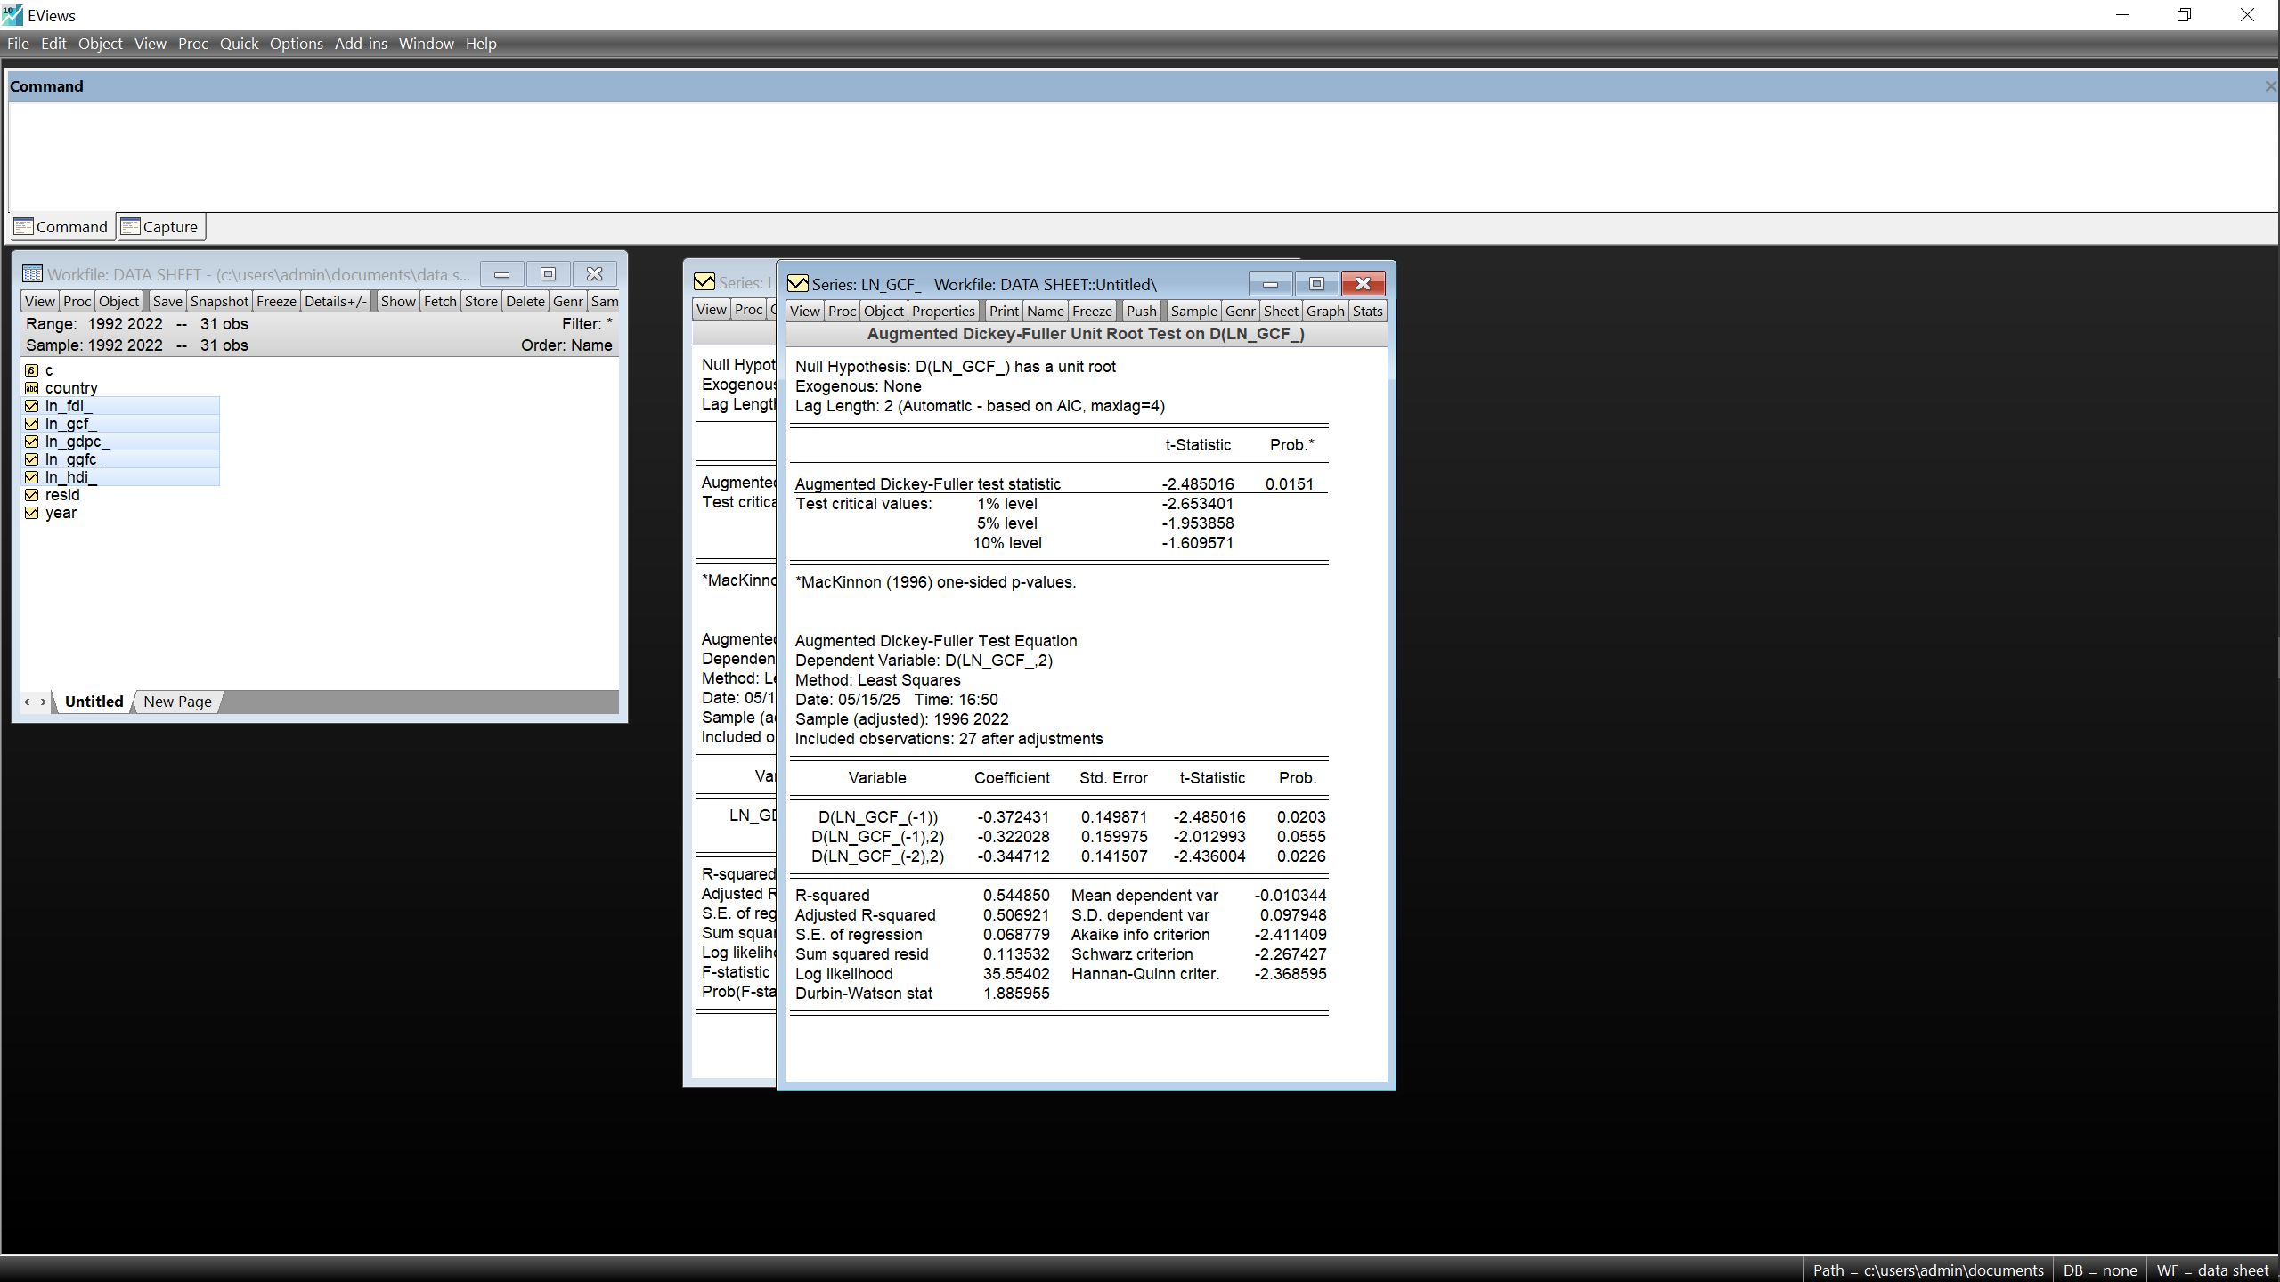
~ln(GGFC) ~ln(HDI)
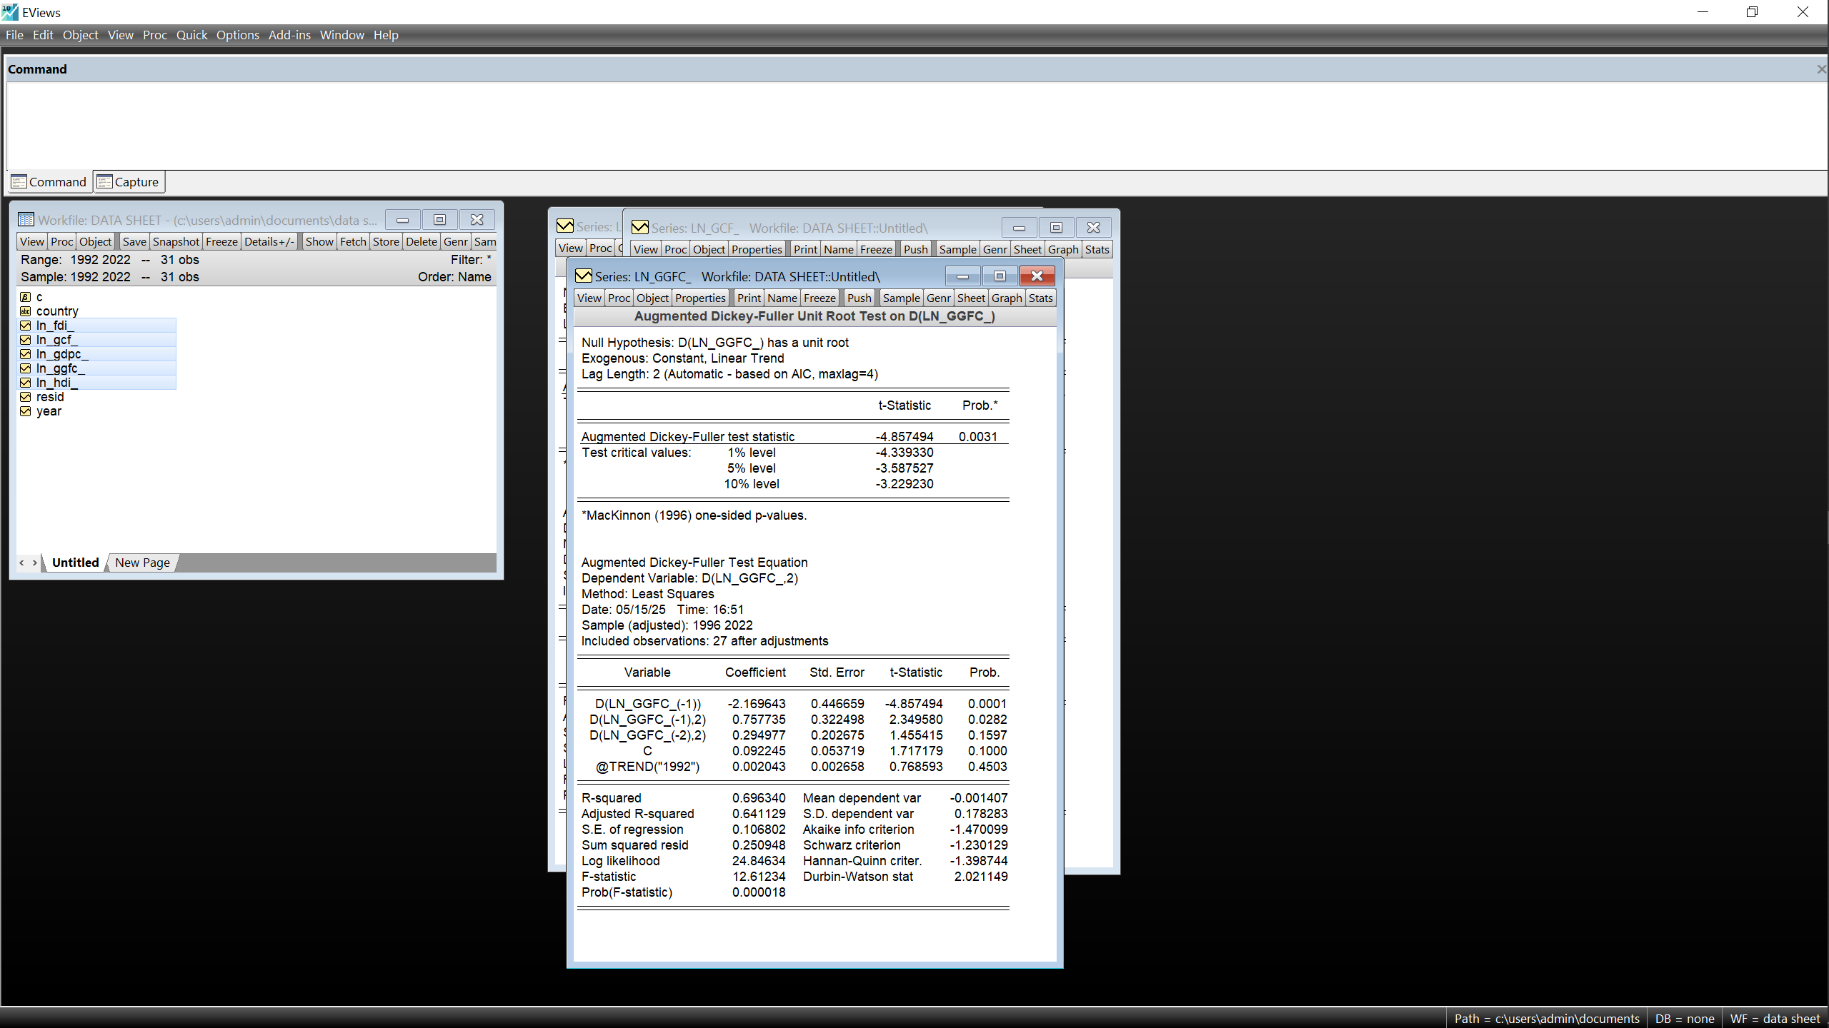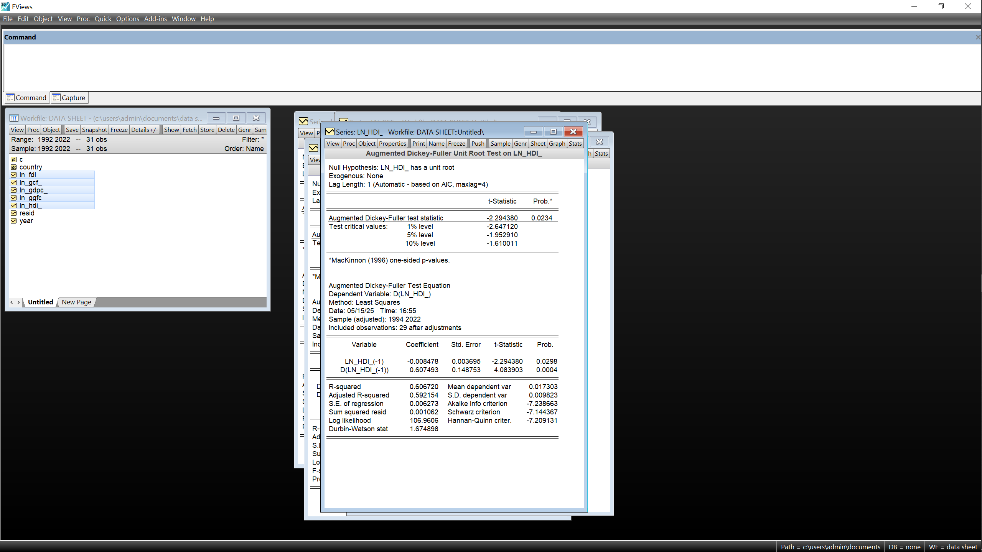
b)Kenya
~ln(GDPc) ~ln(GCF)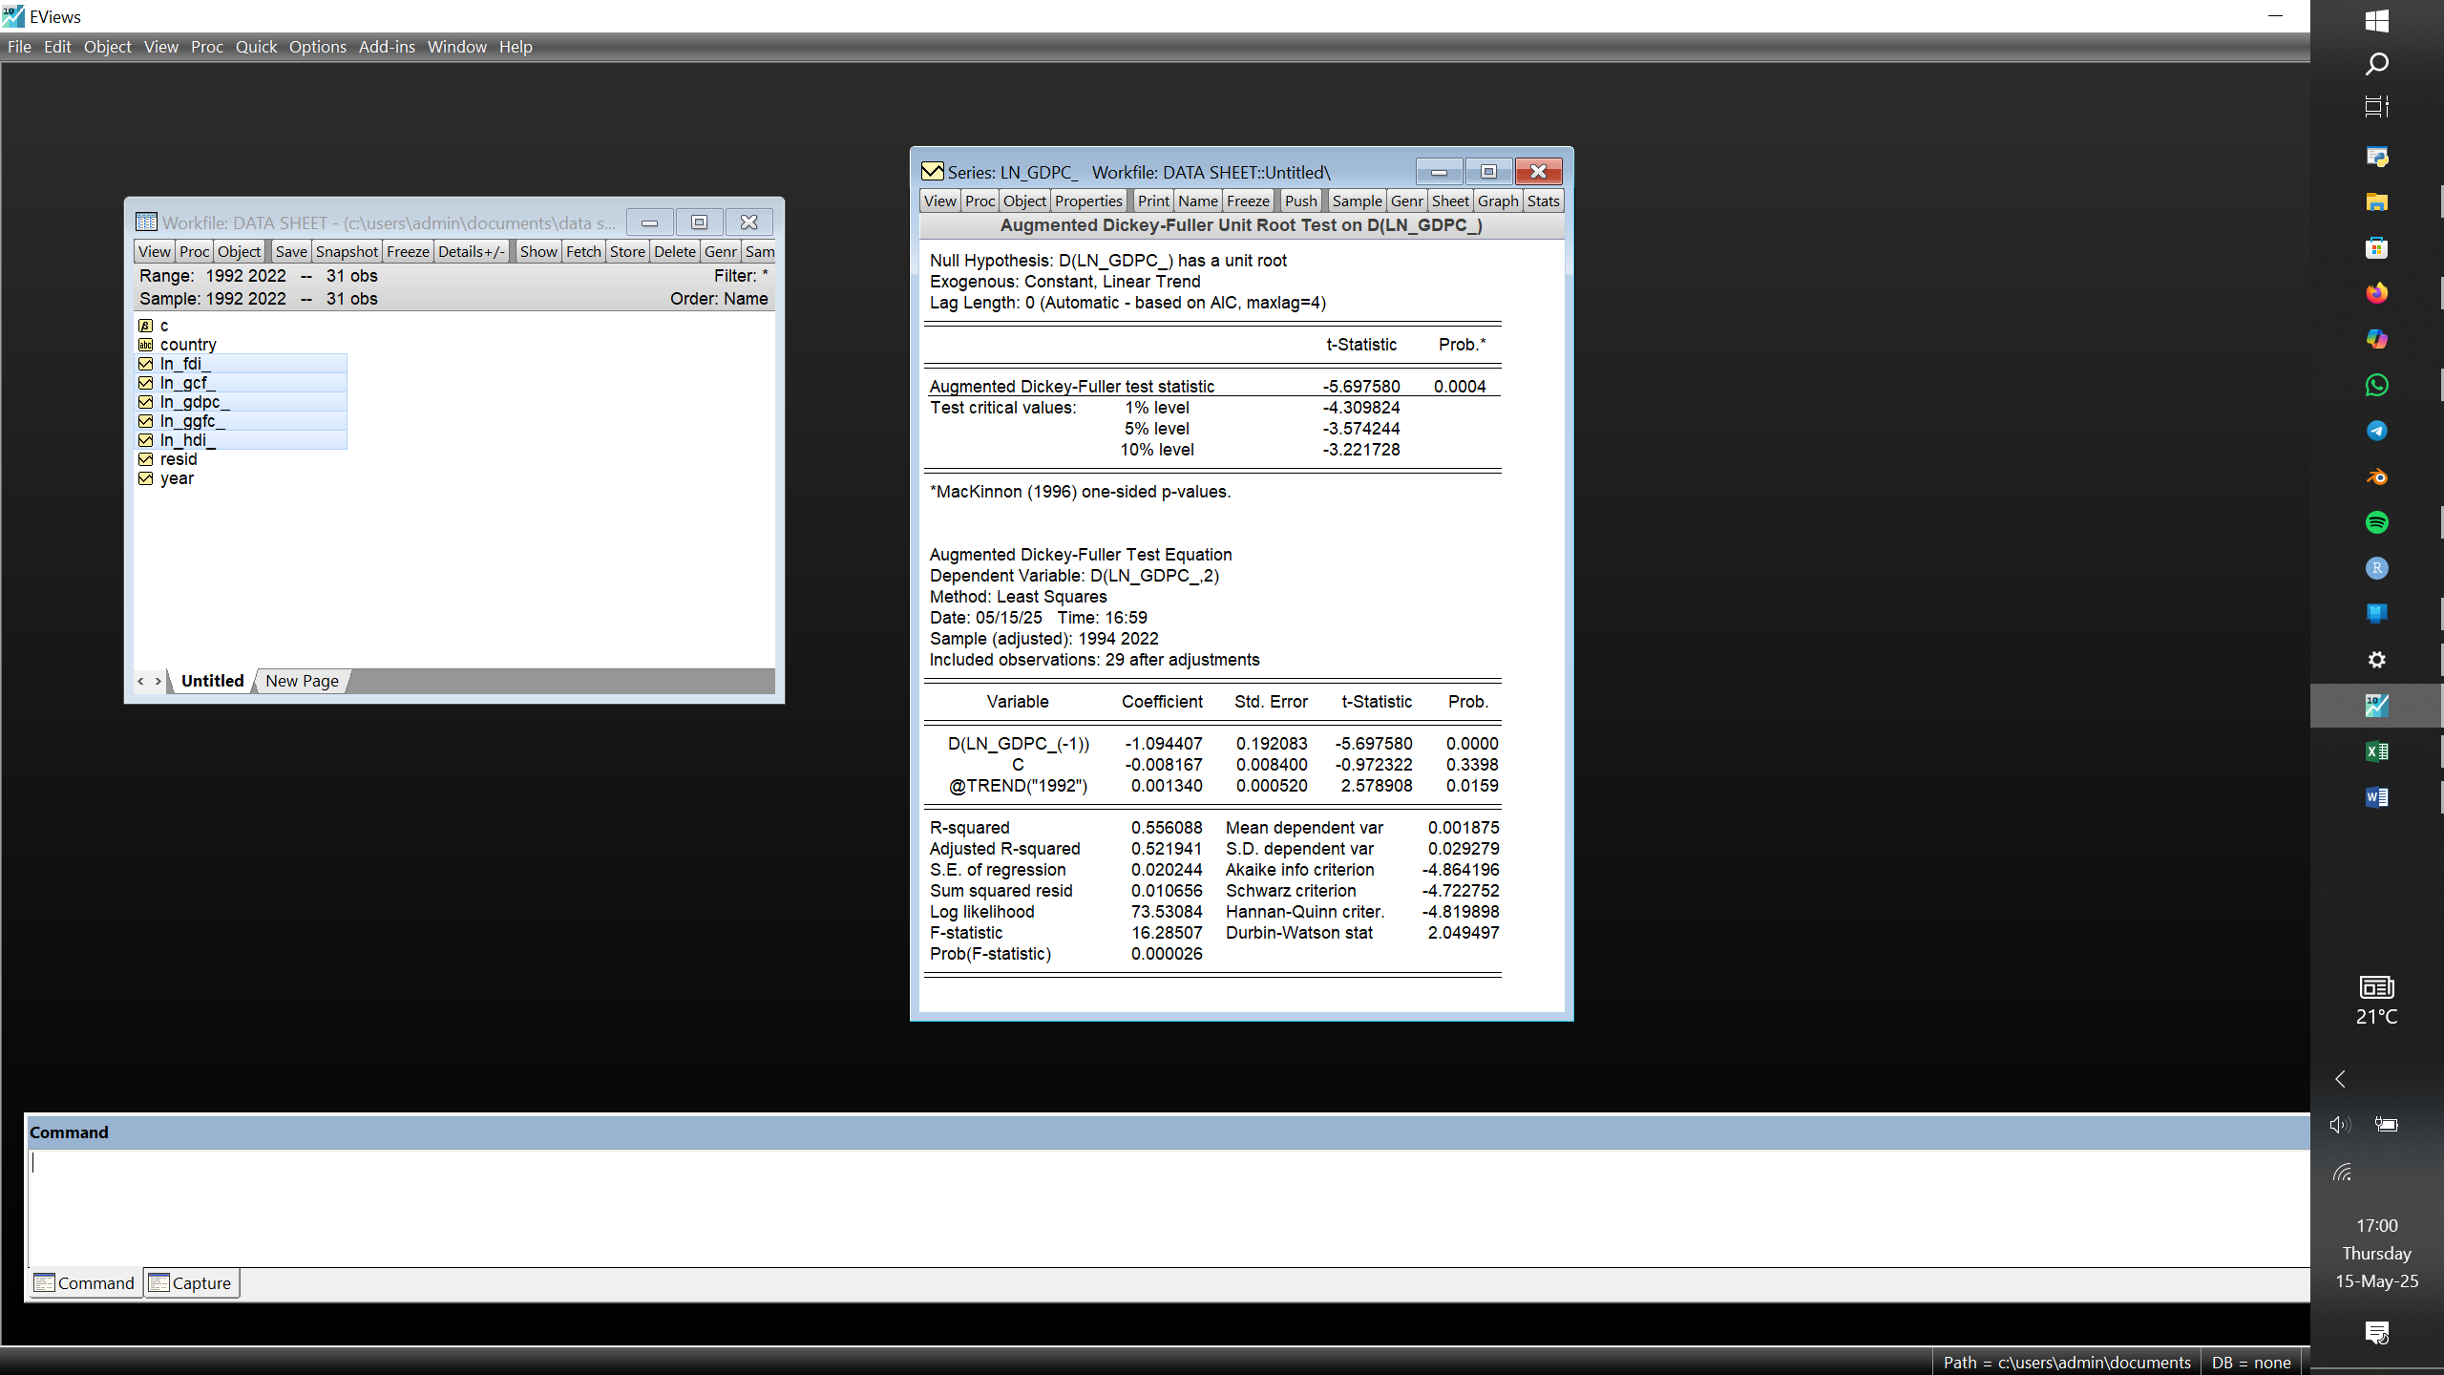 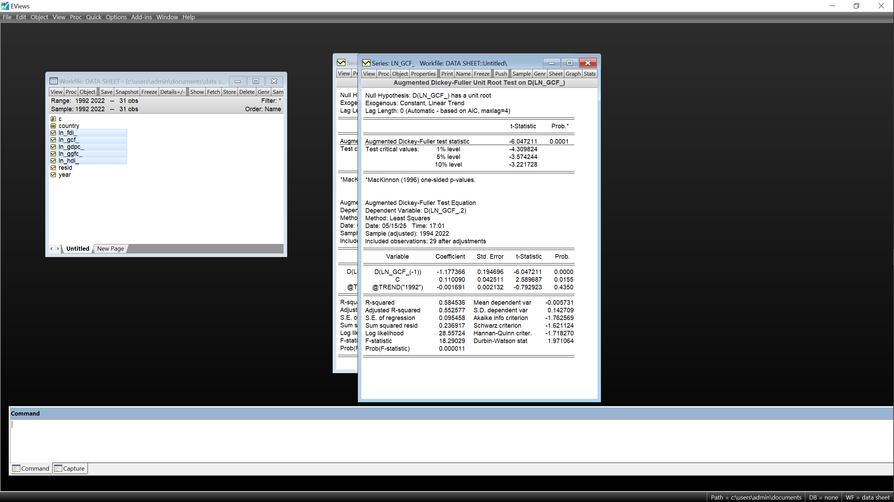
~ln(GGFC) ~ln(HDI) 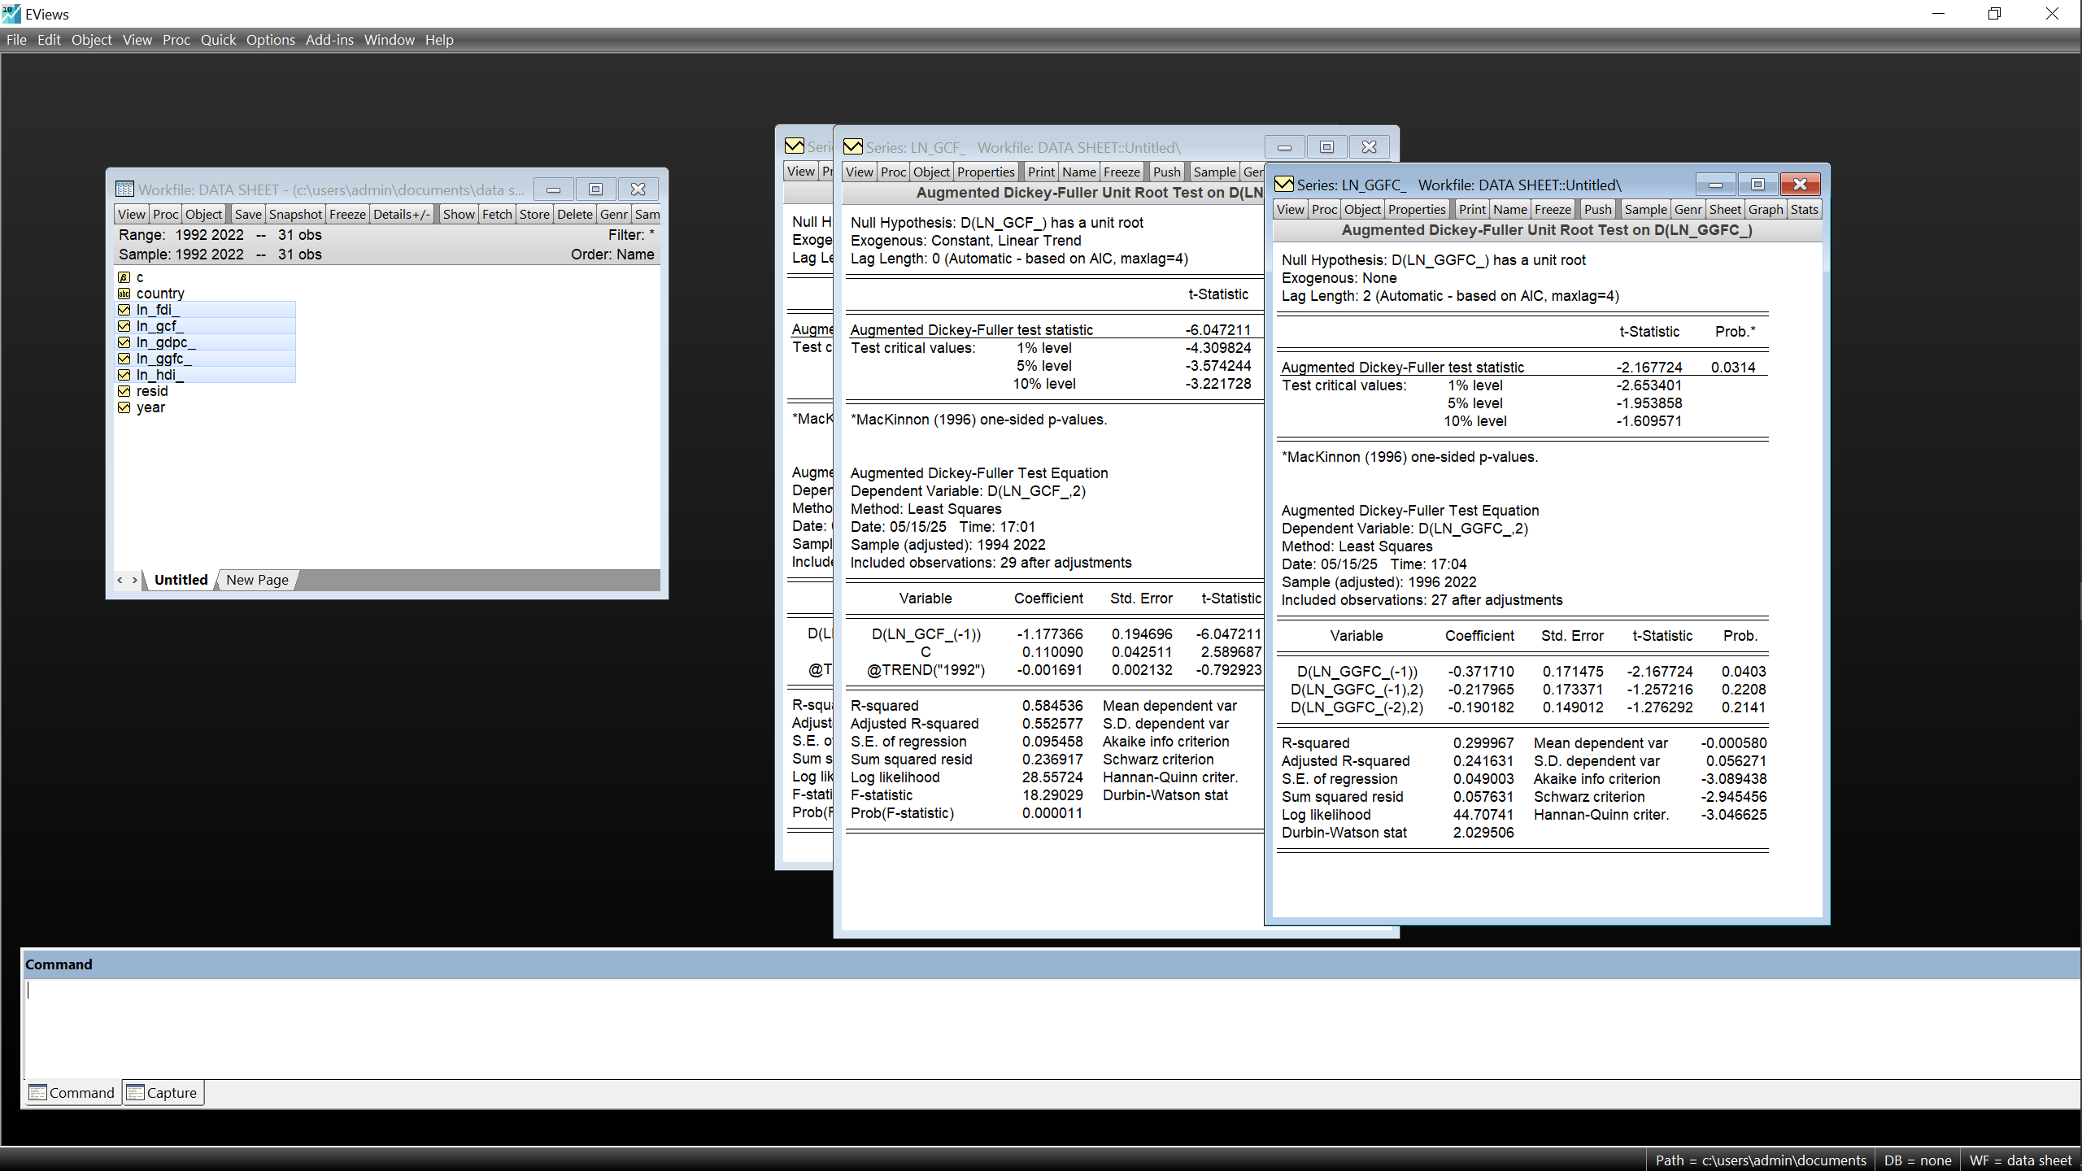 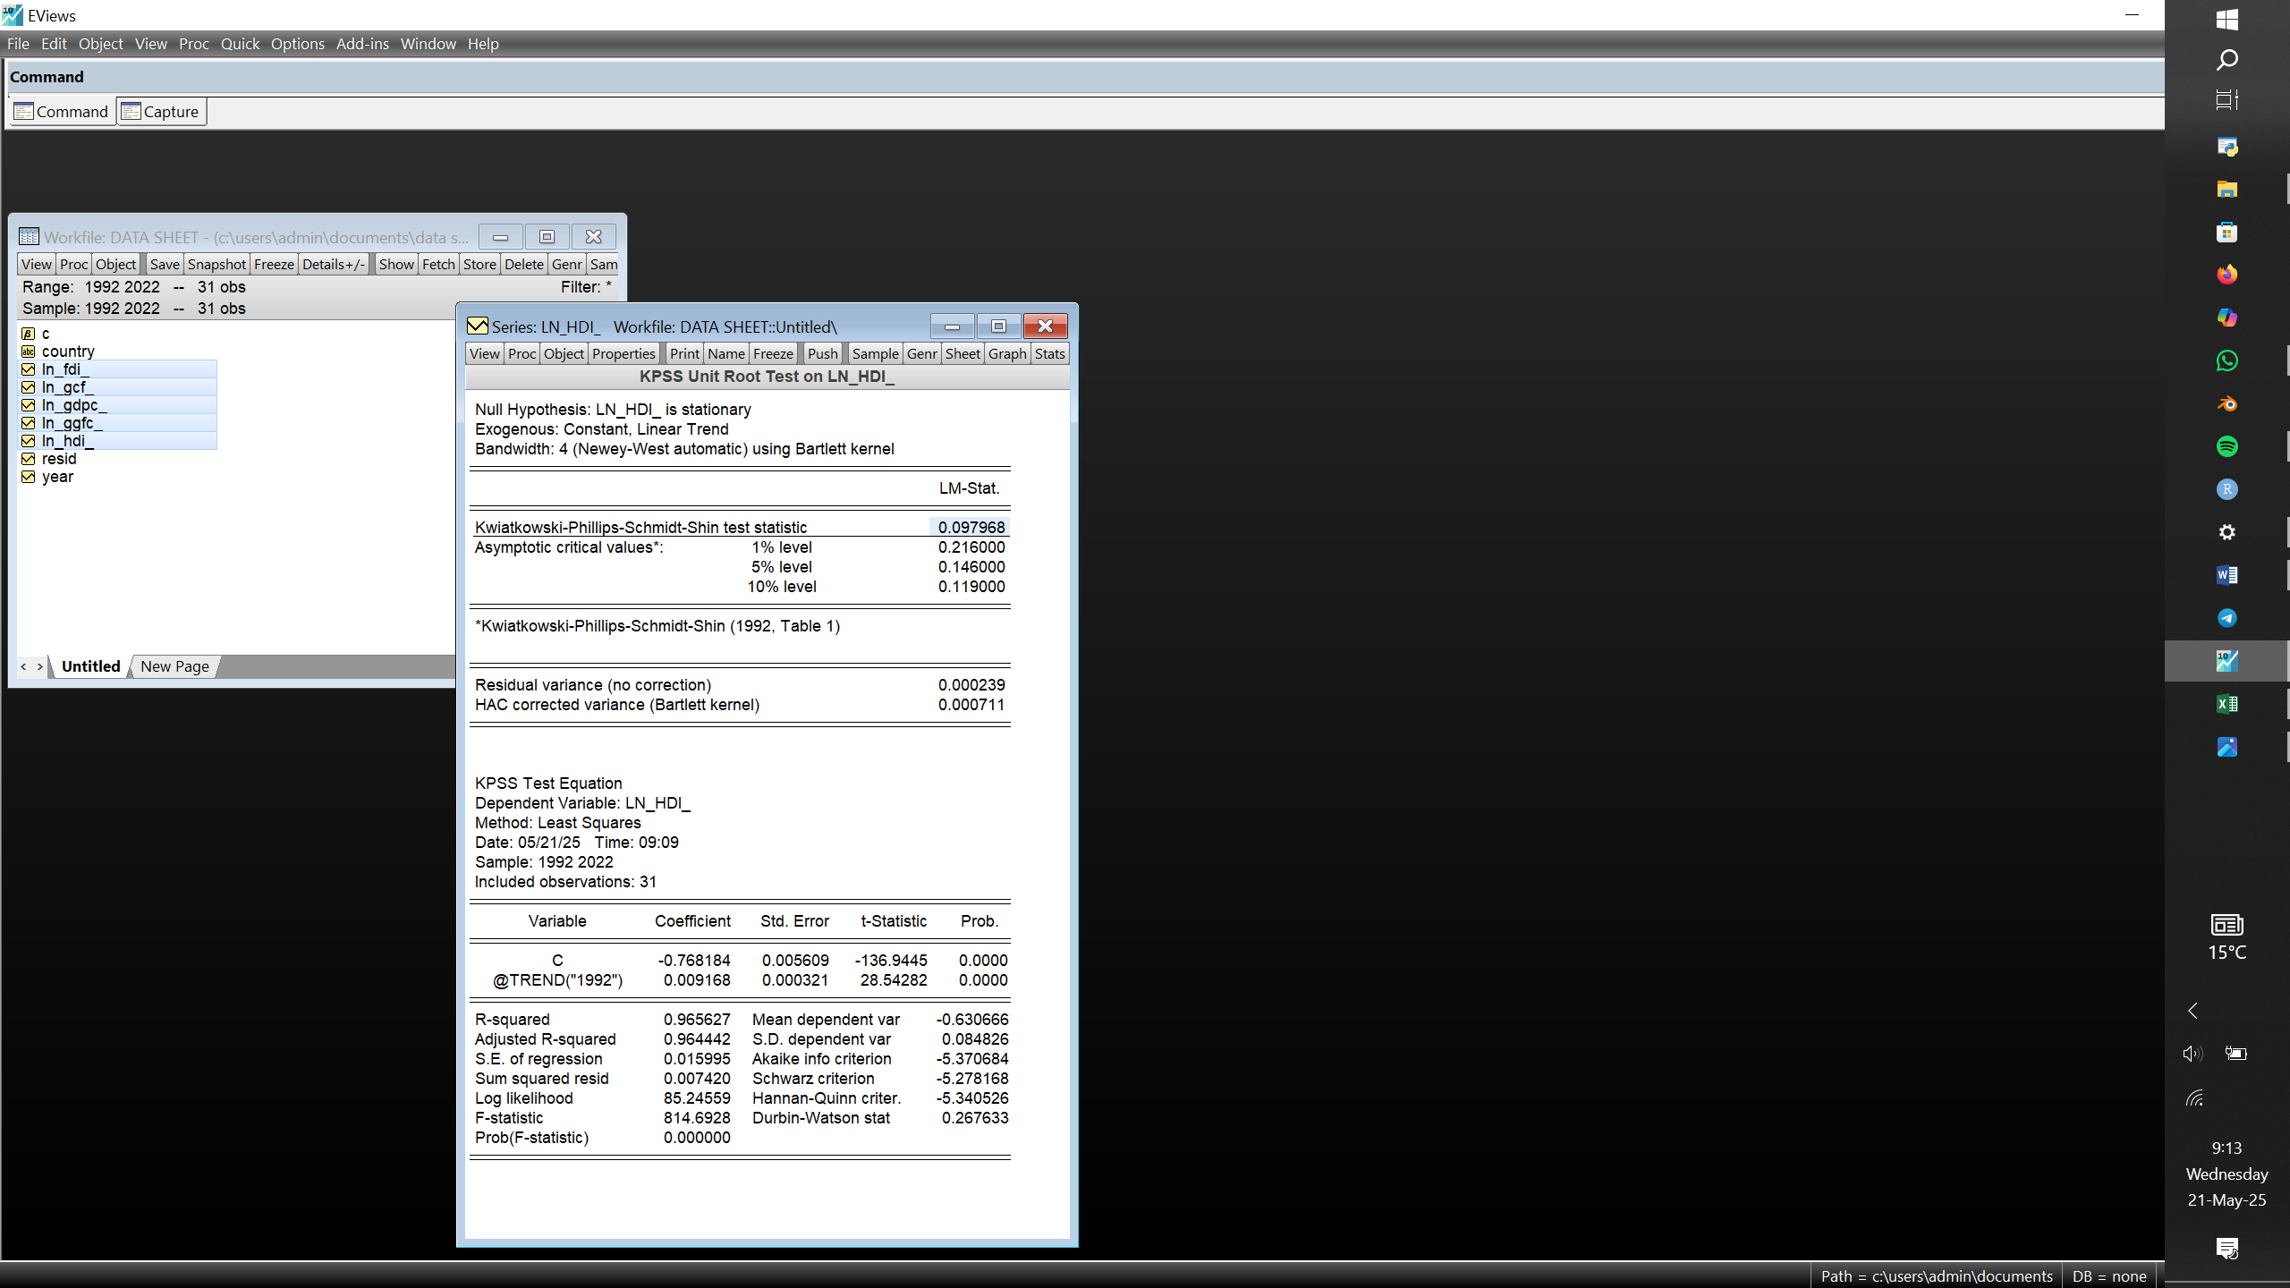
c)UAE
~ln(GDPc) ~ln(GCF)
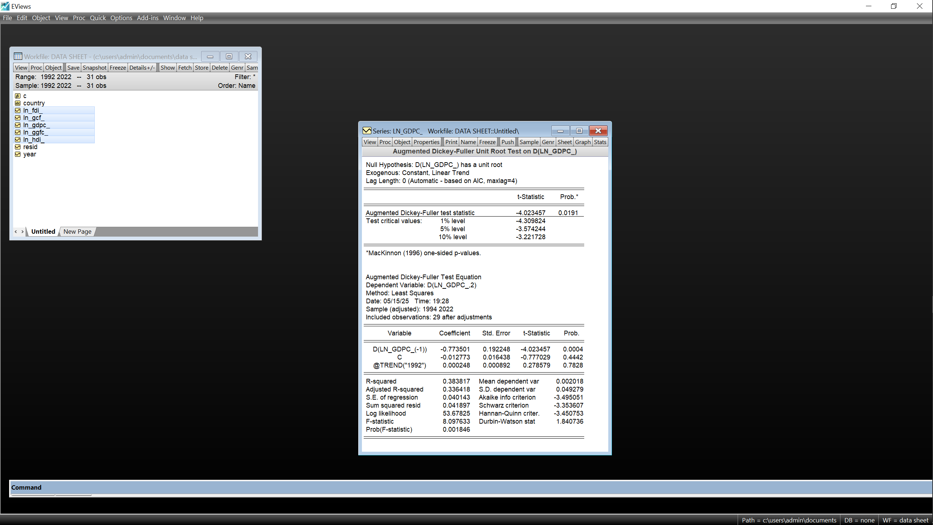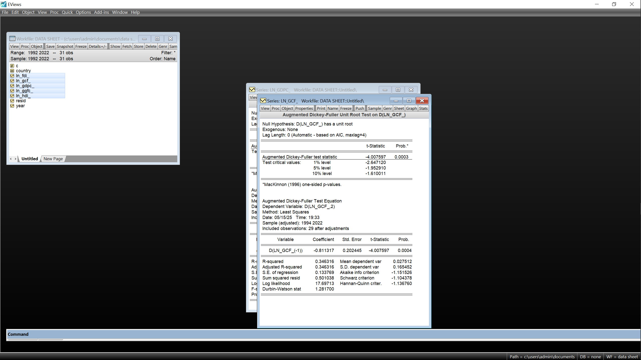

~ln(GGFC) ~ln(HDI)
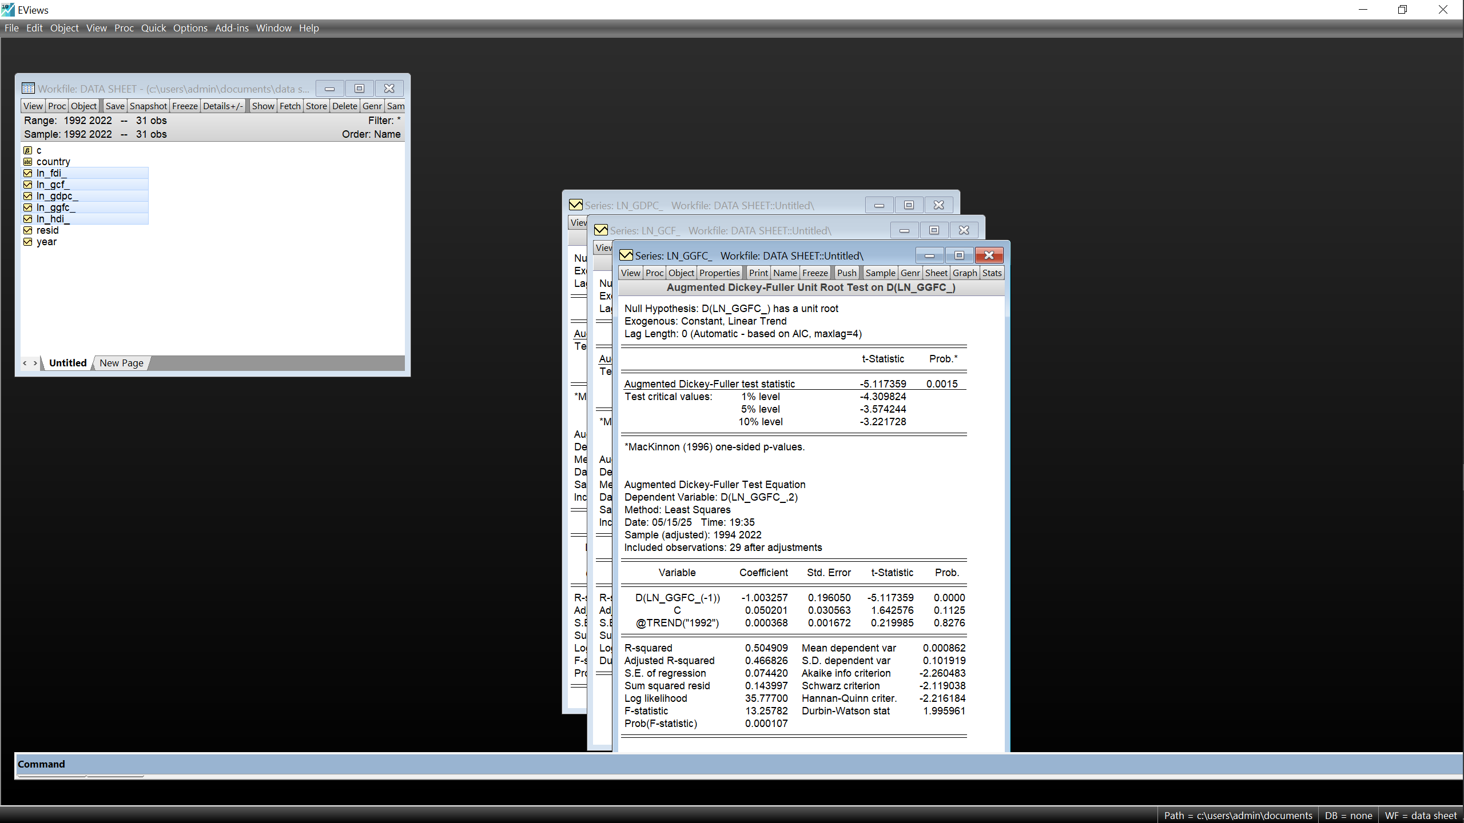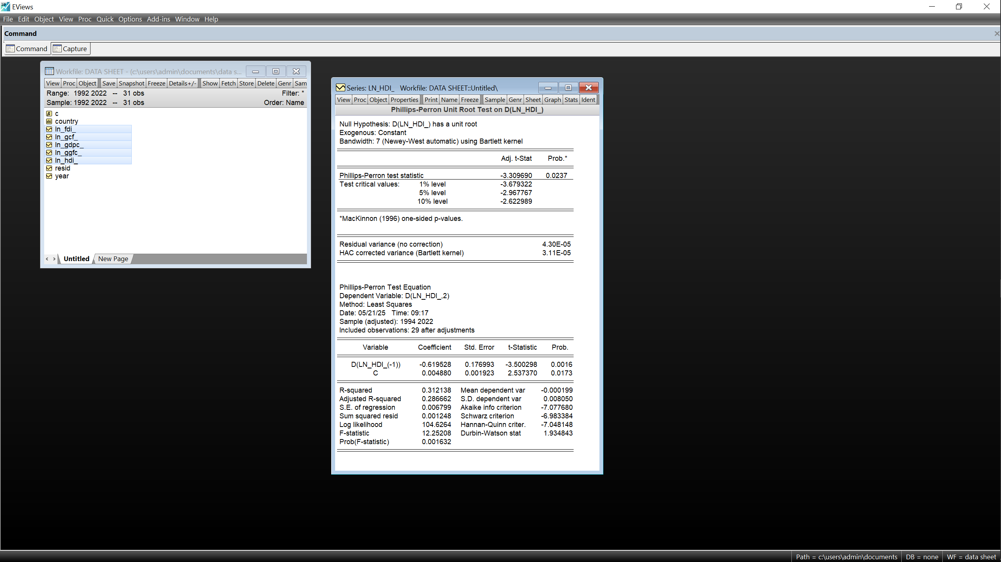

~ln(GDP) ~ln(OPB)
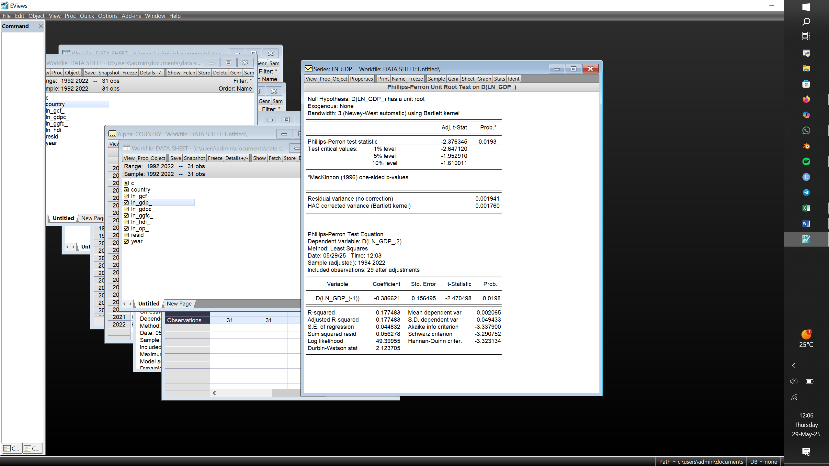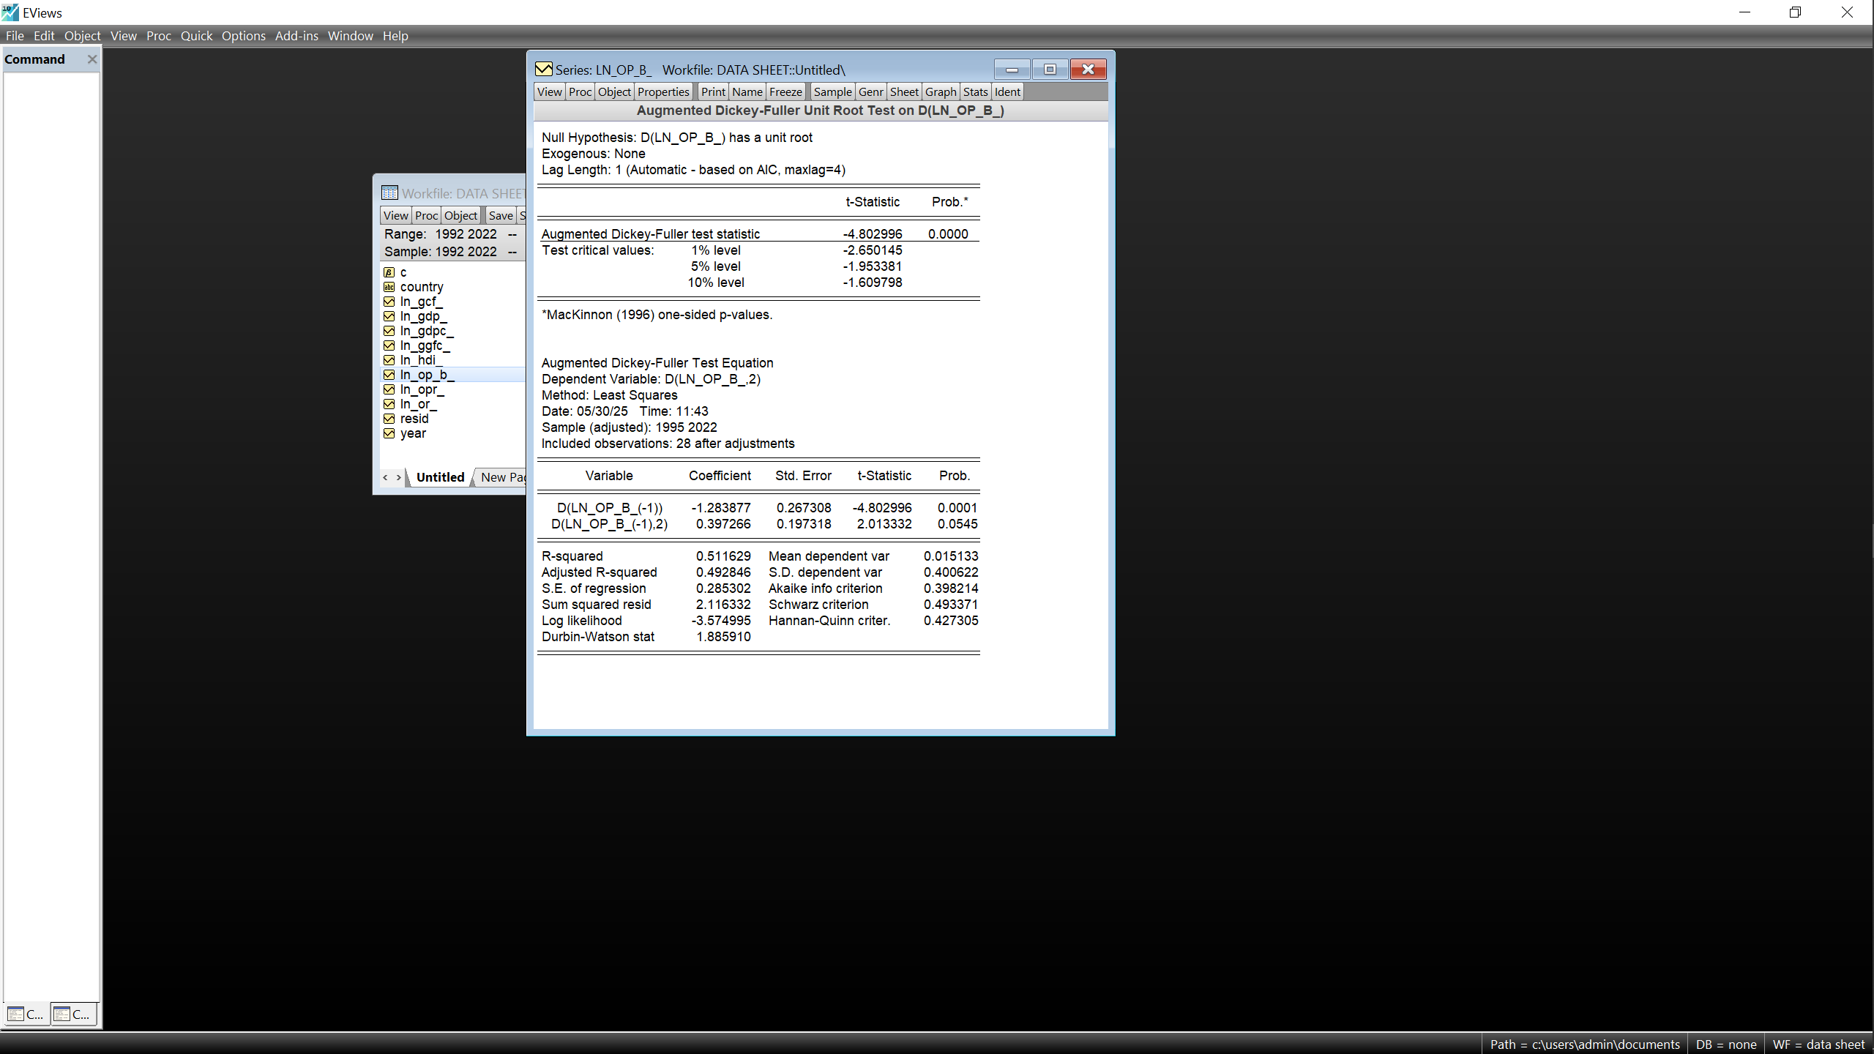
c)USA
~ln(GDPc) ~ln(GCF)
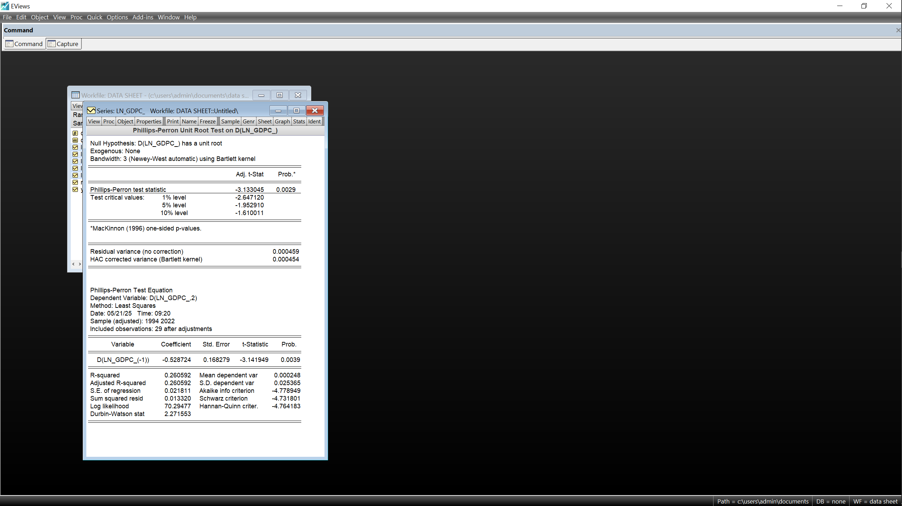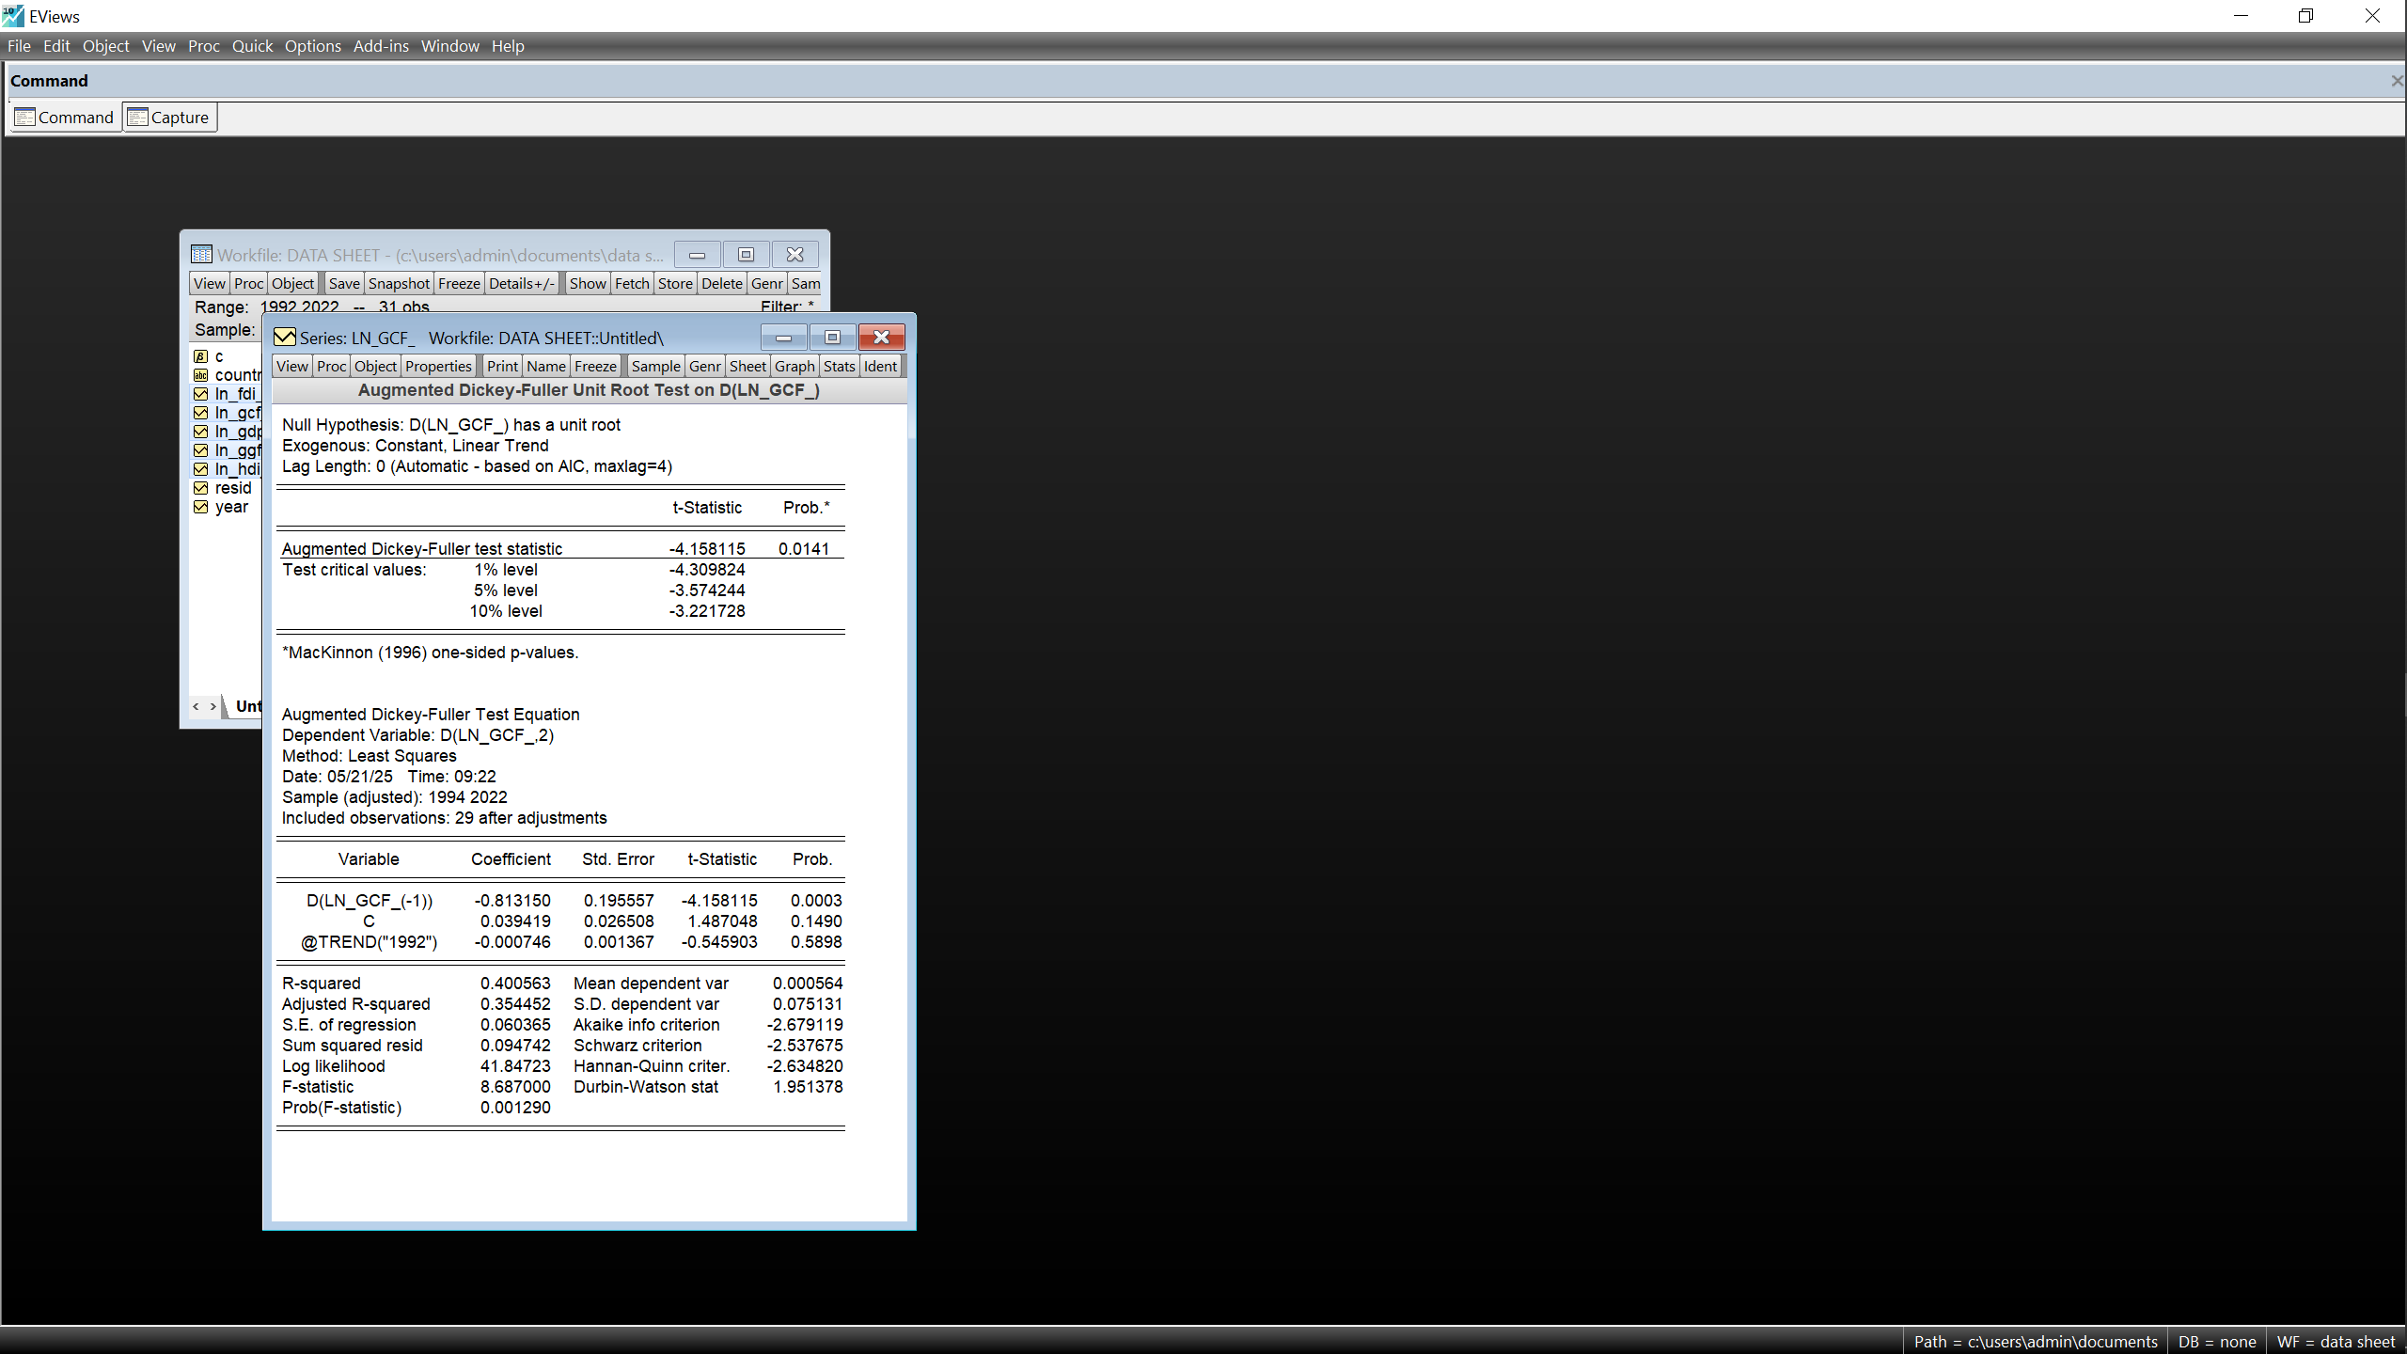
~ln(GGFC) ~ln(HDI)
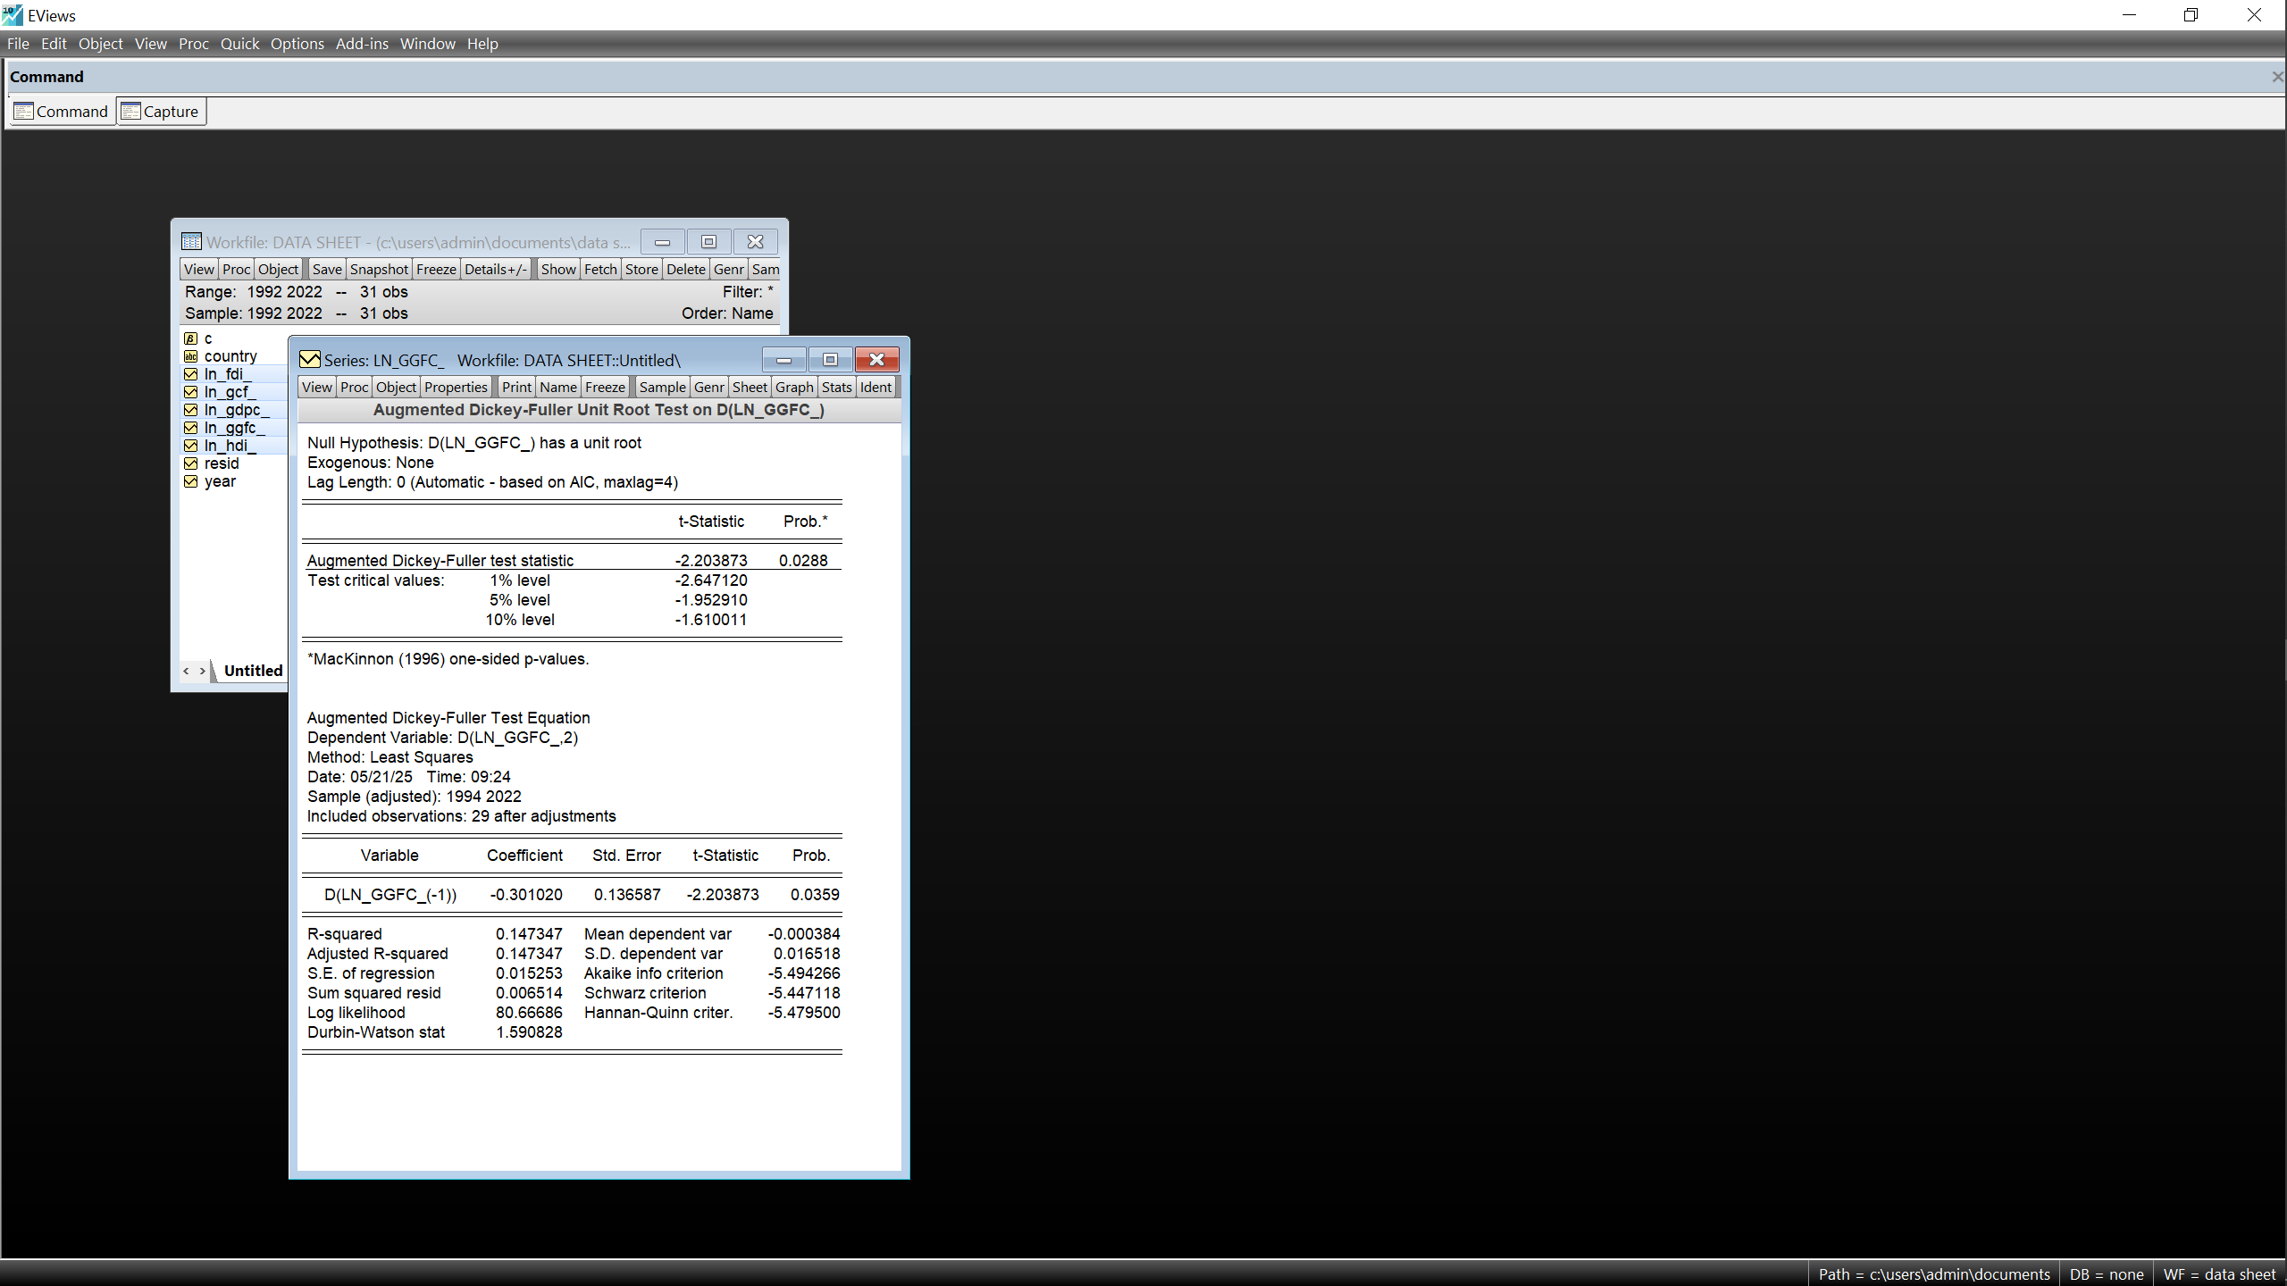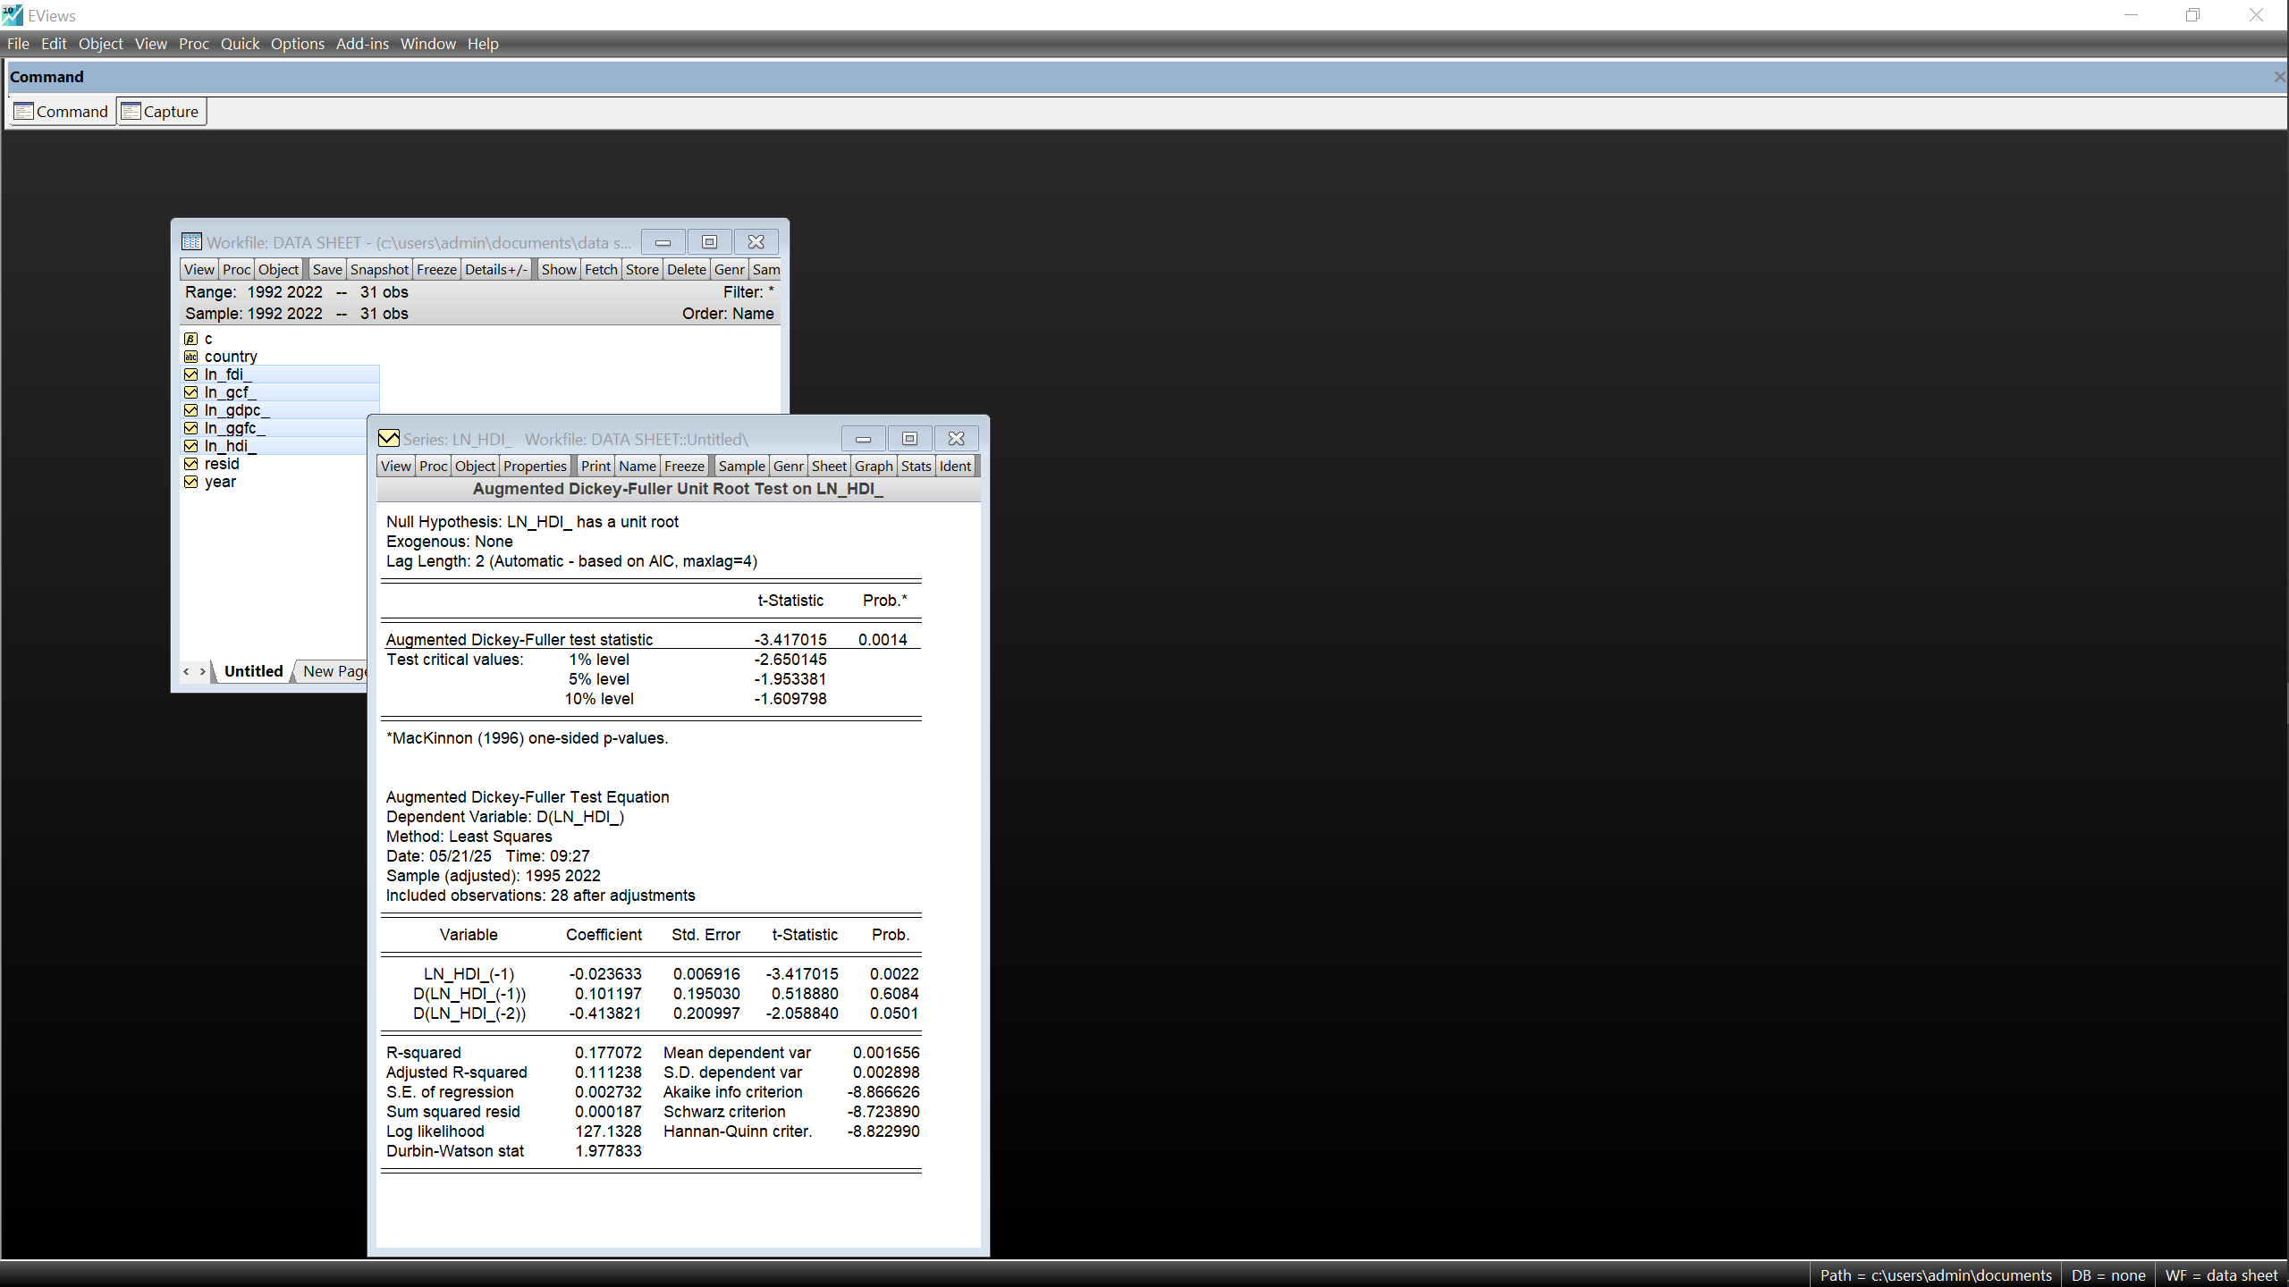
- Appendix 2 : Model 2 of UAE[ln(GDP) dependent on ln(OPB)and ln(GGFC)]
~MODELS
~ARDL Long Run Form and Bounds Test ~ECM
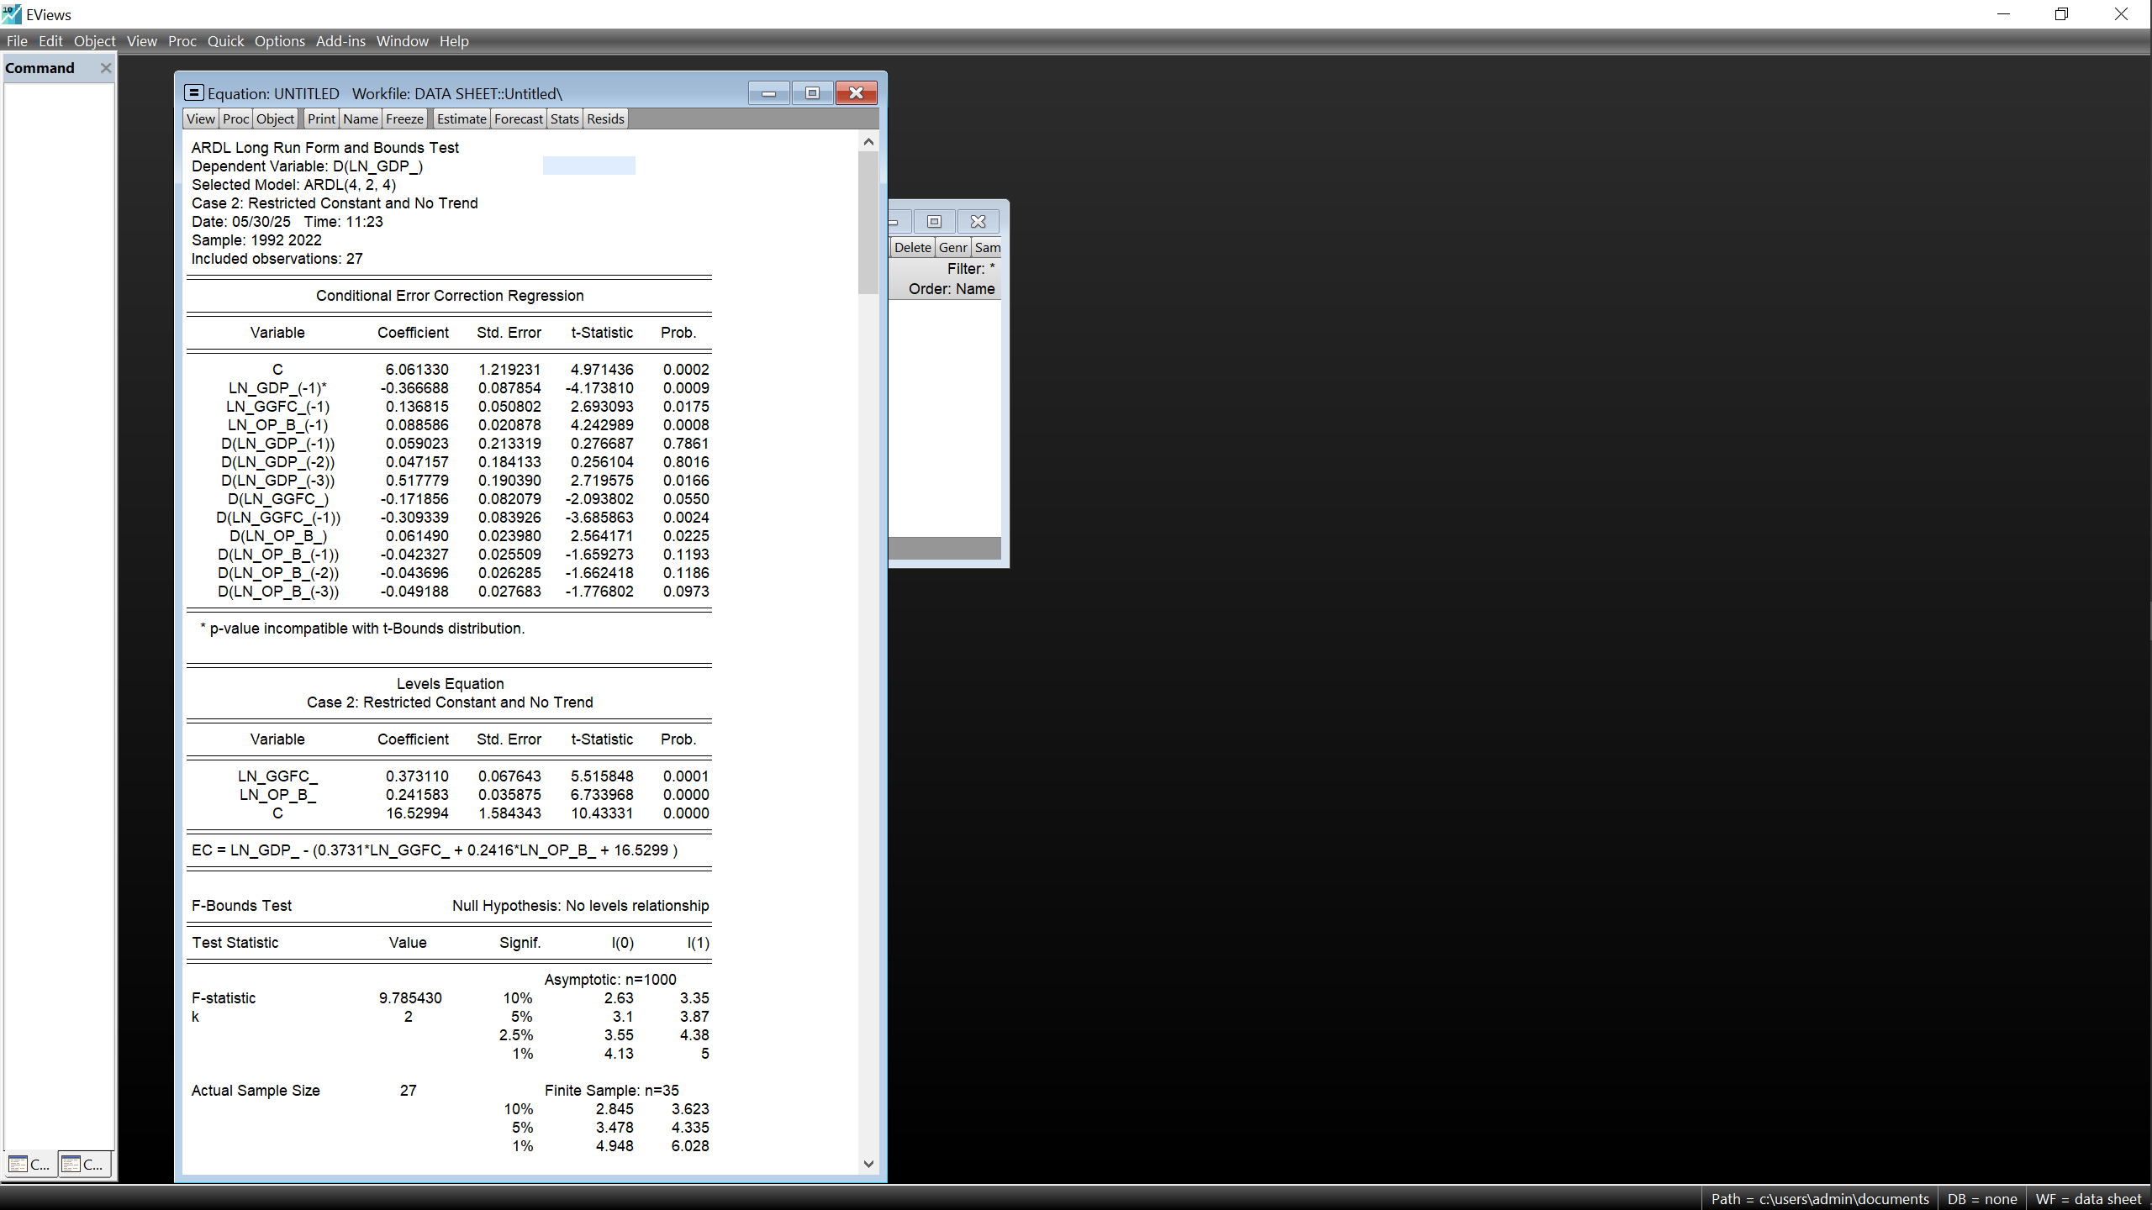
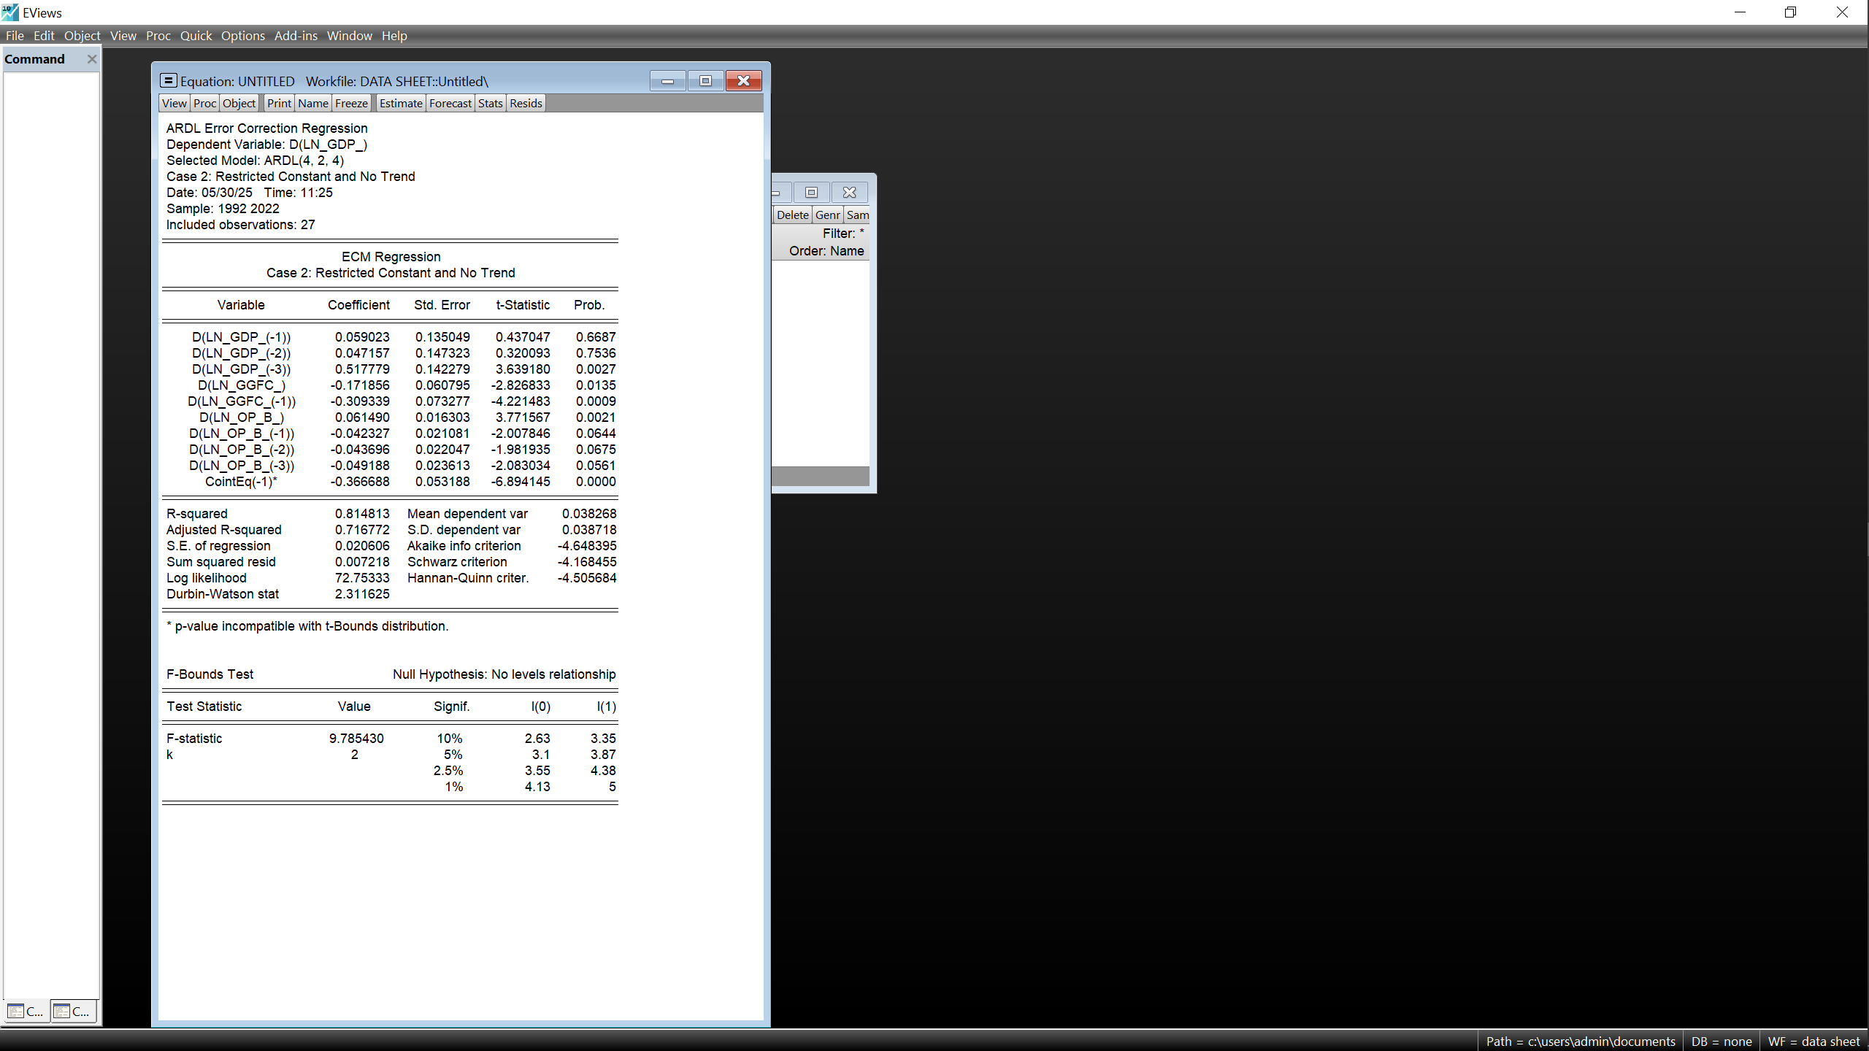

- Appendix 3: Diagnostics of UAE’s model 2
~Model selection Summary ~JB test of Normality
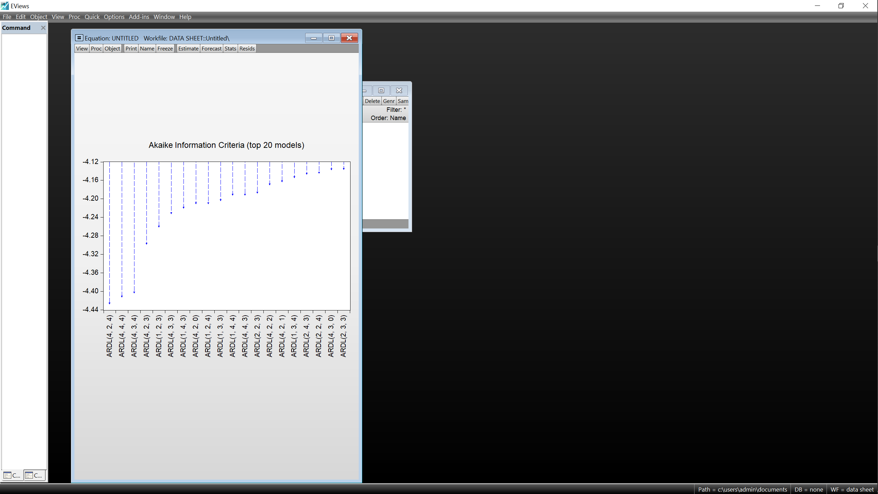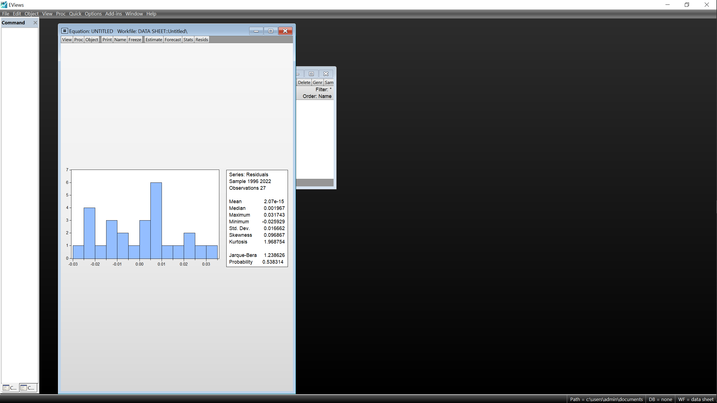
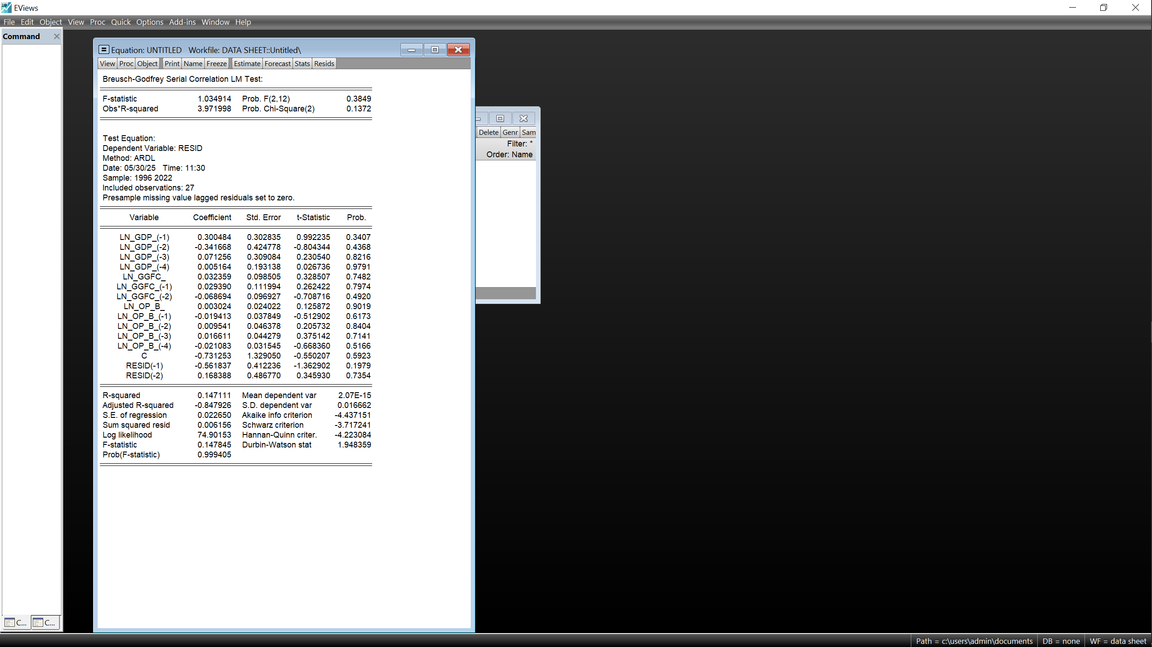
~Serial Correlation Test ~ Heteroskedasticity test
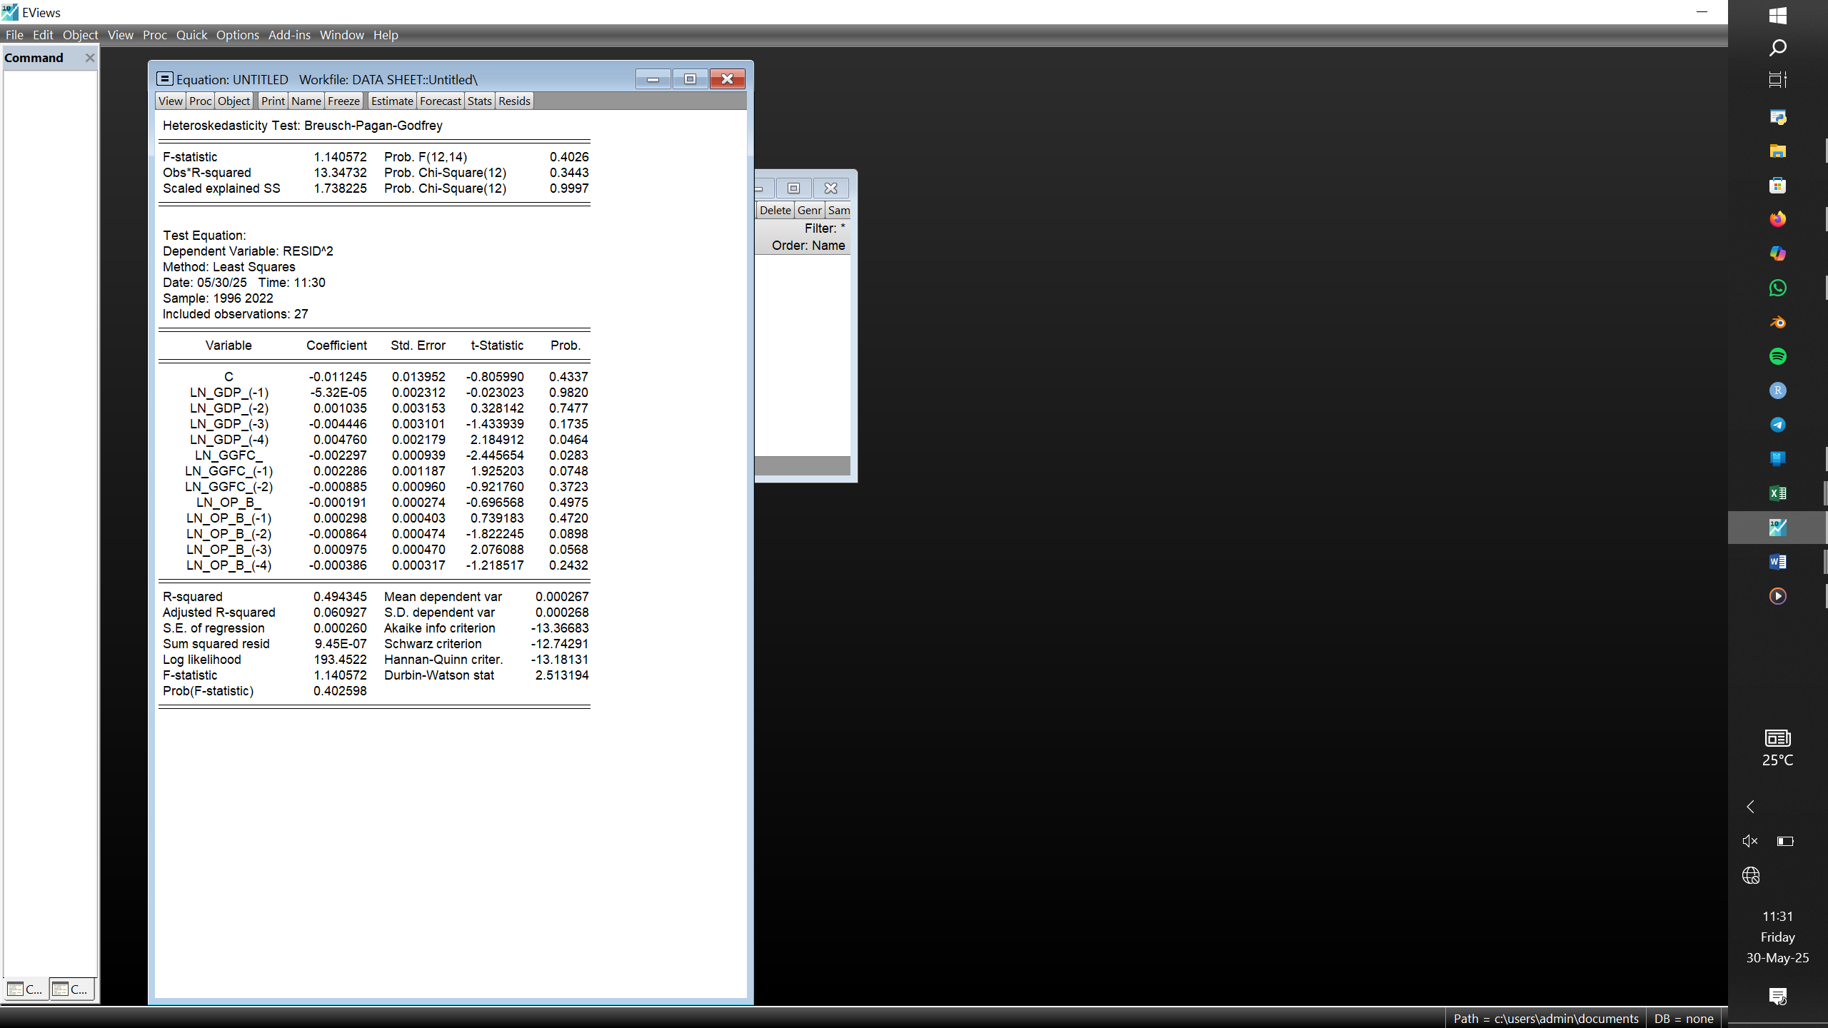

~Stability Tests
~CUSUM and CUSUMSQ
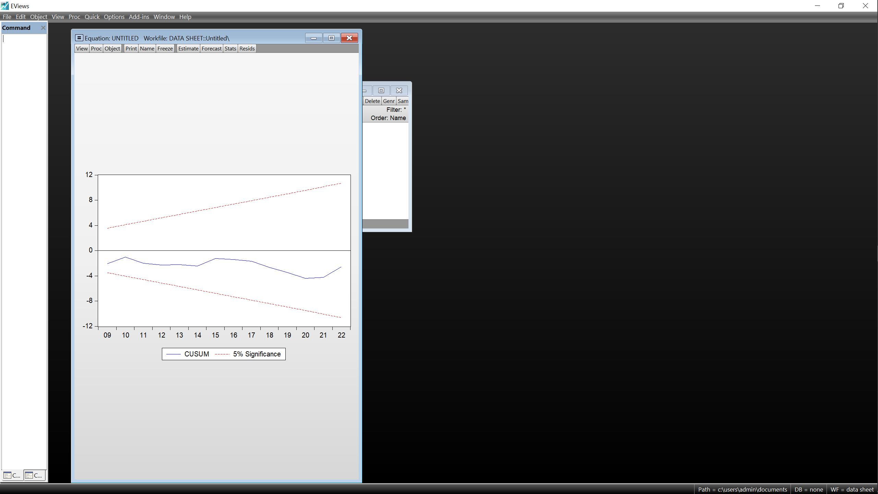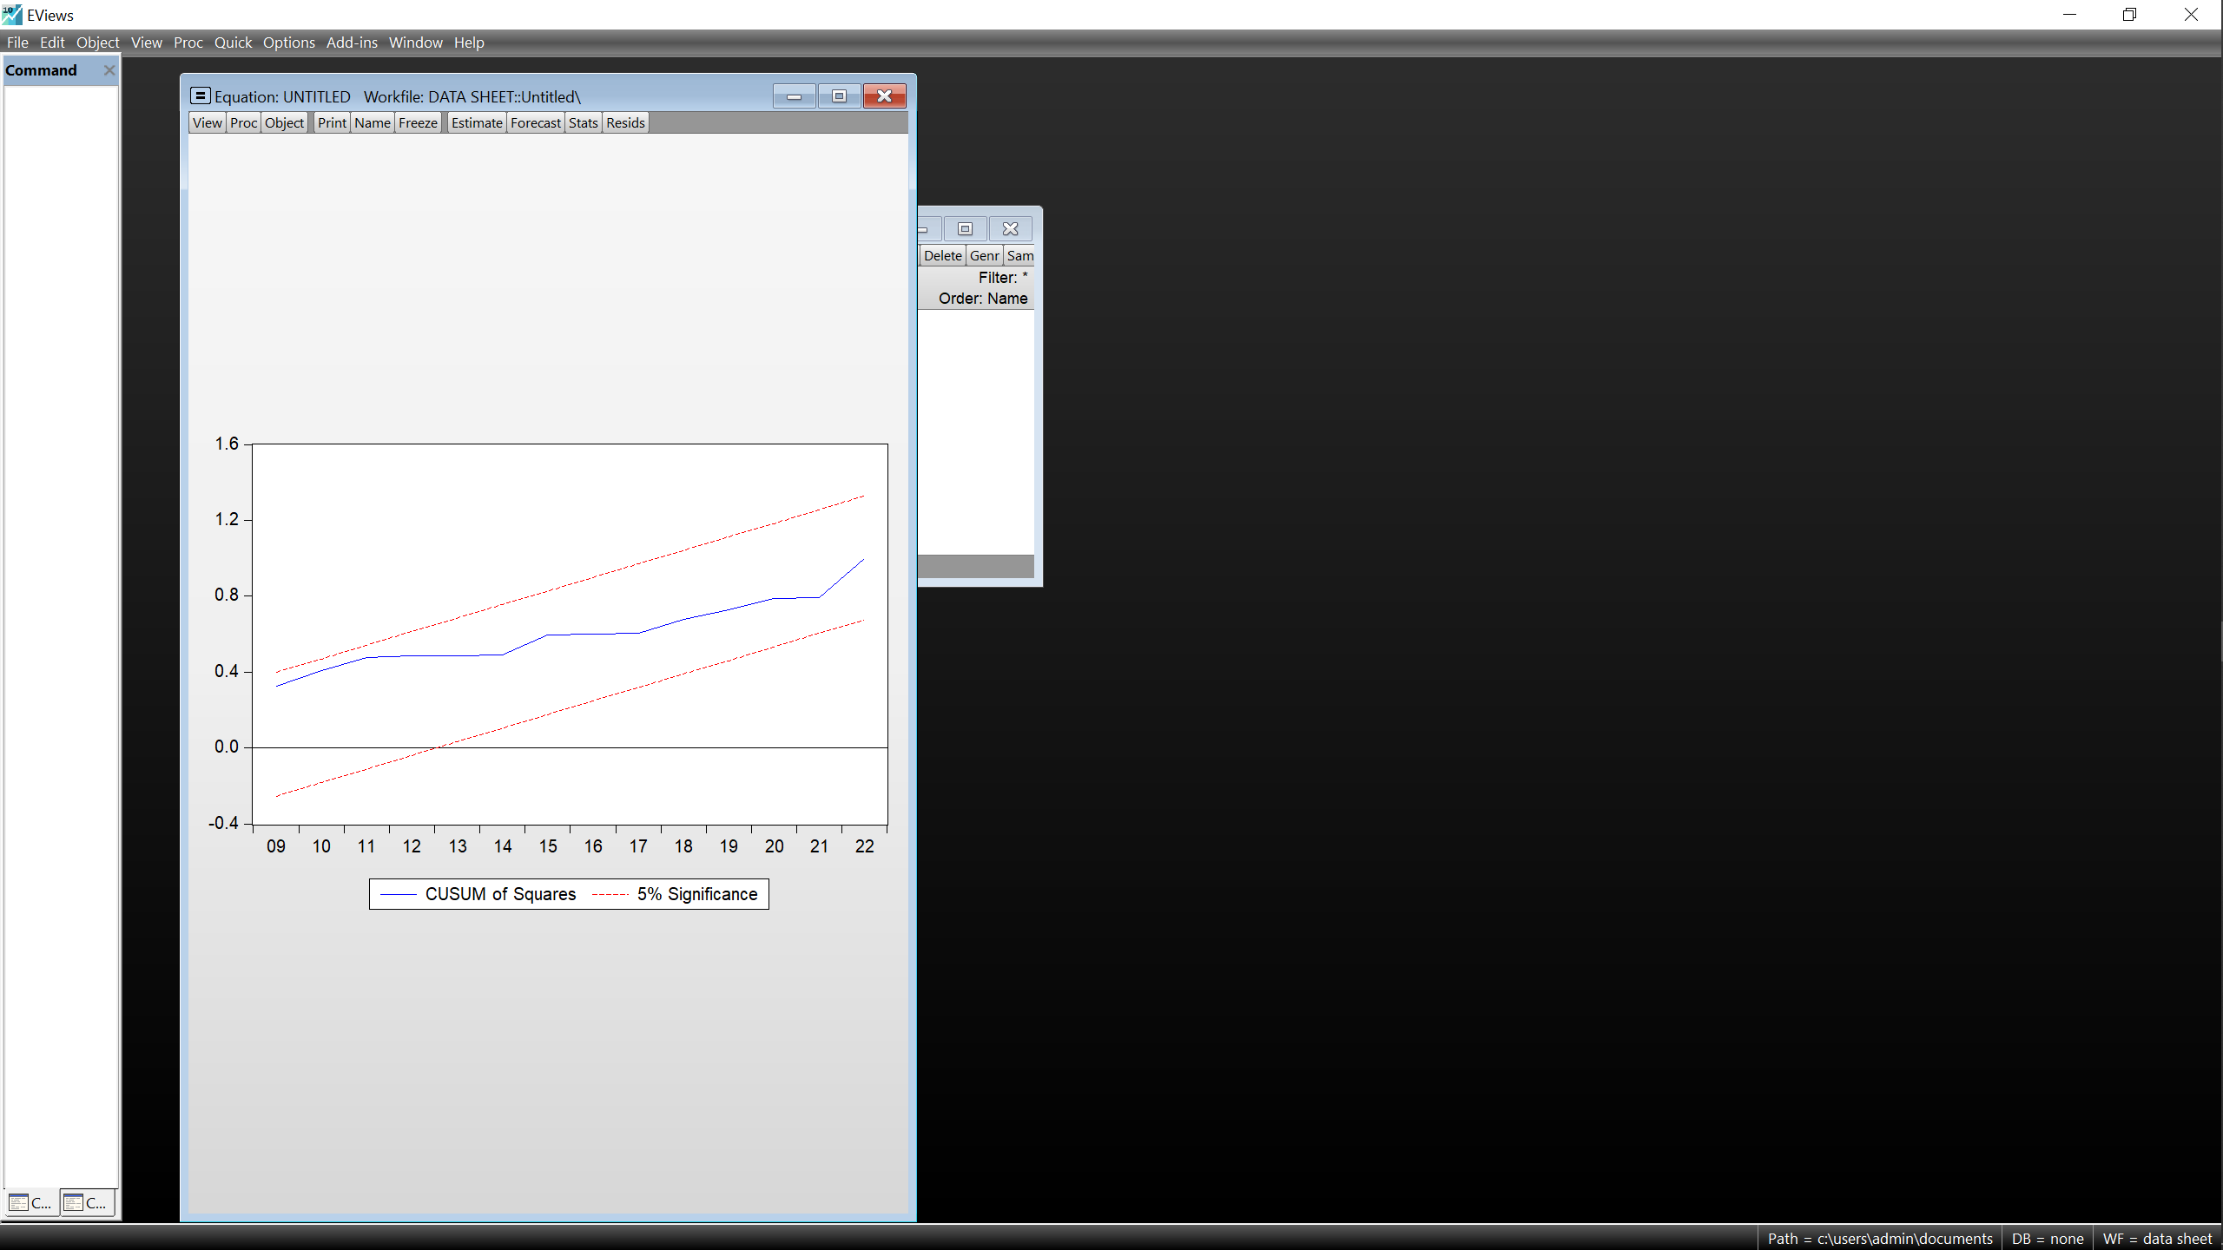
- Appendix 4: Ramsey RESET Tables
a)Uganda b)Kenya
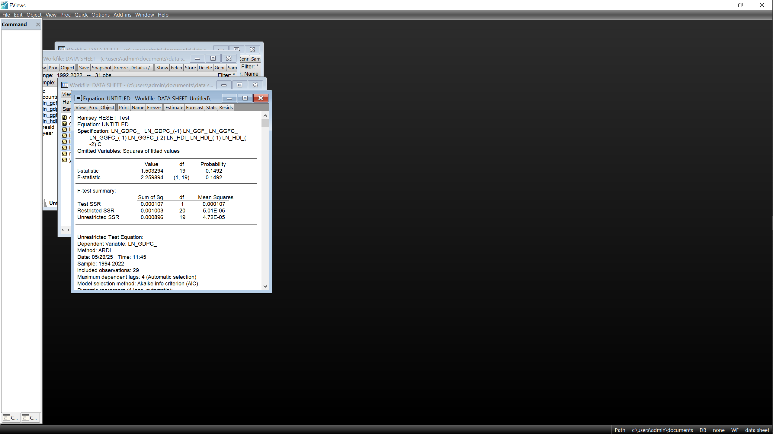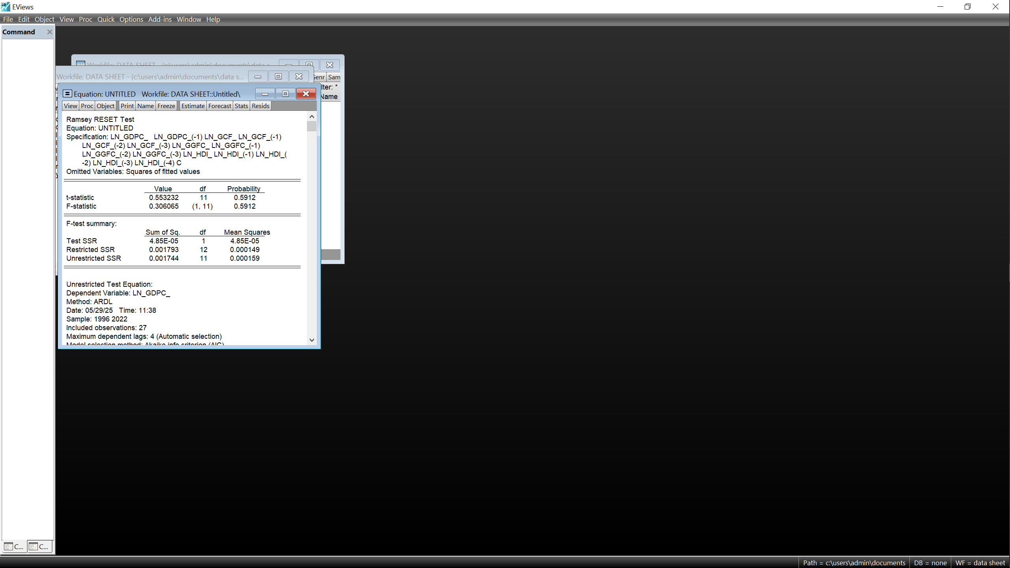
c)UAE
~Model1 ~Model 2
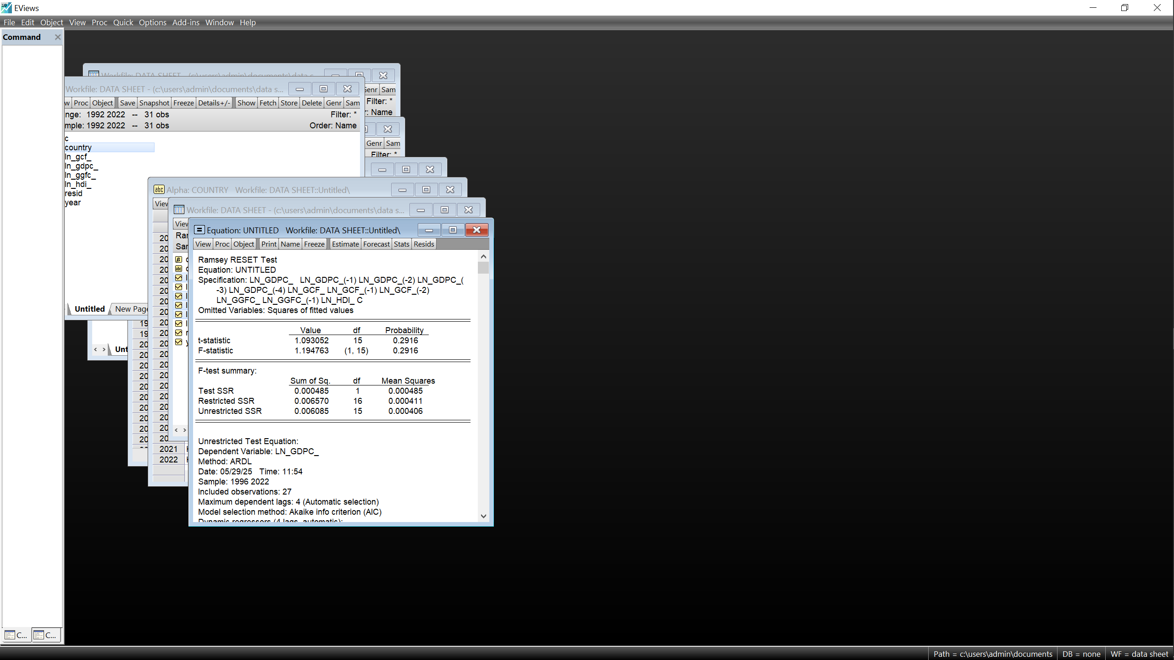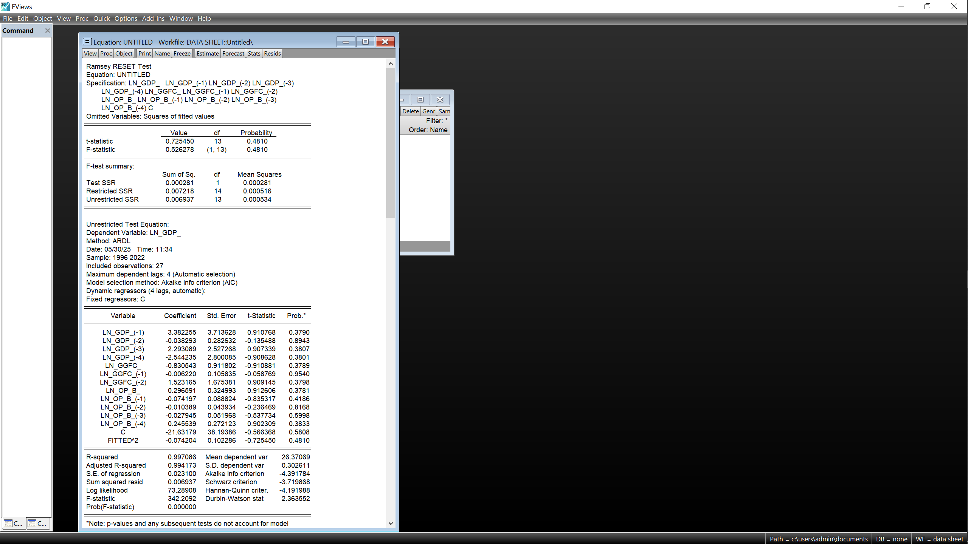

Bibliography
Books
Acemoglu, D. (2008). Introduction to Modern Economic Growth. Princeton University.
Acemoglu, D., & Robinson, J. A. (2012). Why Nations Fail: The Origins of Power, Prosperity, and Poverty. Crown Publishing Group.
Allen, R. (2009). The British Industrial Revolution in Global Perspective. Cambridge University Press.
Borjas, G. (2013). Labour Economics (6th ed.). McGraw-Hill Education.
Davidson, C. (2005). The United Arab Emirates: A Study in Survival. Lynne Rienner.
Gates, P. (1968). History of Public Land Law Development. Washington, D.C.: U.S. Government Printing Office.
Heard-Bey, F. (1982). From Trucial States United Arab Emirates: A Society in Transition. Longman.
Helpman, E. (2004). The Mystery of Economic Growth. Harvard University Press.
Lewis, W. (1955). The Theory of Economic Growth. Allen & Unwin.
Maddison, A. (2007). Contours of the World Economy 1-2030 AD: Essays in Macro-Economic History. Oxford University Press.
Mamdani, M. (1973). From Citizen to Refugee: Uganda Asians Come to Britain. Pambazuka Press.
Mkandawire, T., & Soludo, C. C. (1999). Our Continent, Our Future: African Perspectives on Structural Adjustment. CODESRIA.
Mokyr, J. (1990). The Lever of Riches: Technological Creativity and Economic Progress. Oxford University Press.
Mutibiwa, P. (1992). Uganda Since Independence: A Story of Unfulfilled Hopes. Africa World Press.
Rodney, W. (1972). How Europe Underdeveloped Africa. Bogle-L'Ouverture Publications.
Rodrik, D. (2003). In Search of Prosperity: Analytic Narratives on Economic Growth. Princeton University Press.
Rostow, W. (1960). The Stages of Economic Growth: A Non-Communist Manifesto. Cambridge University Press.
Todaro, M. P., & Smith, S. C. (2020). Economic Development (13th ed.).

Journal Articles
Adam, C. S., & Gunning, J. W. (2002). Residing the Aid Contract: Donors' Use of Performance Indicators in Uganda. World Development.
Ceesay, E. (2022). The Impact of Government Consumption on GDP in The Gambia. African Economic Review, 58–70.
Hoa, P. T. (2016). Human Development Index in Economic Growth: A Two-Way Relationship.
Hosni, R. (2021, October 11). Decomposition of the Sources of Real Exchange Rate Misalignment in Egypt: Evidence from the ARDL Model. Organizations and Markets in Emerging Economies, 11–19.
Humssi, A. A., Petrovskaya, M., & Abueva, M. (2022). Modelling the Impact of World Oil Prices and the Mining and Quarrying Sector on the United Arab Emirates’ GDP. Mathematics, 1–10.
Jack, W., & Suri, T. (2014). Risk Sharing and Transaction Costs: Evidence of Kenya's Mobile Money Revolution. American Economic Review.
Jahan, S. (2014). Keynesian Economics and Its Modern Relevance. IMF Finance and Development.
Nkoro, E., & Uko, A. K. (2016, December 1). Autoregressive Distributed Lag (ARDL) Cointegration Technique: Application and Interpretation. Journal of Statistical and Econometric Methods, 76–85.
Ntamwiza, A. (2022). Gross Capital Formation and Economic Growth: Evidence from Rwanda. Rwanda Economic Journal, 45–59.
Singh, S. (2023). Natural Resources and Economic Growth: A P5+1 Analysis. Journal placeholder.
Smith, R. (2020). HDI Rankings and Their Economic Implications. Global Development Insights, 77–99.
Reports / Government Publications
Authority, U. P. (2023). Albertine Graben Oil and Gas Development: Overview and Progress Report.
Community, E. A. (2022). EAC Regional Integration Agenda.
Congress, U. (1996). Telecommunications Act of 1996.
IMF. (2019). United Arab Emirates: Selected Issues. IMF Country Report.
JICA. (2008). Revisiting Kenya's Industrialisation Strategy. Japan International Cooperation Agency.
Ministry of Economy, U. (2020). Economic Vision 2030.
Ministry of ICT, I. a. (2020). Digital Economy Blueprint: Powering Kenya's Transformation.
UNECA. (2021). Regional Integration and Trade in East Africa. United Nations Economic Commission for Africa.
(2007). Kenya Vision 2030: The Popular Version. Government of Kenya.
Summary of the Affordable Care Act. (2010). Kaiser Family Foundation.
Web Sources & Online Articles
(2020). World Bank – Kenya Economic Update. https://www.worldbank.org/en/country/kenya/publication/kenya-economic-update-navigating-the-pandemic
(2021). World Bank – Uganda Economic Update. https://www.worldbank.org/en/country/uganda/publication/covid-19-economic-update-uganda
(2021). Australian Bureau of Statistics. https://www.abs.gov.au/statistics
(2023). World Bank Data. https://data.worldbank.org
(2024). OECD Data. https://data.oecd.org
Baumohl, E., & Lycosa, S. (2009). Stationarity of Time Series and the Problem of Spurious Regression. https://papers.ssrn.com/sol3/papers.cfm?abstract_id=1480682
Bureau of Labor and Statistics. (2025, May 2). https://www.google.com/search?q=what+is+the+unemployment+rate+in+USA
Callen, T. (2025). Gross Domestic Product: An Economy's All.
Chen, J. (2022, June 22). Emirates Investment Authority (EIA): What It is, How it Works. https://www.investopedia.com/terms/e/emirates-investment-authority.asp
Chernicof, D. (2025, March 13). From Billions to Trillions: Data Centers' New Scale of Investment. https://www.datacenterfrontier.com/machine-learning/article/55272808/from-billions-to-trillions-data-centers-new-scale-of-investment
Drozdowski, M. J. (2024, September 6). Is U.S. Higher Education Still the Best in the World? https://www.bestcolleges.com/news/analysis/2021/10/27/is-us-higher-education-still-the-best-in-the-world
IEA. (2024, June). World Energy Investment 2024. https://www.iea.org/reports/world-energy-investment-2024/united-states
Institute, M. E. (2024, April 4). Renewable Energy and Morocco's New Green Industries.
Oil and Gas Sector. (2023). Petroleum Authority of Uganda. https://www.pau.go.ug
Railways, K. (2021). Standard Gauge Railway Project Overview.
Reuters. (2025, June 6). Botswana’s Debswana Curbs Diamond Production as Weak Demand Persists.
Silver, C. (2025, January 29). The Top 25 Economies in the World. https://www.investopedia.com/insights/worlds-top-economies
Snr, C. (2025, February 19). The Essential Natural Resources of Kenya: A Call For Sustainable Management. https://medium.com/@otollocolly/the-essential-natural-resources-of-kenya-a-call-for-sustainable-management-13e945a7ad30
Transparency International. (2024). Corruption Perceptions Index. https://www.transparency.org/en/cpi/2024/index/aze
UN Environment Programme. (2024, February 12). Our Work in Africa. https://www.unep.org/regions/africa/our-work-africa
US Department of Commerce. (2024, August 9). CHIPS and Science Act Update. https://www.commerce.gov/news/blog/2024/08/two-years-later-funding-chips-and-science-act-creating-quality-jobs-growing-local

Abstract
This dissertation investigates the key economic drivers for UAE and USA from 1992 to 2022, the methods used to leverage their renewable and non-renewable resources and compare their path to economic sustainability to that of Kenya and Uganda as they aim for the same. The Auto-Regressive Distributed Lag econometric model was employed in the time series data sourced from reputable and reliable sources: The World Bank, UN and IMF, to analyze the long-run relationship between macroeconomic growth, government investment, government expenditure and human development on the individual countries. The results proved a positive relationship in USA suggesting an economic performance closely tied to the government investments, its spending patterns and the general wellbeing of its citizens. In contrast, there was no observable direct relationship between UAE’s capital wealth and the investment into certain capital stock. The largest drivers of its GDP were instead, the government’s spending on consumption and the revenue from oil, its principal resource. Kenya on the other hand appears to be experiencing growth without a corresponding development, all the variables except the HDI support growth, with a 1.61% augmentation of Kenya’s GDPc statistically associated with a 1% inverse relationship with its HDI. This is not quite the case for Uganda where the government’s spending on consumption is negatively reflected on its GDPc, its 0.2% increase coincides with a 1% decline on the GDPc. Diagnostic tests confirm the validity and reliability of the ARDL models, strengthening the robustness of these findings. The study highlights the importance of a sound policy making system and effective investment in principal resources in stabilizing a nation’s economy and its human development. Adopting such a system could help Kenya and Uganda break free from the reliance on a system ill-suited to their current needs, one that appears to undermine the implementation of policies that enhance industrialization and living standards. This study provides policymakers with valuable insights and an empirical support for drawing a blueprint for East Africa’s economic transformation. The findings in fact, offer a strategic model that could benefit the entire Sub-Saharan African region, in the ongoing conversation of an envisioned Economic Resurgence.

Résumé (French version of the Abstract)
Cette dissertation examine les principaux moteurs économiques des Émirats arabes unis et des États-Unis entre 1992 et 2022, les méthodes utilisées pour exploiter leurs ressources renouvelables et non renouvelables, et compare leur trajectoire vers la durabilité économique à celle du Kenya et de l’Ouganda, qui aspirent à suivre une voie similaire. Le modèle économétrique ARDL (Auto-Regressive Distributed Lag) a été appliqué à des données de séries chronologiques provenant de sources réputées et fiables telles que la Banque mondiale, les Nations Unies et le FMI, afin d’analyser la relation à long terme entre la croissance macroéconomique, l’investissement public, les dépenses gouvernementales et le développement humain dans chaque pays. Les résultats ont montré une relation positive aux États-Unis, suggérant que la performance économique est étroitement liée aux investissements publics, aux modes de dépenses du gouvernement et au bien-être général de la population. En revanche, aucune relation directe observable n’a été trouvée entre la richesse en capital des Émirats arabes unis et la croissance économique individuelle de ses citoyens. Les principaux moteurs de son PIB sont plutôt les dépenses de consommation publique et les revenus issus du pétrole, sa ressource principale. Le Kenya, quant à lui, semble connaître une croissance sans développement correspondant : toutes les variables, à l’exception de l’IDH, soutiennent la croissance, avec une augmentation de 1,61 % du PIB par habitant statistiquement associée à une baisse de 1 % de l’IDH. Ce n’est pas tout à fait le cas de l’Ouganda, où les dépenses publiques de consommation se traduisent négativement sur le PIB par habitant, une augmentation de 0,2 % coïncidant avec une diminution de 1 % du PIB par habitant. Des tests de diagnostic ont confirmé la validité et la fiabilité des modèles ARDL, renforçant ainsi la solidité des résultats. L’étude souligne l’importance d’un système de prise de décision solide et d’un investissement efficace dans les ressources principales pour stabiliser l’économie d’un pays et son développement humain. L’adoption d’un tel système pourrait permettre au Kenya et à l’Ouganda de se libérer d’un modèle inadapté à leurs besoins actuels, un modèle qui semble freiner la mise en œuvre de politiques favorisant l’industrialisation et l’amélioration des conditions de vie. Cette étude offre aux décideurs des perspectives précieuses ainsi qu’un appui empirique pour élaborer une feuille de route pour la transformation économique de l’Afrique de l’Est. Les résultats fournissent en effet un modèle stratégique susceptible de bénéficier à l’ensemble de la région d’Afrique subsaharienne, dans le cadre du débat en cours sur une résurgence économique attendue.
ملخص الرسالة
(Arabic version of the abstract)
تستقصي هذه الرسالة السائقين الاقتصاديين الرئيسيين للإمارات العربية المتحدة والولايات المتحدة الأمريكية من 1992 إلى 2022، والطرق المستخدمة للاستفادة من مواردها المتجددة وغير المتجددة، وتقارن مسارها نحو الاستدامة الاقتصادية بما يحدث في كينيا وأوغندا حيث يهدفون إلى نفس الشيء. تم استخدام نموذج الانحدار الذاتي المتوزع لفحص بيانات السلسلة الزمنية المستمدة من مصادر موثوقة ومعروفة: البنك الدولي، والأمم المتحدة، وصندوق النقد الدولي، لتحليل العلاقة الطويلة الأمد بين النمو الاقتصادي الكلي، واستثمار الحكومة، وإنفاق الحكومة، والتنمية البشرية في الدول الفردية. أثبتت النتائج وجود علاقة إيجابية في الولايات المتحدة تشير إلى أداء اقتصادي مرتبط ارتباطًا وثيقًا باستثمارات الحكومة، وأنماط إنفاقها، والرفاهية العامة لمواطنيها. في المقابل، لم يكن هناك علاقة مباشرة ملحوظة بين ثروة الإمارات الرأسمالية والنمو الاقتصادي الفردي لشعبها. كانت أكبر عوامل الناتج المحلي الإجمالي بدلاً من ذلك، إنفاق الحكومة على الاستهلاك وإيرادات النفط، وهو المورد الرئيسي لها. من ناحية أخرى، يبدو أن كينيا تشهد نمواً دون تنمية متوازية، حيث تدعم جميع المتغيرات باستثناء مؤشر التنمية البشرية (HDI) النمو، مع زيادة بنسبة 1.61% في الناتج المحلي الإجمالي للفرد في كينيا مرتبطة إحصائياً بعلاقة عكسية بنسبة 1% مع مؤشر التنمية البشرية (HDI) الخاص بها. هذه ليست الحال بالنسبة لأوغندا حيث يُعكس إنفاق الحكومة على الاستهلاك سلباً على الناتج المحلي الإجمالي للفرد، إذ تتزامن الزيادة بنسبة 0.2% مع انخفاض بنسبة 1% في الناتج المحلي الإجمالي للفرد. تؤكد اختبارات التشخيص صحة وموثوقية نماذج ARDL، مما يعزز قوة هذه النتائج. تسلط الدراسة الضوء على أهمية نظام صنع السياسات السليم والاستثمار الفعال في الموارد الرئيسية في استقرار اقتصاد الأمة وتنميتها البشرية. يمكن أن يساعد اعتماد مثل هذا النظام كينيا وأوغندا على التحرر من الاعتماد على نظام غير ملائم لاحتياجاتهم الحالية، وهو نظام يبدو أنه يقوض تنفيذ السياسات التي تعزز التصنيع ومستويات المعيشة. تقدم هذه الدراسة لصانعي السياسات رؤى قيمة ودعماً تجريبياً لرسم خطة لتحويل اقتصاد شرق إفريقيا. وفي الواقع، تقدم النتائج نموذجاً استراتيجياً يمكن أن يفيد منطقة جنوب الصحراء الكبرى بأكملها، في الحوار المستمر حول تصور انتعاش اقتصادي.

